ICESCAPE - “Impacts of Climate on Ecosystems and Chemistry of the Arctic Pacific Environment”

Cruise report from HLY1101
Kevin R. Arrigo, Chief Scientist, Stanford University

Introduction
The Arctic sea ice cover is in decline. The retreat of the summer ice cover, a general thinning, and a transition to a younger, a more vulnerable ice pack have been well documented. Melt seasons are starting earlier and lasting longer. These changes can profoundly impact the physical, biological, and geochemical state of the Arctic Ocean region. Climate models project that changes in the ice cover may accelerate in the future, with a possible transition to ice free summers later this century. These changes are quite pronounced in the Chukchi and Beaufort Sea and have consequences for the Arctic Ocean ecosystem, potentially affecting everything from sea ice algae to polar bears.
The central science question of this program is, “What is the impact of climate change (natural and anthropogenic) on the biogeochemistry and ecology of the Chukchi and Beaufort seas?” While both of these regions are experiencing significant changes in the ice cover, their biogeochemical response will likely be quite different due to their distinct physical, chemical, and biological differences.
ICESCAPE is pursuing the above central science question and associated issues through an interdisciplinary, cross cutting approach integrating field expeditions, modeling, and satellite remote sensing. Central to the success of this program is a quantitative and reliable determination of chemical and biological fluxes to and from open water, ice and snow surfaces, as a function of relevant environmental conditions such as the nature of the surfaces. This will be pursued in ways that couple remotely sensed information to that obtained via state-of-the-art chemical, physical and biological sensors located in water, on or under ice, and in the atmosphere. Assimilation and synthesis of data will benefit from coupled atmosphere, biology/ecology, ocean, and sea ice linked modeling.
The second field phase of ICESCAPE was carried out on the USCGC Healy from 25 June to 29 July 2011 (expedition HLY1101). The principal investigators participating in the cruise were:
Kevin Arrigo, Chief Scientist, Phytoplankton physiology, and primary productivity
Don Perovich, Sea ice distribution, optical properties, and physical structure
Marcel Babin, Dissolved organic matter characterization, bacterial production
William Balch, Particulate inorganic carbon, calcification, underway bio-optical properties
Nick Bates and Jeremy Mathis, Inorganic carbon chemistry
Claudia Benitez-Nelson, Particle export
Karen Frey, Ice optical properties and dissolved organic matter characterization
Scott Freeman and Joaquin Chaves, Ocean optical properties
Sam Laney, Particle size distribution, phytoplankton taxonomic composition
Greg Mitchell, Ocean optical properties, phytoplankton physiology, primary productivity
Bob Pickart, Physical oceanography, eddies, upwelling
Rick Reynolds. Particle size distribution and optical properties
Jim Swift, CTD, rosette, oxygen, nutrients, data processing

During ICESCAPE 2011, we sampled 173 stations (Figure 1), including 173 hydrographic stations and 9 sea ice stations (9 were combined hydrographic/sea ice stations). Our stations extended from the coast of Alaska westward to the US-Russian border – and from the Bering Strait northward to Barrow, Alaska. We made our full suite of optical measurements at more than 20 stations – often under ideal conditions of fully clear or fully diffuse skies. We sampled stations along 14 different hydrographic sections through the Chukchi/Beaufort Seas. In the following sections, I describe the different measurements made during ICESCAPE, organized by research group, and where possible, include some preliminary results.

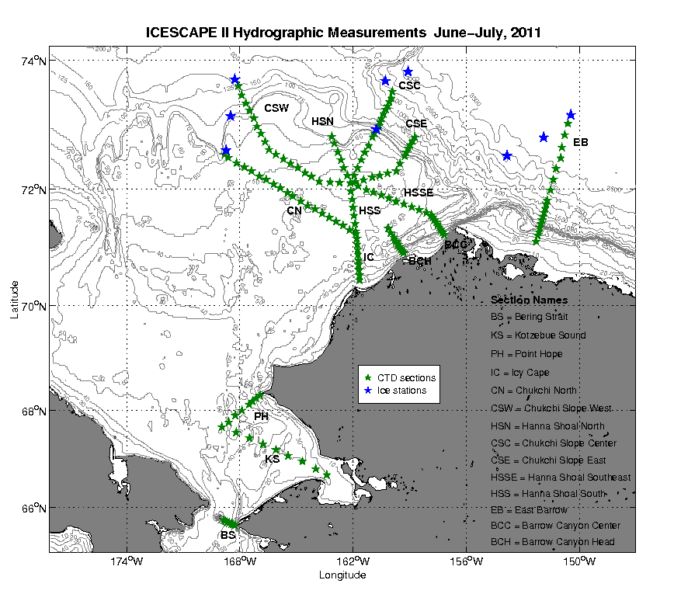

Figure 1. Map showing locations of hydrographic sections sampled during ICESCAPE 2011. Ice stations also included a full suite of hydrographic measurements.
Highlights of ICESCAPE 2011
During ICESCAPE 2011, we made what I consider to be an unprecedented and completely unexpected discovery. We were sampling a transect that extended from the open ocean deep into the sea ice. Outside of the sea ice, we observed low chlorophyll concentrations near the ocean surface. However, these concentrations increased markedly with depth, reaching a maximum of approximately 12 mg m⁻³ at a depth of 20-25 m. This pattern continued for about 35 miles until we reached the ice edge.
However, as soon as we entered the sea ice, we were in for a big surprise. The sea ice was about 0.8 m thick, and as phytoplankton ecologists familiar with blooms in both Arctic and Antarctic waters, we expected that as we moved northward into the ice pack, chlorophyll concentrations in the water column would begin to fall due to lack of light for phytoplankton growth. Much to our shock, surface chlorophyll concentrations started to increase – and increase dramatically. We thought at first that this might be a marginal ice edge bloom that had just been re-covered by sea ice. However, as we continued northward – for another 75 miles – chlorophyll concentrations at the ocean surface kept going up, despite the fact that sea ice had gradually increased to >1 m in thickness. More surprisingly, this high chlorophyll extended to a depth of >30 m, and at its peak, water column-integrated chlorophyll exceeded 1000 mg m⁻². This is probably the highest phytoplankton biomass I have ever heard of anywhere in the global ocean and we observed it under a meter of ice at a distance of 75 miles in from the ice edge!
What we were obviously seeing was an enormous phytoplankton bloom that was developing under the sea ice. Not only has this never been observed before, but I doubt that anyone even thought that such a thing was possible. I certainly didn’t. It turns out, that because of the numerous melt ponds on the pack ice, light transmission to the ocean surface through the sea ice is surprisingly high, about 80%. Thus light appears to be sufficient to support a phytoplankton bloom beneath it.
What does this mean? Well, for starters, it means that we need to rethink our conceptual models of phytoplankton production in Arctic waters, especially on the continental shelf. Our results suggest that these under-ice phytoplankton blooms may be much more widespread than even we observed. For example, that deep chlorophyll layer we observed at stations south of the ice edge that I referred to earlier had been ice covered a couple of weeks before we sampled them. It is very likely that the low surface chlorophyll (and low surface nutrients) we observed were the result of a similar surface phytoplankton bloom that developed when the area was still ice covered and just prior to our sampling it. In fact, it is possible that much of the Chukchi Sea may harbor phytoplankton blooms that develop under the sea ice and strip surface waters of their nutrients. By the time that the sea ice retreats, what remains is a subsurface layer of high chlorophyll deeper in the water column. If so, the Chukchi Sea is a much more productive ecosystem than anyone imagines. And unfortunately, there is as yet no way to observe this productivity from space. Consequently, even current spaced-based estimates of production, which assume under-ice production to be negligible, are likely to be far too low in these waters.
This exciting discovery combines all of the various components of the ICESCAPE program – sea ice bio-optics, ocean optics, physical oceanography, phytoplankton photophysiology and ecology, as well as carbon and nitrogen biogeochemistry. And it would re-write the books on Arctic marine ecology. More to come!
Hydrographic Analysis and Shipboard Velocity Data during ICESCAPE 2011

Robert S. Pickart and Frank Bahr
Woods Hole Oceanographic Institution

Introduction
The Woods Hole Oceanographic Institution (WHOI) hydrographic component of ICESCAPE 2011 included participation in the CTD measurement program, hydrographic analyses, and shipboard velocity measurements and interpretation. In addition, expendable Sippican CTD probes (XCTDs) and temperature probes (XBTs) were employed to fill gaps in the hydrographic coverage.
Direct ocean current velocity measurements were made using the vessel-mounted Acoustic Doppler Current Profiler (ADCP) systems on the Healy. There are two instruments mounted in the hull: an Ocean Surveyor 150 KHz unit (OS150), and an Ocean Surveyor 75KHz unit (OS75). Because a large portion of ICESCAPE 2011 took place on the shallow Chukchi shelf, we relied primarily on the OS150.
This section details the processing and analysis of the hydrographic data and vessel-mounted ADCP data carried out by the WHOI team. During ICESCAPE 2011, 173 CTD stations were occupied in the Chukchi and Beaufort Seas comprising 14 sections (Figure 1 above). Preliminary vertical sections of hydrographic variables and velocity were produced shortly after the conclusion of each section (these were sometimes constructed during the occupation of the section to provide guidance for sampling). Following this, more complete vertical sections were constructed that included water sample data, absolute geostrophic velocity, and bottom depth information from the Healy’s depth sounders. These products will be made available to the science party following the cruise via a WHOI-based website.

I. Hydrographic Analysis
1) Near-real time products
The CTD data were used to construct vertical sections of the following hydrographic properties in near-real time: potential temperature, salinity, potential density, transmissivity, chlorophyll fluorescence, and CDOM (see last year’s report for a description of the interpolation/gridding process). Often times these sections were updated from cast to cast, enabling the science team to see the structure present in the section as it was being occupied. This proved useful for making decisions about future sampling strategy. Similarly, the XCTD and XBT data were processed using the Sippican software and immediately uploaded to the public server. For the XCTD data, near-real time vertical sections of 1-db averaged potential temperature, salinity, and potential density were constructed.

2) Post-section Analysis
Following the completion of a section, and after the water sample data were available, a more complete set of vertical sections was constructed. The procedure was the same as employed during ICESCAPE 2010, which is described in detail in last year’s report. The basic steps are to determine the bathymetry using the ship’s echo sounders and then grid the data using a Spline-Laplacian interpolator For the most part the grid spacing was 5km in cross-stream distance, and 2m in the vertical for the CTD sections and 10m for the water sample sections. This varied, however, from section to section. The final step consisted of the computation of absolute geostrophic velocities using the vessel-mounted ADCP data to reference the thermal wind shear. Vertical sections were created for the following variables: potential temperature, salinity, transmissivity, chlorophyll fluorescence, CDOM, absolute geostrophic velocity, nitrate, silicate, phosphate, dissolved oxygen, and chlorophyll (the latter data were provided by the Arrigo group). Following the cruise, these plots will be available at http://science.whoi.edu/users/seasoar/icescape

II. Vessel-mounted ADCP
1) ADCP system
1.1) Instrumentation
Healy has two shipboard Acoustic Doppler Current Profilers (ADCPs): A 75KHz phased array Ocean Surveyor (OS75) for extended vertical range, and a 150KHz instrument that is better suited for shallow water. Earlier this year, hardware changes to the system (re-routing of the transducer cables to reduce electrical noise) significantly improved their performance by increasing the signal to noise ratio. It led to increased vertical range for both ADCPs.

  - Supporting hardware
The importance of good position and in particular heading information has been noted in last year’s report. Again, the ship’s POSMV heading device performed very well, though like last year, we experienced one short (40-minute) drop-out. Fortunately, heading information from the backup ADU5 system was of high quality during this time, and was used to fill the gap.

  - Software
Data acquisition software for collecting and combining the various data feeds is the final component of the ADCP system. As described in last year’s cruise report, Healy uses the UHDAS package, developed and supported by E. Firing and J. Hummon (University of Hawaii). This software is presently used by the majority of the UNOLS fleet. J. Hummon sailed on this year’s spring shake-down cruise to install and test a major software upgrade.

  - Cruise-specific settings
Given the shallow water depths during ICESCAPE 2011, we relied primarily on the OS150. However, for completeness, the settings for both instruments are listed below.
The default bin lengths for narrowband mode are twice that of the broadband mode: 8m for the OS150 and 16m for OS75, respectively. In addition to reduced vertical resolution, this implies a deeper first bin depth, a perhaps even larger loss in the shallow waters of the Chukchi Sea. With the OS150 broadband mode unavailable to us due to bias problems reported by J. Hummon, we reduced the narrowband mode bin lengths, as we sometimes do on UNOLS ships. This was found to be acceptable during ICESCAPE 2010, so we did it again on ICESCAPE 2011. The only difference to last year’s cruise was an increase in OS150 surface blanking by 2m, as suggested by J. Hummon based on bias observed in the first bin during the shake-down cruise tests. We therefore used the following settings:

OS150:
Transducer depth 8 m
Blanking range 7 m
Bin length 4 m
Center depth of first vertical bin: 18.94 m
Transducer alignment: 28.4 degrees
OS75:
Transducer depth 8 m
Blanking range 8 m
Bin length 8 m
Center depth of first vertical bin: 25.98 m
Transducer alignment: 43.4 degrees
- Onboard data processing and display
The data processing tasks are summarized as follows:
- Single-ping editing to remove acoustic and other interference
- Determine and remove the ship’s velocity including calibration
- Final quality control
- Data display
The CODAS processing package provides tools for these tasks. The software, written in python, matlab, and C, is freely available and can be downloaded from http://currents.soest.hawaii.edu.
As most of these tasks have not changed from last year, we refer to the previous ICESCAPE 2010 report for more detail. Two cruise-specific aspects for ICESCAPE 2011 merit further comment:

2.1 Calibration
We calibrate two ADCP parameters: the transducer alignment relative to the forward direction of the ship’s heading device, and the overall scale factor. In principle, these parameters do not change unless the transducer is temporarily removed (alignment) or exchanged (alignment and scale factor). Although neither took place between ICESCAPE 2010 and 2011, recalibrating the system is good practice if only to verify overall quality.
We applied two standard calibration methods: 1) comparing ship velocity relative to the sea floor measured by ADCP “bottom track” pings with GPS-derived ship velocity, and 2) comparing ship velocity changes relative to an oceanic reference layer to GPS-derived ship velocity changes. The first method requires sufficiently shallow water for the ADCP to “see” the bottom. As a drawback, however, each bottom track ping means one less water track ping to measure the ocean velocity. Therefore, data for this method were only collected during the transits to and from the study area.
The second method typically uses ship velocity changes associated with CTD station arrival and departure, or sharp course changes. It assumes that the velocity of the oceanic reference layer did not change over the course of the ship’s velocity change. Results from this calibration method are typically noisier than those from bottom track, but do not carry the same drawback of losing pings. The large number of stations occupied during this cruise allowed us to derive stable results.
Both methods confirmed existing calibration settings, no further corrections were needed.

2.3 Final quality control
As described in detail in last year’s report, the Arctic provides particular challenges to ADCP operations due to the potential of ice blockage of the transducers. This problem again led to many gaps in the ADCP records when steaming through ice. Fortunately, the transducers typically had some time of unobstructed view during station work. One notable exception was the long ice station on July 19/20 (73° 10’N, 150° 30’W) where the transducers remained blocked for the duration of the station (note: the multi-beam depth sounder was blocked as well; Steve Roberts pers. comm.).
In contrast to ICESCAPE 2011, automatic bottom detection by the processing software worked well on this cruise. We speculate that the increased signal to noise ratio after the transducer cable adjustments helped identify the amplitude maximum associated with the bottom.

2.4 Data display and access
The time series of velocity profiles and corresponding triplets of profile time, longitude, and latitude for each section were saved as Matlab files. These files were then used to make maps of velocity vectors at particular depth horizons and vertical sections of velocity. They were also used to construct sections of absolute geostrophic velocity as described above.
Below are two examples of the ADCP data display. Figure 1 shows a lateral map of the currents north of Point Hope, combining data from several sections and transit segments. The velocity field was averaged vertically between 19 and 55 m (ADCP bins 1 through 10), or whichever fraction thereof was available.
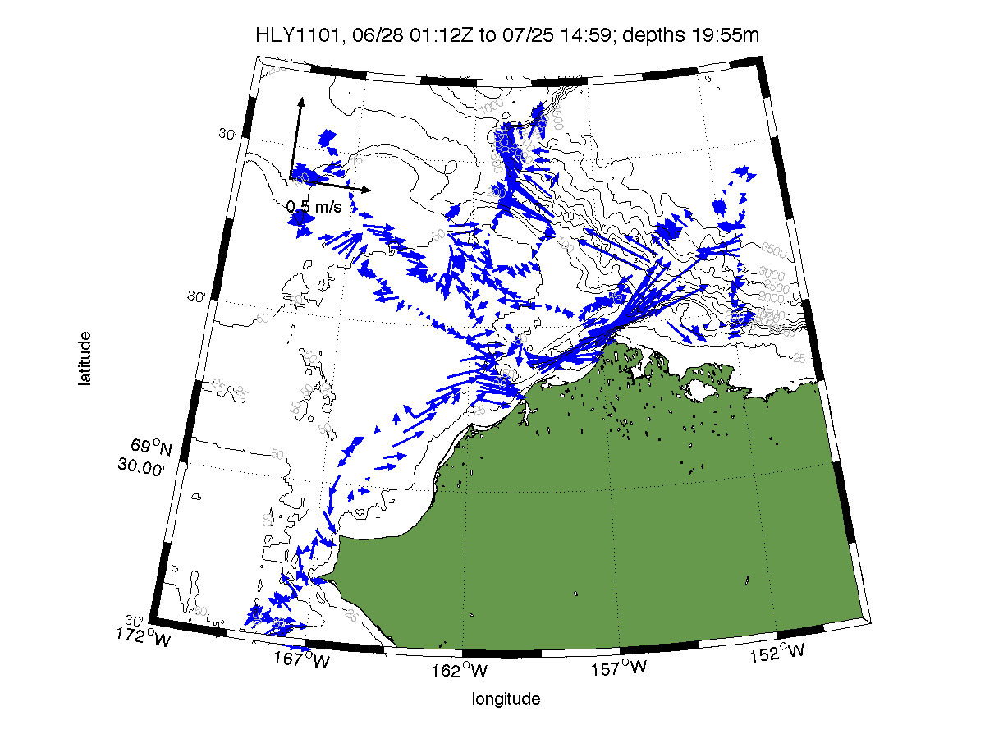
Figure 1: Averaged flow vectors between 19-55m depth from the ADCP during ICESCAPE II.

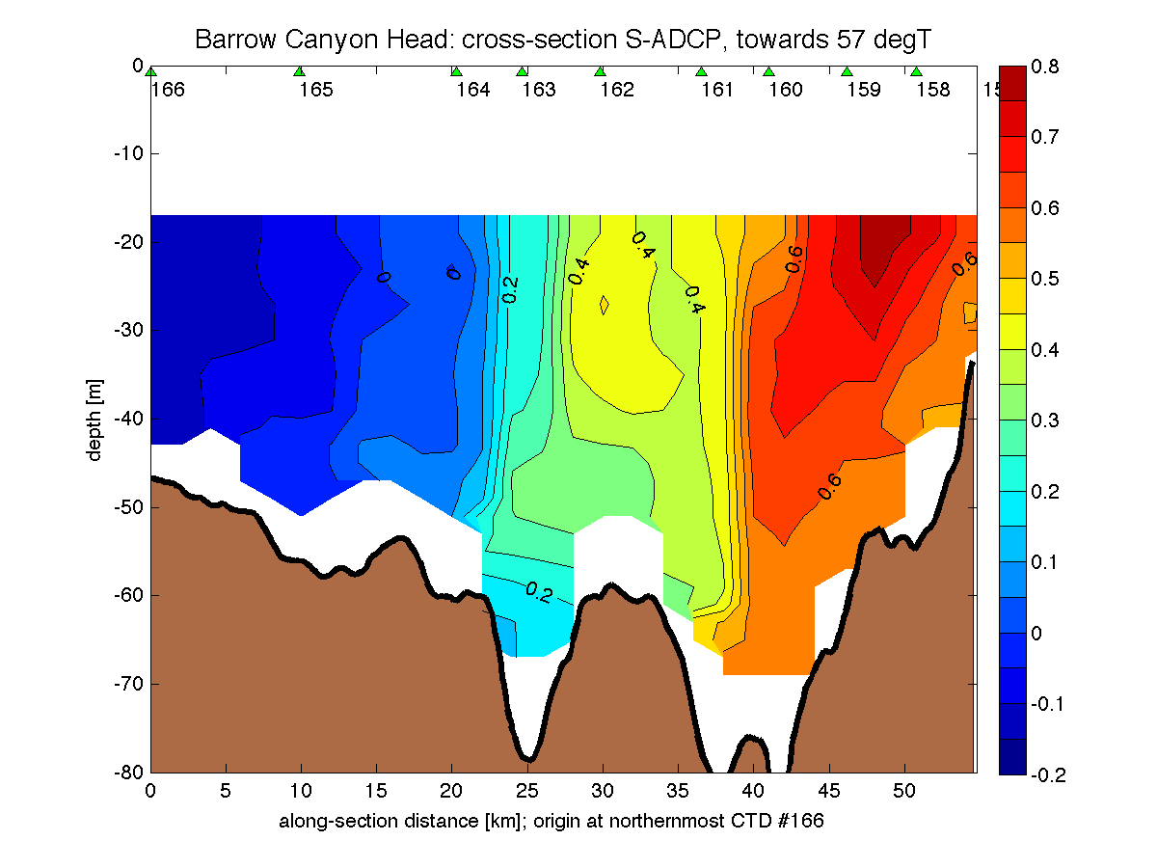
Figure 2. Vertical section across the head of Barrow Canyon.

In Figure 2, the cross-section velocity component is plotted, with positive values indicating flow towards the northeast (57 deg T). In this section, the combined Alaska Coastal Current and flow of denser water hugs the eastern side of the canyon. Note the second velocity maximum farther offshore, situated near the western branch of the canyon near 25 km. As was the case last year, the CTD identified cold, salty water in this region, revealing a second pathway of dense water into Barrow Canyon.

During the cruise, both the plots and data for each section were accessible at http://public.healy.polarscience.net:8060/HLY1101/adcp/web/

Following the cruise, they will be available at http://science.whoi.edu/users/seasoar/icescape2.
CTD/Rosette, Oxygen, and Nutrients

Scripps Institution of Oceanography
Shipboard Technical Support
Jim Swift

Group Members:
Susan Becker (SIO/STS/ODF)
Ryan Engle (SIO/STS/RTG)
Ben Gire (SIO/STS/ODF)
Bob Pickart (WHOI)*
Courtney Schatzman (SIO/STS/ODF)
Jim Swift (SIO)

[*The STS team thanks Bob for his support running and sampling CTD/rosette casts.]

[Scott Hiller (SIO/STS/RTG) also participated in the cruise, but as a representative of the STARC science support team. See separate STARC report.]

Introduction
The SIO/STS program for the Healy 1101, ICESCAPE 2011, cruise went well, with few problems.
The ODF group used two full days in Dutch Harbor to unload and set up. All ODF equipment was in place and secured before sailing. During the two day transit to the first station all ODF systems were made operational. Test station 001, before arriving in Bering Strait, was essential to examine and correct instrument and bottle performance before scientific use.
There were two CTD watches established:
3am – 3pm Ben Gire, Courtney Schatzman, Jim Swift
3pm – 3am Susan Becker, Ryan Engle, Bob Pickart (WHOI)

The CTD computer was operated by the scientist on watch, either Swift or Pickart. A representative from the biology program, usually Gert van Dijken or Matt Mills, observed the CTD cast to help select bottle depths with respect to features of interest. During sampling, Swift or Pickart kept a running log of samples drawn, maintained sampling order, and directed samplers to available rosette bottles.
At the end of the cruise, there was ample time to clean and pack ODF equipment, to complete at-sea data processing, and prepare documentation. A complete SIO/STS/ODF technical data report was delivered before the end of the cruise, along with the data. Although the CTD data are fully usable, small near-surface artifacts that arise from legacy aspects of the CTD processing software may be removed post-cruise. If so, an updated data file will be delivered to Stanford for distribution to the science teams.

ODF data acquired during HLY-1001 are summarized in the table below:

number | description
188 | CTD casts at 173 stations
1594 | rosette bottles (30 liters each) closed
949 | nutrient samples from the rosette*
361 | nutrient samples from melted ice
65 | nutrient samples from melt ponds
27 | other nutrient samples (e.g., underway samples)
483 | nutrient samples from on-board experiments
924 | dissolved oxygen samples
924 | salinity analyses from rosette samples
237 | salinity analyses from ice stations
*Nutrient analyses included the parameters silicate, phosphate, nitrate, nitrite, and ammonium.

CTD/rosette
The CTD worked well the entire cruise. It had a full load of sensors:
- dual temperature/conductivity
- SBE43 oxygen
- 12 30-liter Niskins w/12 pl. SeaBird carousel
- PSA-916 altimeter
- Wetlabs blue transmissometer
- Wetlabs red transmissometer
- Wetlabs ECO CDOM fluorometer
- Chelsea AQIII fluorometer
- Biospherical QSP2300 PAR .

CTD sensors remained stable and consistent throughout the cruise. Rosette performance was exemplary. No bottles failed to trip. There were occasional Niskin bottle leaks due to a lanyard problem (more common) or o-ring malfunction (rare). The 30-liter bottles are at the upper size limit for top performance. In order to assure tight seals, spring tensions must be set very high, making the bottles more difficult to cock. There was no reason, however, to consider using a smaller size for future cruises, so long as a trained marine technician is available to inspect, adjust, and cock the bottles.
Upon the completion of each CTD cast an automated set of scripts was run to produce a 0.5 db pressured-averaged file of the hydrographic variables. Specifically, the following scripts were applied as part of Seabird’s DOS batch file routines:
a. Datcnv – Converts raw hex to ascii engineering units.
b. Loopedit - Eliminates pressure slowdowns or reversals in the data.
c. Bottlesum - Creates a bottle trip file.
d. Binavg - Creates a 0.5db pressure bin averaged file from the cast.

The beginning downcast scan number recorded by the CTD console operator was used in the Datcnv processing program to strip out unwanted data during the initial soaking period of each cast (while the pump was turning on). The batch file processing program also included the program "ctdlog.exe" written by C. Mattson (SIO), which created a running log of the CTD casts (station number, name, date, time, latitude, longitude, uncorrected water depth, maximum CTD pressure, starting scan number). Various products from the batch file processing, including the 0.5db pressure-averaged downcast CTD file and the updated CTD log file, were immediately transferred to the public server on the Healy. Hence, the science party had instant access to a preliminary version of the cast data.

Chemistry
Nutrient samples were run on an AA3 autoanalyzer. Overall the machine ran well. In addition to the Niskin bottle samples, samples were run from ice stations, taken from ice cores as well as water samples from below the ice. Data QC overall looked very good. All data from ocean stations were uploaded to the STS database.
The dissolved oxygen autotitrator rig ran well with no problems. There were very consistent standards and blanks from day to day values. All data were uploaded to the STS database.
The Healy’s 8400B Autosal was interfaced to a computer with ODF software. The instrument and data acquisition worked well. All data from ocean stations were uploaded to the STS database. ODF ran a number of ice station samples for the science party as well (0.5-30.0 psu range).

Data
CTD acquisition was accomplished with SeaSave software, and data recorded on the CTD computer. The raw CTD data were also passed to the ODF server for plotting (property plots/vertical sections plots) and independent data processing. Salinity, oxygen, and nutrient data with CTD bottle trips were uploaded to the ODF (“CLIVAR”) website established on board. All bottle nutrient, oxygen and salinity data were kept up to date.
The distribution of ODF CTD and bottle data to the scientific party ran very well the entire cruise. Bottle and CTD data were available in usable form to those on board throughout the cruise. Those on-board groups who provided other (non-ODF) data to ODF had their data merged into the other rosette data in the distribution file (the "_hy1.csv" format file).
The final shipboard bottle data are in excellent condition for scientific use. Bottle oxygen and nutrient data are reported in community standard µM/kg units. The ODF bottle data are quality coded with WOCE quality codes.
Problems with ODF CTD data reporting were very few and easily repaired, mostly having to do with idiosyncrasies in the CTD processing software. See the ODF data report for a thorough explanation of data acquisition, processing, and reporting methodologies and outcomes. The final shipboard versions of the ODF CTD data, whether from the SeaSave, WHP-Exchange, or ASCII version of the data files, should be completely satisfactory for scientific use.
Shipboard Data Collection and Science Support
STARC* REPORT

Scott Hiller (SIO)

*Ship-based Science Technical Support in the Arctic
Ship-based Science Technical Support in the Arctic (STARC) was implemented in 2011 by the National Science Foundation. The STARC program provides science support for Arctic cruises, with careful consideration of the objectives for each science mission, the equipment and technical personnel required, and the research area and specific logistics required. The NASA ICESCAPE HLY1101 was the first cruise to benefit from the new STARC program on Healy. Three technical support personnel carried out science support for this cruise:
Scott Hiller, Scripps Institution of Oceanography – responsible for CTD/XBT equipment, installed lab equipment, salinometer, echosounders, ADCP, science seawater sensors and MET sensors;
Steve Roberts, National Center for Atmospheric Research / Earth Observing Laboratory (NCAR/EOL) – responsible for the Mapserver real time GIS system, echosounders, ADCP, MET sensors, Science Seawater system, Terascan real time satellite imagery system, gravimeters, and data qc / distribution; and
Donny Graham, Electronic Support Unit Seattle, Allied Technology Group – responsible for science network service to include: user accounts, email, data share, wireless access, internet access, science network webpage, as well as personal computer support.

Several pre-cruise meetings were held during the months prior to this cruise. Ship's science equipment and underway data systems were prepared to meet the needs identified by the science party.
STARC personnel on this cruise maintained a 24-hour watch on all equipment collecting underway data and assisted with problems encountered by the science party. The following equipment and sensors were maintained and made available to the science party:
- EM122 multibeam bottom mapping system
- 75khz/150khz Acoustic Doppler Current Profiler (ADCP) running UHDAS
- Knudsen 12khz/3.5khz echosounder for depth
- VSAT satellite broadband internet/voice system
- Iridium satellite internet/voice system
- POSMV GPS/inertial navigation system
- Science seawater system including:
thermosalinograph, 4 different types of fluorometers, oxygen sensor, hull temperature sensor, flow meter, pressure sensor and a PCO2 system
- Meteorological sensor system including:
bow-mounted anemometer and air temperature sensor, bridge-mounted anemometers, air temperature sensor, humidity sensor, barometric sensor, aft hangar-mounted PAR, LWR, and SWR sensors
- Gravimeter (BGM-3)
- Mapserver realtime GIS mapping system
- Terascan realtime satellite receiver for ice images, weather data and MODIS images.
- Seabird CTD equipment to include:
12 bottle – 30 L rosette, 911plus CTD with dual temperature and conductivity sensors, dissolved oxygen sensor, two different model transmissometers, chlorophyll fluorometer, CDOM fluorometer and an altimeter.
- Guildline 8400B salinometer and sample bottles

The science spaces and facilities on Healy are complex and require constant attention. STARC personnel are well trained and experienced in all facets of shipboard data collection and science support requirements.
The NASA ICESCAPE 2011 cruise (HLY1101) was well planned and ship time was utilized efficiently for science operations. The diverse 48-person science team, with their many programs and varied equipment, required attentive technical support to help ensure a successful cruise. There were science activities conducted in lab spaces and on the starboard and aft working decks at all times, with small boat deployments and the deployment of scientists on the ice in addition.
Items of note with regards to STARC technical support on this cruise include:
- Sound speed profiles were made available to the EM122 multibeam system through CTD and XBT casts.
- POSMV #2 was displaying frequent drops in heading accuracy and the manufacturer (Applanix) is looking into the problem.
- The ADU-5 GPS receiver required resets on a periodic basis to maintain stability.
- A new PCO2 system was installed in the underway seawater system in May2011 and HLY1101 was the first cruise for this system. Science support personnel are learning quickly what it takes to keep the system running properly.
- Prior to getting underway from Dutch Harbor, a new Turner C3 fluorometer was installed in the science seawater system.
- A few minor electronic problems developed with the CTD equipment and repairs were made immediately with no down time between casts.
- The heater lamps stopped working in the lab salinometer and were subsequently replaced.
- There are problems developing with the pumps associated with the science seawater system and the Healy’s engineering department were made aware of the problems.
- With careful use of the science seawater system, no ice blockages were encountered during the cruise.
- New layers were added to Mapserver for ICESCAPE to include 8 different types of images downloaded from the Terascan satellite system and ice analysis websites.
- Maintained the Healy Field Catalog for daily data quality control and plots.
- Web based ice observation forms made available to the science ice teams.
- Science support technicians maintained a detailed Electronic Log (ELOG), describing in detail the operation and maintenance procedures performed on equipment during the cruise.
- Two new ethernet network switches were installed in lab spaces at the request of the science party.
- 3 spare computers were supplied to the science party to replace broken computers.
- The Healy’s SBE19 Seacat CTD was configured and supplied to ice station personnel for conducting shallow CTD casts through ice holes.
A post cruise review will be conducted to identify effective processes and processes needing improvement, and lessons learned incorporated into future cruise plans.
Carbon System Measurements (prepared by Rebecca Garley)

Nick Bates
Bermuda Institute of Ocean Sciences (BIOS)

Jeremy Mathis
University of Alaska Fairbanks (UAF)

Group Members:
Rebecca Garley (BIOS)
Kristen Shake (UAF)
Lauara Weingartner (UAF)

Objective:
The purpose of our group on this cruise is to study the current status of the Arctic Ocean’s inorganic carbon system. Our primary aim is to investigate the progress and impacts of the increasing atmospheric carbon dioxide (CO₂) levels. Oceans absorb much of the increasing CO₂ with a higher capacity to hold gases in colder waters. The Arctic Ocean is undersaturated with respect to CO₂ and so is a CO₂ sink, becoming a larger CO₂ sink as sea ice recedes exposing larger areas of ocean. As ocean CO₂ levels increase the carbon chemistry of the water is altered, including decreasing pH, termed ocean acidification. The ocean can act as a buffer but only effectively on much longer timescales than the changes are currently occurring. To study this we are collecting samples for dissolved inorganic carbon (DIC) and total alkalinity (TA) from open ocean and under ice. Surface samples collected from the CTD and the ships underway system can be used along with wind speed data to calculate the CO₂ flux along the whole cruise track.

Samples Collected:
In total, 173 CTD stations were sampled for DIC and AT totaling 942 samples which are to be shipped back to Bermuda to be processed in the Marine Biogeochemistry Laboratory at the Bermuda Institute of Ocean Sciences. For the on-board analysis, 166 CTD stations were sampled for DIC; 160 full water column profiles for TA plus 5 partial profiles for TA stations. Less TA samples were processed due to a longer run time for TA samples compared to DIC, causing a backlog of samples that we wanted to be analyzed <12 hours after sampling to prevent change due to biological processes. Samples were also taken from the underway seawater system, during transits, every 1.5 - 2 hours. 131 samples were collected, 102 being analysed on board and 37 will be shipped back to BIOS for analysis. Duplicate DIC/TA samples of the under ice water column to 30m depth and the melt ponds were collected at each of the 9 ice stations, totaling 63 samples to be shipped back to the lab at BIOS for analysis. Of the duplicates, 43 were run on board. Ice core samples were also taken to measure DIC only at station 128 for the top, middle and bottom of a multi-year ice core and a melt pond ice core. This was more of a test as we had not done it before and as our new DIC machine requires low volumes it was possible from the sample sizes collected.

Table 1: Summary of sample types; number of samples collected; number of samples analysed onboard the Healy and those shipped back to Bermuda Institute of Ocean Sciences (BIOS) for future analysis.

Sample type | # of stations | # of samples | # DIC/TA samples shipped to BIOS | # DIC analyzed onboard | # TA analyzed onboard
CTD | 166 | 905 (incl. 51 replicates) | n/a | 905 | 856
CTD | 173 | 942 (incl. 22 replicates) | 942 | n/a | n/a
Underway | n/a | 139 (incl.23 replicates) | 37 | 102 | 100
Ice station water column | 9 | 63 | n/a | 45 | 43
Ice station water column | 9 | 63 | 63 | n/a | n/a
Ice core | 1 | 6 | 0 | 6 | n/a

Sampling and Analysis Methods:
Samples for Dissolved Inorganic Carbon (DIC) and Total Alkalinity (TA) were collected in 200ml glass bottles according to standard JGOFS methods. Milli-Q cleaned bottles were rinsed out, bottom filled using silicone tubing, allowed to overflow approximately 3 times the bottle volume, ensuring no bubbles were in the sample, and sealed with a small headspace to allow for water expansion.
Of the water samples from all depths the CTD-rosette sampled, two sample sets were collected. The first sample set was collected at every station and depth and fixed with 100µl mercuric chloride for analysis back at the BIOS lab. The second set was collected at almost every station and was not spiked but stored in a dark fridge at ~4ºC for no longer than 12 hours before being run on board to minimize any biological activity altering the sample. Samples from the underway system and ice stations were also fixed if being shipped back to BIOS or stored if being run on board. The ice core samples were taken from the core, vacuum-sealed in a bag and stored in the fridge until the ice had fully defrosted before analysis.
The values for DIC and TA were used to calculate other parameters of the carbonate system using CO2calc (Robbins et. al., 2010). The parameters calculated include pH, pCO₂, [HCO₃⁻], [CO₃²⁻], saturation states of calcite and aragonite and CO₂ flux.

Alkalinity on the VINDTA:
TA samples were run on the VINDTA (Versatile Instrument for the Determination of Titration Alkalinity) (www.marianda.de). TA was measured on the VINDTA 3S by titration with a strong acid (HCl). The titration curve shows 2 inflection points, characterizing the protonation of carbonate and bicarbonate respectively, where consumption of acid at the second point is equal to the titration alkalinity.

DIC on the AIRICA:
DIC samples were run on the AIRICA (Automated Infra-Red Inorganic Carbon Analyzer) (www.marianda.de). A sample is run 4 times, each time acidifying the sample with phosphoric acid to liberate the CO₂ which flows with a N₂ carrier gas through a LI-COR where the total carbon is measured by an infrared detector.
Same bottle samples were first run consecutively to check the precision. Then Certified Reference Materials (CRMs) produced by the Marine Physical Laboratory at UCSD were run every 12 hours on the VINDTA and approximately every 8 samples on the AIRICA to determine the accuracy of the measurements and correct for any discrepancies. Samples were run once the instrument precision was ±2 µmol kg⁻¹ or better.
The VINDTA was on board last year and worked well both years. The AIRICA is a new machine and hadn’t been used at sea before. It was slightly temperamental but overall performed well. The samples to be analyzed back at the BIOS lab will be used to compare the performance of the machines. Those samples can be measured for TA on the same machine (2 in lab) and for DIC on the VINDTA 3C that measures the total carbon by a colorimetric titration and is currently the most precise method for DIC measurement.
The preliminary data from this cruise showed low DIC in the Bering Sea shelf water, the shallow areas of Kotzebue Bay and off-shelf in the polar mixed layer. The off-shelf stations also indicate pCO₂ of up to 350 µatm suggesting it is drawing down CO₂ and equilibrating with the atmosphere. Areas of low pCO₂ included the region of the under ice bloom (stations 55-62) where surface CTD data gave values of ~110 µatm and underway samples gave very low values of ~70 µatm.
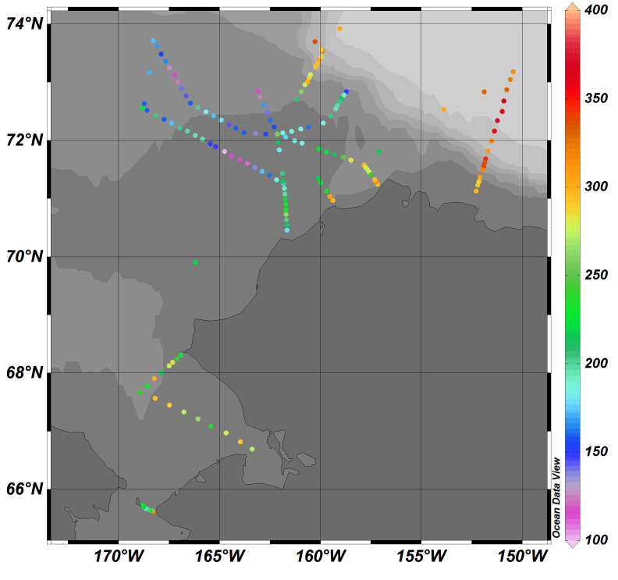

Figure 1: Plot of surface pCO₂ from CTD stations

References:
Robbins, L.L., Hansen, M.E., Kleypas, J.A., and Meylan, S.C., 2010, CO2calc—A user-friendly seawater carbon calculator for Windows, Max OS X, and iOS (iPhone): U.S. Geological Survey Open-File Report 2010–1280, 17 p.

Core measurements, Primary Production and Phytoplankton Physiology

Kevin R. Arrigo
Stanford University

Group Members:
Matthew Mills (Stanford)
Gert van Dijken (Stanford)
Zach Brown (Stanford)
Kate Lowry (Stanford)
Shanique Martin (Stanford)
Alessandra Santiago (Stanford)

The primary objective of our ICESCAPE 2011 research program was to sample the core particulate variables (Table 1) at both the water column and ice stations. The later consisted of both ice core sampling and under ice water column sampling. In addition to these bulk particulate measurements, we also measured several phytoplankton photophysiology variables including photosynthesis vs. irradiance, simulated in-situ primary productivity, and underway measurements of phytoplankton fluorescence using a fast repetition rate fluorometer. Lastly, six experiments investigating the competition between phytoplankton and bacterial utilization of NO₃ were conducted (Table 2). The collected data will provide the core measurements of phytoplankton biomass and photophysiology that will be combined with the chemical and physical measurements collected by other groups to provide a detailed picture of the biogeochemistry of the Chukchi Sea during the 2011 Summer season.

Table 1. Number of stations and number of samples for each variable during the Icescape 2011 cruise.
Station Type | # | HPLC | Chl a | Ap/Ad | CHN | TPP | DOP | CDOM | P-E | SIS
Water Column | 173 | 551 | 889 | 313 | 518 | 157 | 157 | 291 | 85 | 17
Ice Station | 9 | 59 | 158 | 31 | 151 | 25 |  |  |  | 8
Station Type |  | RNA/  DNA/  Protein | Poly-P | δ¹⁵NO₃ | Nutrients | N₂O | AOA/B
Water Column |  | 22 | 22 | 60 |  | 128 | 19
Ice Station |  |  |  |  | 58
Abbreviations: HPLC- high performance liquid chromatography, Chl a- chlorophyll a, Ap/Ad- particulate absorption spectra, CHN- particulate organic carbon and nitrogen, TPP- total particulate phosphorus, DOP- dissolved organic phosphorus, CDOM- color dissolved organic matter, P-E- photosynthesis vs. irradiance, SIS- simulated in-situ productivity measurements, Poly-P- polyphosphates, Nutrients- dissolved NH₄, NO₃, PO₄, and Si concentration, AOA/B- ammonia oxidizing archaea and bacteria.

While underway we completed analysis of fluorometric chlorophyll samples, as well as the simulated in-situ productivity and photosynthesis vs. irradiance measurements. The majority of our particulate analyses will happen once ICESCAPE 2011 is complete. Samples will be analyzed for POC, POP, TPP, DOP, HPLC-pigments, bulk RNA/DNA/protein concentrations, and δ¹⁵NO₃. The core data provided from this program will foster collaborations between ICESCAPE research groups. For example, the data collected at the ice stations by both the Perovich and Frey groups will be important for providing the physical perspective needed to understand the algal dynamics in the ice. Likewise, the physical and biophysical data collected by the Pickart, Mitchell, Laney, and Balch teams will help us to understand phytoplankton distributions in the Chukchi Sea.

NO₃ utilization experiments
A total of 6 bioassay experiments were conducted with the objective of investigating phytoplankton and bacterial competition for NO₃. The experimental design consisted of triplicate control and treated bottles that were incubated on deck under 30% incident irradiance. All treatment bottles were spiked with ~ 5 µmol L⁻¹ NO₃ and the bottles were sampled every 24 hours up to 144 hours. Variables sampled at each time point are listed in Table 2. Sample analysis completed onboard consisted of nutrients, chlorophyll a, ¹⁴C-primary productivity, bacterial abundance, and bacterial productivity. Still to be analyzed back at Stanford University are the particulate nutrient and macromolecular samples, the ¹⁵N-uptake samples, and the nanoSIMS.

Table 2. Numbers represent the number of experiments each variable was sampled at the listed time point.
Variable | Initial | T= 24h | T= 48h | T= 72h | T= 96h | T= 120 | T= 144
Chl a | 6 | 6 | 6 | 6 | 6 | 2 | 2
CHN | 6 | 6 | 6 | 6 |  |  | 2
TPP | 6 | 6 | 6 | 6 |  |  | 2
Nutrients | 6 | 6 | 6 | 6 | 6 | 2 | 2
DOP/DON | 6 | 6 | 6 | 6 |  |  | 2
Community Composition | 6 | 6 | 6 | 6 |  |  | 2
Bacterial Abundance | 6 | 6 | 6 | 6 |  |  | 2
14C-primary productivity | 6 |  |  |  | 4 |  | 2
Bacterial productivity | 6 | 6 | 6 | 6 |  |  | 2
15NO3 uptake by >1.2 µm fraction | 6 |  |  |  | 4 |  | 2
15NO3 uptake by whole community | 6 |  |  |  | 4 |  | 2
NanoSIMS | 6 |  |  |  | 4 |  | 2
Poly-P | 6 | 6 | 6 | 6 |  |  | 2
RNA/DNA | 6 | 6 | 6 | 6 |  |  | 2
Protein | 6 | 6 | 6 | 6 |  |  | 2
Abbreviations: Chl a- chlorophyll a, CHN- particulate organic carbon and nitrogen, TPP- total particulate phosphorus, Nutrients- dissolved NH₄, NO₃, PO₄, and Si concentration, DOP/DON- dissolved organic phosphorus and nitrogen, NanoSIMS- nano-scale secondary ion mass spectrometry, Poly-P- polyphosphates.

Community composition analysis will be led by Sam Laney and carried out at Woods Hole Oceanographic Institution. The experiments, while developed and led by the Arrigo research group, were a collaborative effort with Sam Laney and Eva Ortega, both of whom analyzed samples at each time point. Additionally, the success of the experiments were dependent on the onboard nutrient analysis conducted by Susan Becker.

Remote sensing
Remote sensing . Ocean color satellite imagery was used to follow the spatial and temporal development of phytoplankton blooms in the Chukchi Sea. An automated system was set up at Stanford University where near real-time satellite imagery acquired by the MODIS/Aqua sensor was downloaded every 3 hours from NASA ftp-servers. The chlorophyll product was extracted, somewhat manipulated and mapped to a common polar stereographic projection. In addition daily composites were generated from the individual scenes (up to 12 per day). On these daily chlorophyll composite images ice cover was superimposed. The ice mask was generated from SSM/I brightness temperatures, retrieved twice daily from the NSIDC ftp-site and processed to sub-pixel resolution (6.25 km) using the PSSM algorithm. Finally, these composites were automatically e-mailed to the USGC Healy in PNG format.
Scripps Photobiology Group (SPG)
Greg Mitchell
Scripps Institution of Oceanography

Group Members:
Brian Schieber
Elliot Weiss
Ben Knowles

The ICESCAPE 2011 cruise was very productive for Scripps Photobiology Group (SPG). The group’s science plan consisted of data collection through daily deployment of several bio-optical instruments complemented with water sample collection and analysis from Process Stations and Survey stations. Process and Survey stations are defined in the CTD report. We also carried out studies of water samples for bottle casts collected below the sea ice through ice cores. An overview of observations from in situ systems and water sample analysis is provided in Table 1.
In-situ radiometric, backscattering, turbidity, fast rate fluorometry, and attenuation coefficient data was collected through the deployment of an integrated bio-optical package (IOP) and a free fall Profiling Reflectance Radiometer (PRR800/810). The IOP package deployed in collaboration with the Reynolds group included:
- Chelsea FastTracka Fast Repetition Rate Fluorometer
- Wetlabs AC9 Absorption and Attenuation Meter
- Wetlabs C-Star Red Transmissometer
- CDOM “Triplet” (provided by Sam Laney)
- Two HobiLabs Hydroscat-6 Spectral Backscattering Sensors (Stramski/Reynolds)
- LISST-100x Laser Particle Sizer (Reynolds/Stramski)
- WetlabsChl Fluorometer (Reynolds/Stramski)

The IOP down cast was typically conducted at 10m/min to within 2m of bottom depth. For the up cast, the package was held near the bottom, at the CTD determined chl maximum (if applicable), at 10m and at the surface for higher resolution time series analysis. Separately we deployed the Profiling Reflectance Radiometer (PRR800/810) system. This system consisted of a free fall under water profiling unit, PRR 800, and a mast mounted radiometer, PRR 810. The PRR 800 is equipped with 3 data collecting heads and including Ed (Downwelling Irradiance), Lu (Upwelling Radiance), and Eu (Upwelling Irradiance) at 19 channels from 312 – 700 nm. The deck mounted unit, PRR 810, obtains surface reference Es (Irradiance), also at 19 channels. A typical PRR deployment consisted of 3 replicate casts, one to 10m above the bottom (up to 150m) and two to 30 - 40m, water depth and ice conditions permitting. The IOP was deployed at 47 stations and the PRR was deployed at 35 stations during the ICESCAPE2011 cruise. Additionally, the PRR 810 sensor collected surface spectral irradiance data (300-750 nm) for the entire cruise.
The IOP and PRR casts coincided with the midday CTD cast, complementary water samples were collected from 4-7 Niskin bottle depths. In collaboration with the Arrigo group, Photosynthesis vs. Irradiance (PvsE) and simulated in situ (SIS) photosynthesis experiments were conducted. Typically for PvsE samples were taken at the surface and at the CTD determined chl maximum and 4-5 depths were used in the SIS experiments... PvsE experiments are summarized in more detail in the Arrigo group report. Spectrophotometric scans of particulate absorption by phytoplankton/detritus (ap/ad) and CDOM absorption (as) were performed at 1 nm resolution from 300-800 nm. In collaboration with other groups, samples were preserved for HPLC Pigment, Particulate Organic Carbon (POC) and total suspended matter analysis. The detailed inherent and apparent optical properties, including hyperspectral estimates of the 3 components of total absorption coefficients, will be used to improve regional algorithms for remote sensing of chlorophyll and modeling of primary production. By characterizing hyperspectral absorption to 300 nm, apparent optical properties to 312nm and backscattering (with Reynolds) to 360 nm, our data sets will extend the ability to utilize the UV region of the spectrum for improved inverse models of spectral reflectance to retrieve chlorophyll, CDOM, and detritus for the optically complex Arctic region where there is very strong regional differentiation in satellite ocean color algorithms.
We used a Fluoromax-4 spectrofluorometer to perform 3D Excitation and Emission Matrix (EEM) scans of CDOM samples. The data from this instrument appears most promising in characterizing different components of the CDOM and in tracking water mass distributions. With the same instrument configured differently we also carried out analysis if in vivo chlorophyll excitation spectra of freshly filtered particulates on glass fiber filters for most samples where PvsE analysis was carried out, and also a large number of other water samples in the upper photic zone.
Dr. Mati Kahru of SPG provided daily near-real time satellite imagery of Chl-a concentration (from MODIS Aqua) in support of ICESCAPE. This imagery was available via a web link for routine download to ship daily. A merged product at daily, 5, 15 and 30 days was also created from the different satellites and multiple daily overpasses (MODIS Aqua and Terra). The products were used by Steve Roberts as overlays within the ship’s GPS system. Given the high latitude and custom designed tools for merger of multiple overpasses each day from different sensors, these data were valuable for overall cruise planning.

Table 1. SPG Sampling Summary

Sampled Item | Stations or Samples | Notes
Ed, Lu, Es, Eu profiles | 35 stations | AOP BSI PRR
Fast Repetition Rate Fluorometer | 47 stations | IOP Fluorometer
CHL Fluorescence | 47 stations | IOP Chl Fluorometer
CDOM Fluorescence | 47 stations | IOP Triplet
Backscatter | 47 stations | IOP Triplet
CHL Fluorescence | 47 stations | IOP Triplet
Beam transmission and absorption - 9λ | 47 stations | IOP AC-9
Beam Transmission (Red @ 660nm) | 47 stations | IOP Transmissometer
PvE and Simulated In situ production | See Arrigo group report
Ap | 348 samples | Cary 100 Spec
Ad | 348 samples | Cary 100 Spec
As | 347 samples | Cary 100 Spec
CDOM Fluorescence EEM | 212 samples | Fluoromax-4
In vivo chl-a fluorescence excitation | 275 samples | Fluoromax-4

Imaging FlowCytobot
Sam Laney
Woods Hole Oceanographic Institution

Group Members:
Emily Brownlee (WHOI)

One of the primary goals of this component was to operate the Imaging FlowCytobot in flow-through mode on the transit up to and back from the Chukchi study region, and throughout the study region between fixed stations, using an ad-hoc surface seawater supply located in the fueling hose room, 2nd deck. The phytoplankton cell images collected with this instrument provide information about the microplankton assemblage composition, for comparison to HPLC proxies for assemblage composition and for direct assessment of algal composition while at sea. A secondary goal was to use the same instrument to examine discrete volume samples, e.g. from CTD casts (Niskin samples), from ice stations (meltponds, sub-ice profiles, and melted sea ice), and from nutrient addition grow-out experiments with Dr. Matt Mills, to provide similar algal composition information. For most CTD stations and for the Mills experiments as well, the same seawater samples were analyzed using flow cytometry (FCM) on ship, with an Accuri C6 flow cytometer. The cytometer was also provided to Dr. Eva Ortega-Retuerta for performing at-sea heterotrophic bacterial counting in her studies and sampling. During the flow-through sampling periods, periodic samples for HPLC were taken to augment the HPLC samples that were collected in the core sampling program.
Samples from CTD bottles were analyzed from 98 of the 173 CTD stations occupied during ICESCAPE 2011. The stations that were skipped corresponded primarily to many of the “chlorophyll-only” stations on closely spaced transects, where no time was available to perform IFCB analyses. Between-station sampling in flow-through mode was performed over approximately 2600 nm in ICESCAPE 2011. Protist analysis of benthic grab samples were done in 2011, a new approach not done in 2010.

Sample type | Stations/locs | Total # of samples (5 ml vols.)
Flow through system
Dutch Harbor – Bering Strait | ~1400 nm | n/a
Dutch Harbor – Seward | ~ 660 nm | n/a
Chukchi – Bering Strait | ~ 410 nm | n/a
Miscellaneous Chukchi | ~ 250 nm | n/a
Total flow through
CTD bottle samples | 98 stations
Ice station: ice cores | 9 ice stations | 7 cores
Ice station: sub-ice |  | 24 under-ice profiles
Ice station: meltpond |  | 9 meltpond samples
ASB | 14 | 20 samples
Benthic grab | (1) | 1
Protist analyses: Emily Brownlee, a WHOI graduate student, examined approximately 50 samples from full station CTD casts and ice stations and preserved them in Lugol’s Iodine for later enumeration and identification of protist assemblage. The data will be used to determine changes in protist community structure at multiple depths as well as in melt ponds in comparison to under ice samples. Specifically, herbivorous ciliate micrograzers will be identified and used to verify abundances of those imaged by the Imaging FlowCytobot.
Optical detection of particle concentration, composition, and size within Arctic waters

Rick A. Reynolds
Scripps Institution of Oceanography

Group Members:
Jens Ehn
Kuba Tatarkiewicz
Guangming Zheng

The goal of our project is to develop the scientific basis and operational algorithms that will permit the use of in situ and remote sensing optical measurements to examine biogeochemically important characteristics of marine particle assemblages (i.e. concentration, composition, and size distribution) and how they change in response to potential climate and environmental variability in the Arctic region. The specific objective of the fieldwork conducted on this and the previous ICESCAPE cruise was to collect an appropriate dataset for optical modeling and subsequent algorithm development. Our efforts combined detailed characterization of the seawater particle assemblage with concomitant measurements of absorption and scattering by particles.

Work at sea
Our work onboard HLY1101 consisted of two basic activities at water column stations:
- Deployment of an instrument package (denoted as “IOP” in the cruise event log) to measure in situ vertical profiles of the inherent optical properties of seawater. This package consisted of a suite of specialized optical and biological sensors belonging to our group, G. Mitchell, and S. Laney.
- Collection and analysis of discrete water samples from the CTD-Rosette for characterizing suspended particles and their optical properties.
In addition to water column sampling, a new aspect of our work this year included analysis of sea ice particles collected at 6 of the ice stations by ourselves or other ICESCAPE teams.

1. In situ measurements
Our primary sensors on the IOP package consisted of two HS6 backscattering sensors (Hobi-Labs) and a LISST-100X particle size analyzer (Sequoia Scientific). The combined data of the two HS6 sensors provide estimates of the volume scattering function at 140° and optical backscattering coefficient in eleven bands spanning the UV/VIS/NIR spectral region; 394, 420, 442, 470, 510, 532, 550, 589, 649, 730, and 852 nm. The LISST measures the forward volume scattering function at 532 nm (32 angles within the range 0.08–13.5°), from which the in situ particle size distribution over the approximate size range 1-200 μm can be derived.
The IOP was deployed at 47 stations throughout the cruise (Fig. 1). 31 of these deployments were complemented by radiometric measurements of the in water light field taken from the bow (Mitchell) or from the ASB (Chavez). Profiles were measured from the sea surface to 3-5 m above the sea bottom, or to a maximum of 300 m in deeper waters.
Final processing and correction of HS6 and LISST data requires additional information from other sensors (e.g. temperature, salinity, spectral absorption and attenuation), and will be conducted after the cruise. Once this ancillary information is available to us, we anticipate processing and quality control of these data to be completed within 3 months.
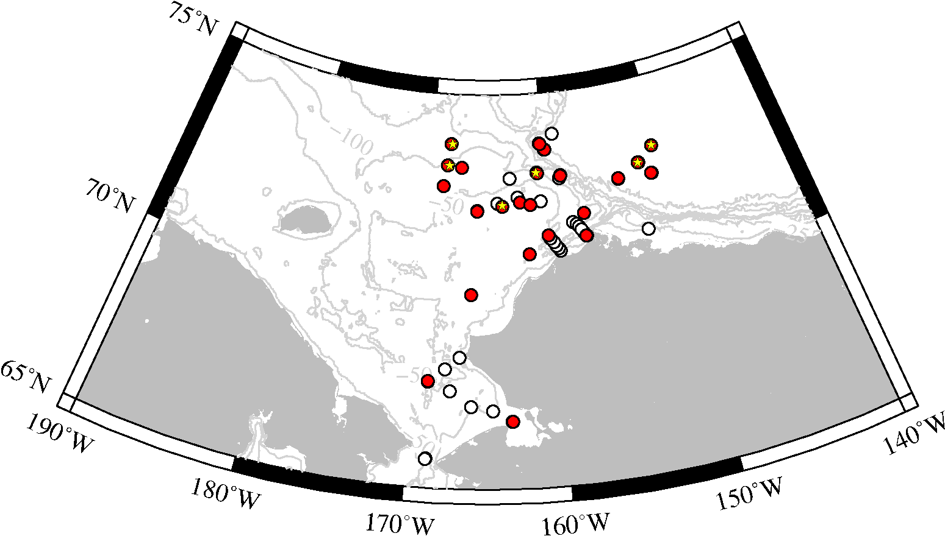
Figure 1. Location of the 47 IOP deployments made during the HLY1101 cruise. Red symbols indicate “full” stations where the full suite of measurements including the complete PSD was performed. The yellow stars depict locations where ice samples were obtained.
2. Discrete water sample analysis
Immediately before or after IOP deployments and as close in time as possible, water samples from the CTD-Rosette were collected for analysis in the laboratory. Typically 2 or 3 depths were chosen for analysis depending upon observed features in the water column. Because of our interest in ocean color remote sensing, surface samples (nominally 2-4 m depth) were always analyzed. Additional depths sampled generally included either the chlorophyll fluorescence maximum, features such as maxima in beam attenuation or backscattering, or within 3-5 m of the bottom. For stations located off the shelf with water depths exceeding 2000 m, samples at 300 m were taken to provide reference measurements of relatively clear waters. A total of 136 discrete water samples from 43 different stations were sampled during HLY1101 (Table 1). This number includes 18 discrete samples associated with ice stations which represent either melt pond samples, melted surface ice scrapings or ice cores, interstitial water from within the ice, or water samples collected immediately below the ice/water interface. The entire suite of water sample measurements described below were made at about half (25) of the stations in which the IOP was deployed; only a subset of core measurements were done at the other stations.

Bulk measurements of particle mass concentration and composition:
Samples for the mass concentration of suspended particulate matter (SPM) and particulate organic carbon and nitrogen (POC/PON) were collected onboard using precombusted glass fiber filters, dried at 60 °C, and will be returned to the laboratory for post-cruise analysis. The dry mass of SPM samples will be determined gravimetrically using a Mettler-Toledo MT5 microbalance with a resolution of 1 μg. POC determinations will be done at the UC Santa Barbara analytical facility using standard high-temperature combustion methods. Sample analysis should be complete within 6 months following the end of the cruise.
The combination of POC and SPM measurements provides an indicator of the contributions of particulate organic matter (POM) and particulate inorganic matter (PIM) to the overall particle assemblage, where SPM = POM + PIM. The POC:SPM ratio will allow classification of bulk particulate composition into different categories, for example mineral-dominated, organic-dominated, or mixed assemblages. We will also estimate the POM and PIM directly through the loss on ignition technique, in which the dry weight of particles on filters is measured before and following high-temperature combustion. Such information will provide an additional means for characterizing the particle composition and complement the classification based on POC:SPM ratios.
Table 1. Summary of IOP deployments and the number of discrete samples taken for various physical, chemical, or optical analyses. The numbers for SPM, POC, and ap include replicate samples.

Particle number concentration and size distribution:
A combination of multiple techniques and instruments was employed to measure the particle size distribution (PSD) over the size range of a few tens of nanometers to 200 micrometers. All measurements were performed on fresh samples immediately after collection, or in the case of the LISST measured in situ. Because some of these determinations are highly labor intensive and require the ship to be stationary for several hours, the full PSD was not measured on every water sample. A total of 28 complete PSDs using the entire suite of sizing instrumentation were obtained during the cruise.
Particle concentrations and high size resolution measurements were obtained on 58 discrete water samples with a Coulter Multisizer III (Beckman-Coulter). Samples were routinely measured with a combination of two aperture tubes (30 μm and 200 μm), which when combined span the size range of approximately 0.8 – 120 μm. The Coulter method provides very high size resolution (< 0.01 μm), and thus resolves well narrow or closely-spaced features in the PSD. Overall more than 1800 replicate measurements on water volumes ranging from 100 μL to about 500 mL were taken with the Coulter counter, from which the final PSDs will be determined. Remaining analysis of Coulter data includes baseline correction, merging of data from the two apertures, and quality control. This process will be completed within a few months following the cruise.
An important limitation of past research has been a lack of measurements for particles smaller than 1 μm, a size range hypothesized to play an important role in influencing optical properties such as the backscattering coefficient. On both ICESCAPE cruises we have performed novel measurements of submicron sized particles with a new instrument (NanoSight LM10) which estimates particle size from the Brownian motion of individual particles imaged with a CCD camera through a microscope objective. The span of particle sizes measured by this technique is approximately 0.05–1 μm. Based upon the experience and knowledge obtained during last year’s cruise and subsequent experiments in the laboratory, this year we were able to significantly improve our measurement protocol. In particular, a major effort was placed upon obtaining a greater number of measurements per sample in order to improve statistical accuracy throughout the size range measured by this instrument. On this cruise, we recorded 8,830 15-sec. videos of particles undergoing Brownian motion, representing more than 1 TB of data. Included in these numbers are ice samples, and experimental samples provided by other investigators.
In situ measurements of the PSD were obtained from the LISST-100X at the 47 stations in which the IOP instrument package was deployed. Because it is an optical measurement with a fast sampling rate, the LISST can provide vertical profiles of the PSD at high depth resolution. The size range spanned by the LISST is relatively broad (~ 1–200 μm), but at the cost of decreased resolution in size (only 32 size classes). 16 discrete ice samples (e.g. melted ice cores) were also analyzed with the LISST operating in benchtop mode.

Absorption and Scattering of Particles
The volume scattering function (VSF) of particle suspensions was measured on 107 freshly-collected samples using a benchtop multiangle scattering meter (Dawn-EOS, Wyatt Tech.). The Dawn measures scattering intensity of a laser beam (532 nm) at 18 scattering angles from 22.5° to 147°. Measurements were done for both vertically and horizontally polarized light, from which the unpolarized VSF can be calculated. For the majority of samples, additional measurements taken after acidification of the sample (acetic acid, 0.05% v/v final concentration) were taken to estimate the separate contributions of inorganic and organic carbon to the scattering signal.
Samples for determining the spectral absorption coefficient of particles, a_{p}(λ), were collected on glass fiber filters and immediately frozen in liquid nitrogen for post-cruise analysis back in the laboratory. Absorption measurements will be made over a broad spectral range (300-850 nm) with a resolution of 1 nm on a customized dual-beam spectrophotometer (Perkin-Elmer Lambda-19) equipped with a 15 cm integrating sphere. An important aspect of our filter pad measurement is that the sample filter (as well as the reference filter during a baseline scan) is mounted inside the integrating sphere in a configuration which minimizes scattering error to a negligible level, allowing a higher accuracy of absorption data compared with traditional filter pad techniques. A supplementary measurement will be made on samples following pigment extraction in order to partition total a_{p}(λ) into phytoplankton and non-phytoplankton (detrital) components.

Preliminary results and observations
For purposes of algorithm development, our sampling strategy was targeted towards obtaining a comprehensive suite of high-quality focused measurements on a subset of the cruise stations. A key aspect of our approach was to obtain samples from a wide array of habitats and water types, yielding a large diversity in the concentration and composition of particle assemblages. We were successful in accomplishing this goal, as our sampling locations include stations from the various coastal transects, the Chukchi “hot spot” station, locations near and within sea ice, plankton blooms, waters with strong river influence or affected by melting “dirty ice”, and clearer oceanic waters from the Beaufort Sea. Within the water column, the targeting of specific features such as chlorophyll a fluorescence maxima or bottom nepheloid layers provided particle assemblages rich in organic or inorganic matter. Samples of “dirty ice” collected from ice stations and melted onboard yielded extremely concentrated suspensions of inorganic particles, possibly of terrigenous origin, for analysis.
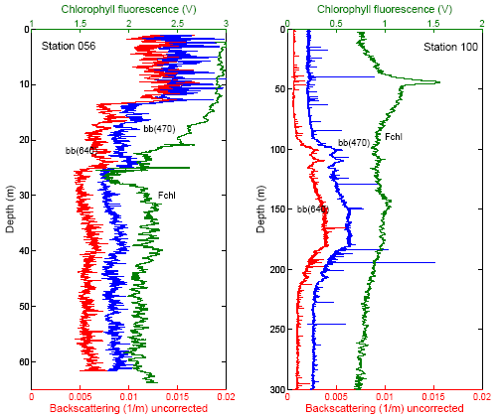
Although our general sampling approach was targeted, high spatial resolution deployments of the IOP package were made at three transects during the cruise; Kotzebue Sound, and two transects across Barrow Canyon. The latter two transects are of particular interest as Barrow Canyon represents a major conduit for transport of particulate matter from the Chukchi shelf to the Beaufort Sea.
Figure 2. Vertical profiles obtained at two stations of the backscattering coefficient in two spectral bands (470 and 640 nm) and chlorophyll a fluorescence. The backscattering values are uncorrected for attenuation of the signal over the measurement path length, fluorescence values are shown as voltages.
The magnitude, spectral shape, and vertical structure of the backscattering coefficient, b_{b}(λ), varied considerably between stations. Figure 2 is an illustration comparing vertical profiles of b_{b} in two spectral bands obtained from two stations. Station 56 was characterized by a large plankton bloom in the water column underneath the ice, and both chlorophyll a fluorescence and backscattering coefficients were elevated in the upper 10m. In contrast, at station 100 near the shelf break surface backscattering values were about 7.5 times lower, but a broad layer with elevated backscattering was observed between 100 and 220 m. This maxima was not coherent with chlorophyll fluorescence, but appears to be associated with a large concentration of bacterial biomass. It was frequently observed that the backscattering coefficient appeared to be uncoupled from the chlorophyll fluorescence or beam attenuation profiles. The latter observations suggest possible changes in the particulate backscattering to scattering ratio, which is generally considered to be a useful indicator of particle size or composition. The comprehensive set of measurements we obtained on this cruise will allow us to examine such assertions in detail.
Accompanying the changes in seawater optical properties, we observed a wide diversity in the magnitude and shape of the particle size distributions with the Coulter counter. The slope of the particle number per unit volume as a function of particle diameter varied from steep values (steeper than -4) typical of oligotrophic open ocean to flatter distributions with slopes indicative of a greater contribution of large particles. For a subset of our samples, the PSD was generally featureless with no distinct peaks evident in the distribution. These samples were generally collected near the bottom or in regions of recent ice melt, and likely represent suspensions dominated by mineral or other inorganic particles. In many cases, however, it was observed that a single slope does not provide an adequate description of the PSD over the measured size range of ~0.8 – 100 μm (i.e. the slope changes with diameter). The presence of well-defined peaks in the distribution, corresponding to specific populations of particles, was a common feature of these PSDs. These features were observed at different particle sizes, from as small as about 1.5 μm to 50-60 μm. Such features are not captured by most parameterizations used to describe and model the particle size distribution.
Measurements made with the NanoSight system suggest that such variability is also present in the submicron particle fraction. We observed dramatic visual differences between stations in the concentration and size distribution of particles between the size range of ~50 to 500 nm. Preliminary analysis of a subset of data suggests that concentrations in this size range varies more than 500-fold among samples, with the lowest concentrations associated with offshore stations in the Beaufort Sea and the highest concentrations found in sediment-laden ice samples. Qualitatively, these preliminary observations suggest that the submicron particle fraction may be more dynamic than is generally assumed, a finding that may have important implications for variability in particle backscattering, interpretation of remote-sensing reflectance, and carbon cycling within the colloidal size range.
The broad diversity of environments sampled, coupled with the relatively comprehensive suite of optical and biogeochemical measurements performed by our group and other ICESCAPE investigators, has provided a unique database in which to accomplish our goal of exploring optical proxies for biogeochemically-relevant properties of the suspended particle assemblage. Such information will lead not only to improved retrievals of chlorophyll a, POC, and other standard ocean color data products, but also to the development of new remote-sensing algorithms providing additional information on the constituents of seawater.
Bio-optical and biogeochemical measurements in support of satellite ocean color calibration and validation

Joaquin Chaves and Scott Freeman
NASA Goddard Space Flight Center

Group Members:
Michael Christensen

During the 2011 ICESCAPE campaign, NASA’s Goddard Space Flight Center (GFSC) group performed bio-optical measurements during 14 Arctic Survey Boat (ASB) deployments off the USCG cutter Healy (Fig. 1). During those deployments, 67 casts were performed for the measurement of apparent optical properties (AOPs), and 48 for the determination of inherent optical properties (IOPs; i.e., absorption and scattering) (Tables 1, 2). The group’s work was focused around the ASB deployments due to the better suitability of this smaller platform, over the 420 ft cutter, for accurate measurements of the underwater light field. The ASB platform allowed the measurement of optical properties in the water column with its vertical physical structure nearly intact. Measurements were possible within the ubiquitous, near-surface low salinity melt-water layer that develops during the summer months.

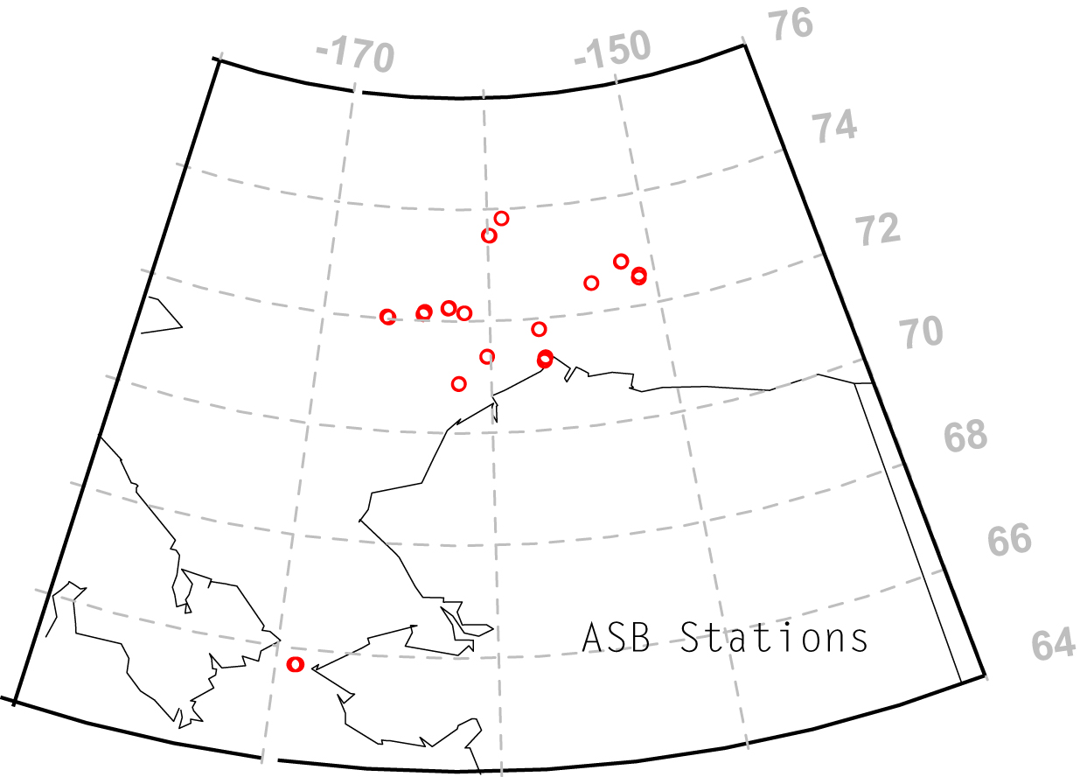
Figure 1. Locations of Arctic Survey Boat (ASB) deployments during the ICESCAPE 2011 campaign.

The bio-optical measurements were conducted to support calibration and validation activities for the current NASA ocean color satellite missions. The AOP measurements included in-water instruments (Submersible Biospherical Optical Profiling System, SuBOPS; Biospherical Instruments, Inc.) to determine spectral water-leaving radiances that are essential to remote sensing applications. The IOP measurements were centered on the HOBI Labs Inc. (Bellevue, WA) instrument package, which was modified to include an AC-9 absorption and attenuation meter from WETLabs Inc. (Philomath, OR). The HOBI Labs package comprises a Hydroscat-6 backscattering and fluorescence meter; an a-Sphere in-situ spectral absorption meter; a Seabird Electronics (Bellevue, WA) FastCAT CTD sensor; and photosynthetically active radiation (PAR) sensors from Biospherical. Both systems used Biospherical reference radiometers to measure incident solar irradiance. AOP and IOP cast were conducted to maximum depths of 60 and 37 m, respectively.
At each of the ASB deployments where optical measurements were conducted, near-surface (< 50 cm) water was collected from the ASB for the analyses, at GFSC, of phytoplankton pigments using HPLC techniques (n=53), particulate organic carbon (POC) (n=36), gravimetric determination of suspended particulate matter (SPM) (n=21), dissolved organic carbon (DOC) (n=52), and light absorption by particulates (a_{p}) (n=36), and colored dissolved organic matter (a_{CDOM}) (n=52). These data, in conjunction with the concurrent bio-optical measurements, will be valuable for the development and further refinement of algorithms for the determination of phytoplankton pigments and other novel data products (e.g. DOC, POC) from remote sensing platforms.
One of our group’s objectives is to further understanding of the quantitative relationships between AOPs and IOPs, and in turn with the dissolved and the suspended (living and detrital) components within the water column layer amenable to ocean color remote sensing detection. To that effect, during the current campaign we refined our IOP sampling design to differentiate from the bulk in situ absorption properties of the water column, those attributable to the dissolved and particulate fractions. During consecutive IOP casts at the same sampling location, a 0.2 μm filtering capsule was attached, alternatively, to the intake flow of the AC-9 and a-Sphere instruments. For each instrument, at each location, we measured then during one cast the absorption properties of the intact water column (i.e., “unfiltered”), and one where particles where excluded (i.e., “filtered”) (Figures 2, 3).
Preliminary data from stations 152 and 166 (Figures 2-5) exemplify some of the challenges associated with the determination of phytoplankton pigments accurately from space. The fluorescence profiles at 700 nm (Figures 2a, 3a) suggest contrasting chlorophyll a stocks at these locations. At station 152 the fluorescence is flat and low throughout the profile relative to the values found at station 166, which exhibited a sharp fluorescence peak below 30 m depth (Figure 3a). At the latter site, an increase in backscattering was strongly associated with that high chlorophyll layer. At station 152, however, the high scattering layers were associated with a relatively negligible increase in the fluorescence signal (Figure 2a). The absorption profiles at each site, measured with both the a-Sphere and the AC-9 instruments, show overall agreement with backscattering values, where high absorption was found at layers with an elevated backscattering signal (Figures 2b, c, 3b, c). Absorption spectra for all depths (Figures 2d, e, 3d, e), and moreover, the particle absorption (a_{p}) profile estimated from the difference between the filtered and unfiltered casts (Figures 2f, g, 3f, g) provide additional evidence about the constituents imparting different optical properties to the water column at these two sites. The a_{p} spectra at station 152 shows the typical monotonic decrease from lower to higher wavelengths associated with absorption by chomophoric detrital material (Figure 2f, g). In contrast, the a_{p} spectra at station 166 is reminiscent to that of chlorophyll and associated phytoplankton pigments (3f, g).
The preliminary AOP data do not show these differences as clearly as the IOP data. While differences in the rate of attenuation of E_{d} are visible (figure 4a, 5a), the remote-sensing reflectances (R_{rs}, figures 4c, 5c) are remarkably similar, with a higher, broader peak in the green wavelengths at station 152, and a narrower, slightly bluer reflectance at station 166.
One of the objectives of the data analyses of the wider dataset yet to be conducted, including that from the previous year’s mission, will be to better establish the quantitative relation between the optical parameters measured and the various components, living detrital, and dissolved. These data will allow us to expand the current understanding of the bio-optical variability in this high latitude environment, where climate record-quality measurements to support calibration and validation of ocean color missions are lacking.

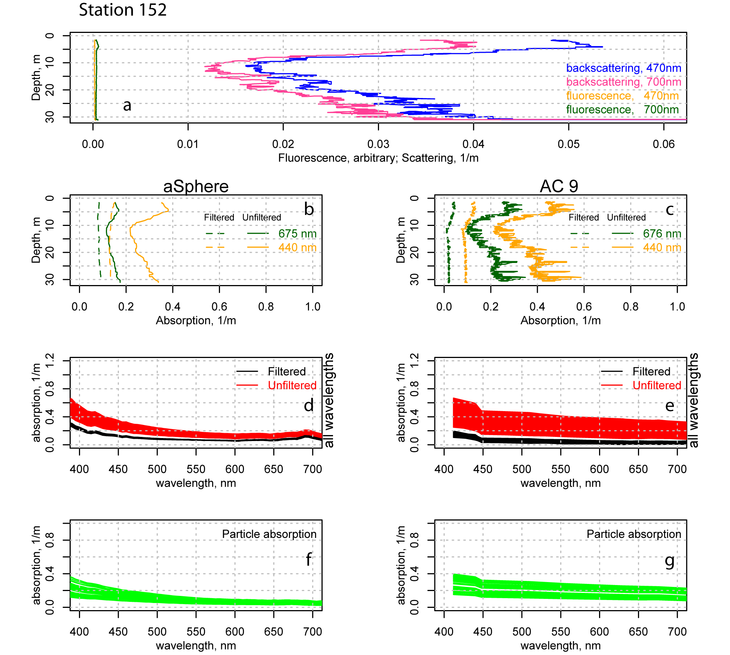

Figure 2. Station 152, ASB, July 22, 2011. a. Profiles of backscattering (b_{b}) and fluorescence at 470 nm and 700 nm. Profiles of absorption at 440 nm and 675 for filtered and unfiltered consecutive casts performed with the aSphere (b), and the AC-9 (c). Absorption (a) spectra for all depths for consecutive filtered and unfiltered casts performed with the aSphere (d), and the AC-9 (e),. Computed particle absorption (a_{p}) from the difference between binned absorption averages for filtered and unfiltered casts at 1.0 m depth bins, for the aSphere (f), and the AC-9 (g).

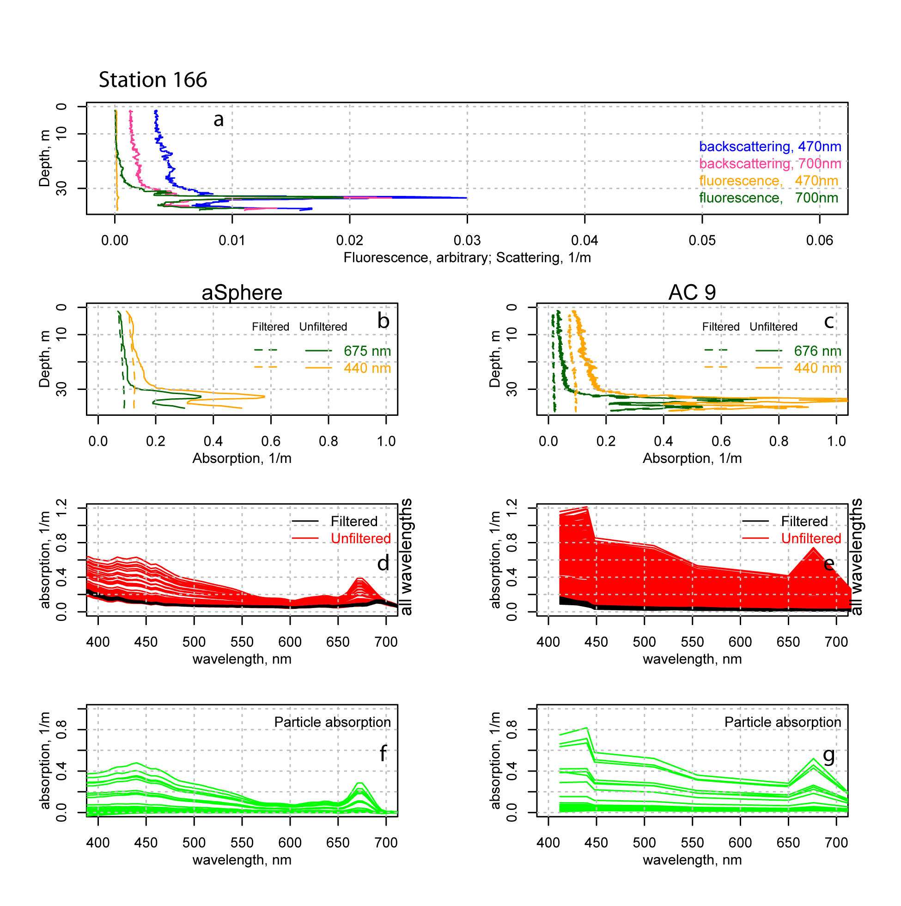

Figure 3. Station 166, ASB, July 23, 2011. a. Profiles of backscattering (b_{b}) and fluorescence at 470 nm and 700 nm. Profiles of absorption at 440 nm and 675 for filtered and unfiltered consecutive casts performed with the aSphere (b), and the AC-9 (c). Absorption (a) spectra for all depths for consecutive filtered and unfiltered casts performed with the aSphere (d), and the AC-9 (e),. Computed particle absorption (a_{p}) from the difference between binned absorption averages for filtered and unfiltered casts at 1.0 m depth bins, for the aSphere (f), and the AC-9 (g).

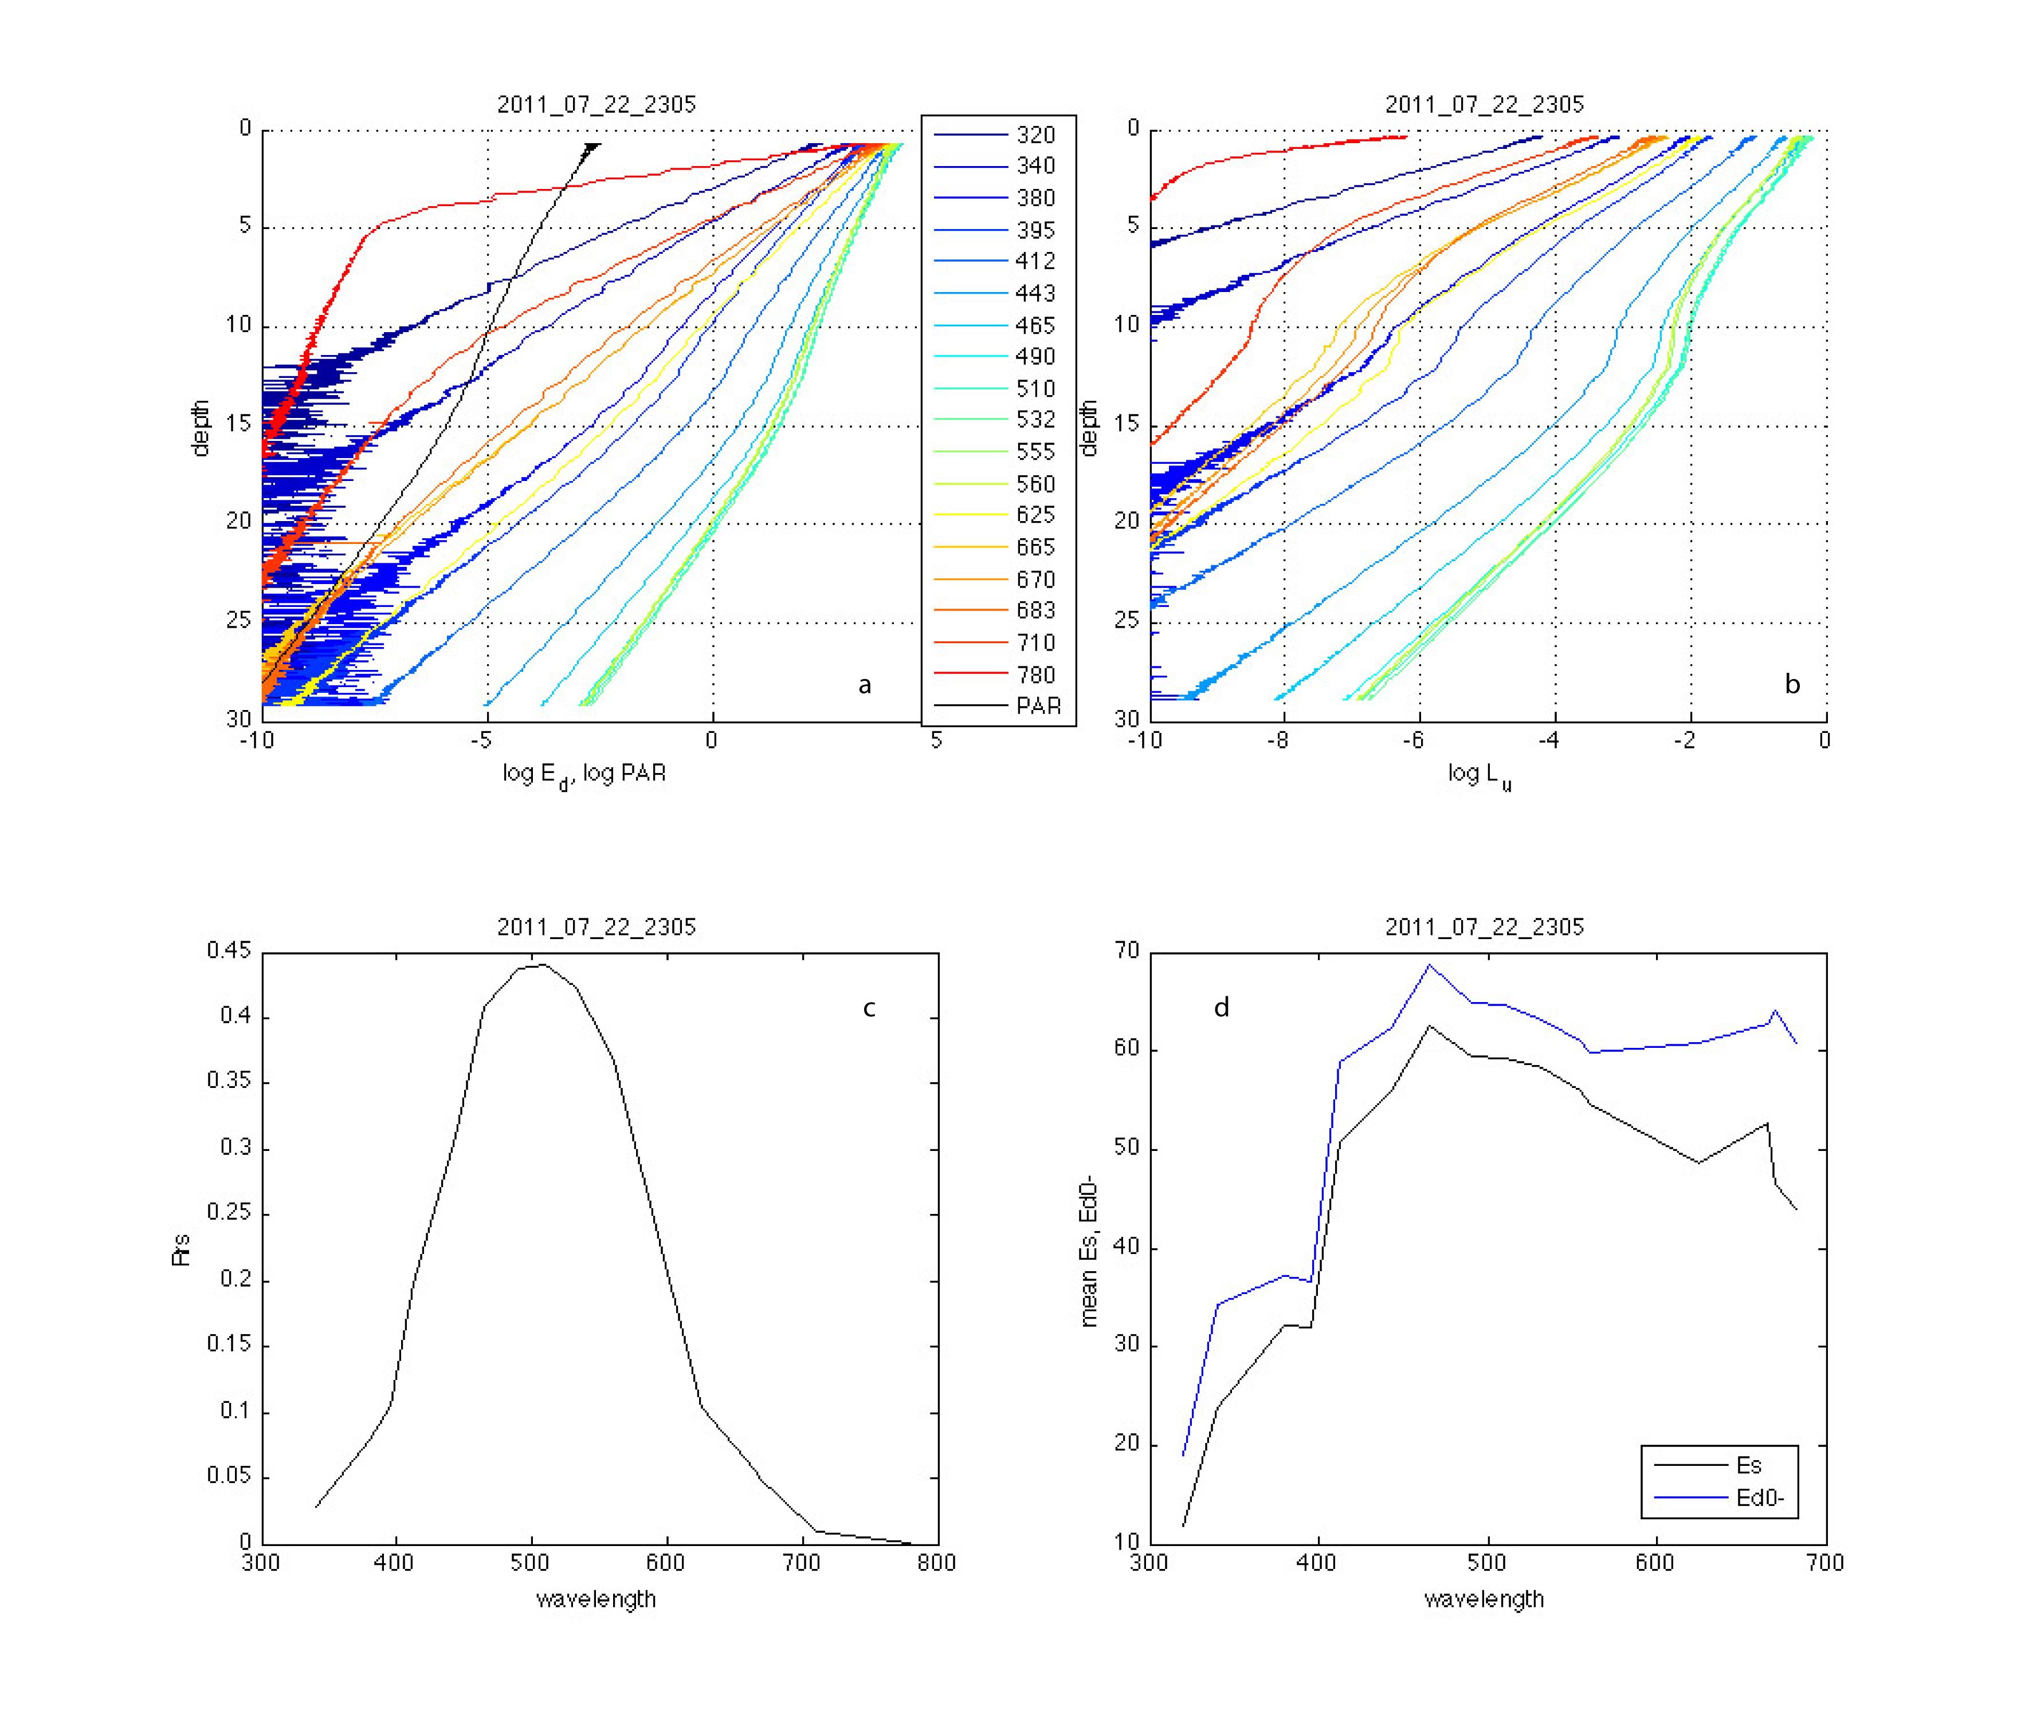
Figure 4. Station 152, ASB, July 22, 2011. A. E_{d} and PAR vs depth. B. L_{u} vs depth. C. R_{rs} D. E_{d} and mean E_{s}

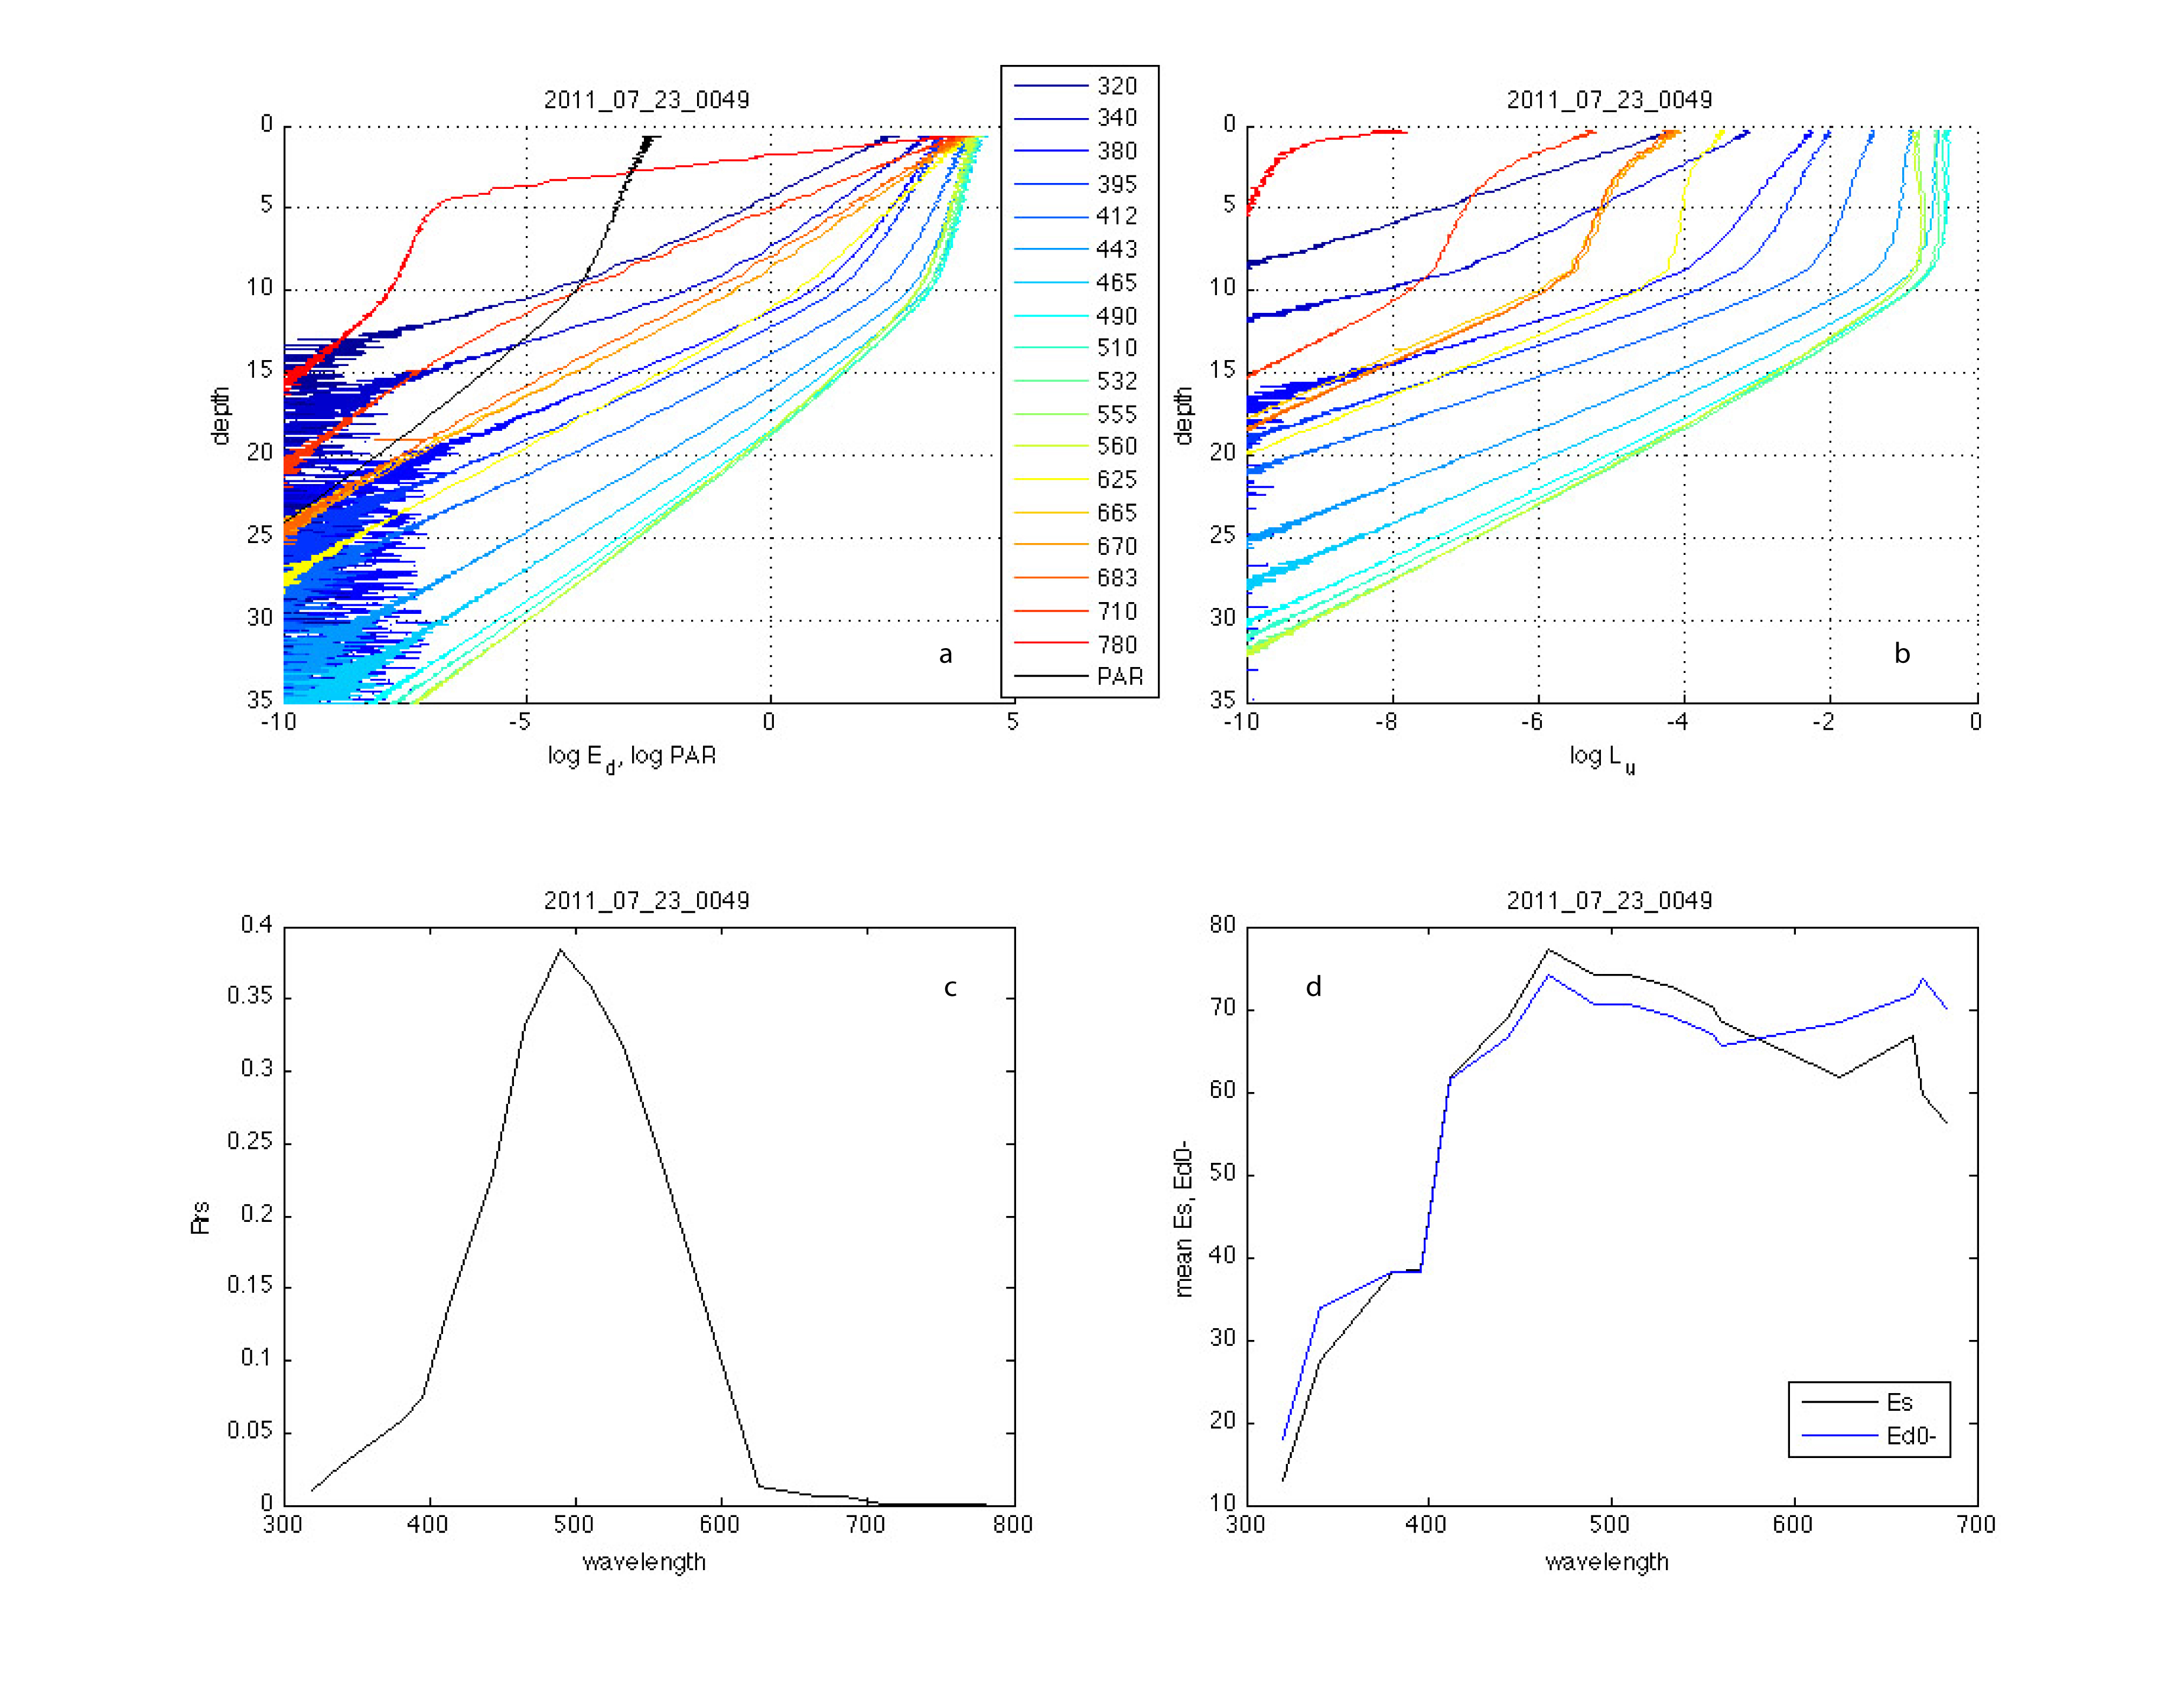
Figure 5: Station 166, ASB, July 23, 2011. A. E_{d} and PAR vs depth. B. L_{u} vs depth. C. R_{rs} D. E_{d} and mean E_{s}
Table 1. The AOP Master Log for USCG Healy 2011 field campaign with all times in GMT. Longitude and latitude are given in decimal degrees, depths in meters.

File | Longitude | Latitude | station | Depth (m) | Sky Conditions | wind speed (kn)
2011_06_28_2146 | -168.776 | 65.724 | 8 | 55 | 8/8 overcast | 21
2011_06_28_2149 | -168.776 | 65.724 | 8 | 55 | 8/8 overcast | 21
2011_06_28_2152 | -168.773 | 65.724 | 8 | 55 | 8/8 overcast | 21
2011_06_28_2321 | -168.900 | 65.718 | 8 | 55 | 8/8 overcast | 21
2011_06_28_2325 | -168.900 | 65.718 | 8 | 55 | 8/8 overcast, light rain | 21
2011_06_28_2328 | -168.900 | 65.717 | 8 | 55 | 8/8 overcast | 21
2011_07_02_2213 | -161.794 | 70.886 | 31 | 50 | 8/8 overcast | 11
2011_07_02_2217 | -161.795 | 70.885 | 31 | 50 | 8/8 overcast | 11
2011_07_02_2220 | -161.795 | 70.885 | 31 | 50 | 8/8 overcast | 11
2011_07_02_2336 | -161.790 | 70.888 | 31 | 50 | 6/8 overcast, lt rain | 11
2011_07_02_2339 | -161.790 | 70.887 | 31 | 50 | 4/8 overcast | 11
2011_07_02_2344 | -161.790 | 70.887 | 31 | 50 | 2/8 overcast | 11
2011_07_02_2351 | -161.788 | 70.887 | 31 | 50 | 2/8 overcast | 11
2011_07_03_2258 | -165.874 | 72.024 | 46 | 48 | 8/8 overcast | 20
2011_07_03_2302 | -165.878 | 72.024 | 46 | 48 | 8/8 overcast | 20
2011_07_03_2308 | -165.884 | 72.024 | 46 | 48 | 8/8 overcast | 20
2011_07_04_0026 | -165.959 | 72.041 | 46 | 48 | 8/8 overcast | 20
2011_07_04_0029 | -165.961 | 72.042 | 46 | 48 | 8/8 overcast | 20
2011_07_04_0034 | -165.966 | 72.042 | 46 | 48 | 8/8 overcast | 20
2011_07_08_2202 | -163.780 | 72.168 | 73 | 50 | 0/8 bright sun | 14
2011_07_08_2212 | -163.787 | 72.167 | 73 | 50 | 0/8 bright sun | 14
2011_07_08_2217 | -163.790 | 72.166 | 73 | 50 | 0/8 bright sun | 14
2011_07_08_2357 | -163.852 | 72.131 | 73 | 50 | 0/8 bright sun | 14
2011_07_09_0001 | -163.855 | 72.130 | 73 | 50 | 0/8 bright sun | 14
2011_07_09_0005 | -163.858 | 72.130 | 73 | 50 | 0/8 bright sun | 14
2011_07_09_2145 | -162.339 | 72.246 | 81 | 38 | 2/8 fog/haze | 18
2011_07_09_2152 | -162.346 | 72.246 | 81 | 38 | 2/8 fog/haze | 18
2011_07_09_2202 | -162.356 | 72.246 | 81 | 38 | 2/8 fog/haze | 18
2011_07_09_2317 | -162.368 | 72.237 | 81 | 39 | 6/8 clouds, no haze | 17
2011_07_09_2322 | -162.373 | 72.237 | 81 | 39 | 6/8 clouds, no haze | 17
2011_07_09_2327 | -162.377 | 72.237 | 81 | 39 | 6/8 clouds, no haze | 17
2011_07_12_0031 | -159.822 | 73.524 | 99 | 2017 | 8/8 overcast | 13
2011_07_12_0042 | -159.837 | 73.525 | 99 | 2017 | 8/8 overcast | 13
2011_07_12_0050 | -159.849 | 73.527 | 99 | 2017 | 8/8 overcast | 13
2011_07_13_2157 | -159.047 | 73.831 | 101 | 3169 | 1/8 clouds on horizon | 11
2011_07_13_2204 | -159.052 | 73.831 | 101 | 3169 | 1/8 clouds on horizon | 11
2011_07_13_2209 | -159.055 | 73.831 | 101 | 3169 | 1/8 clouds on horizon | 11
2011_07_13_2221 | -159.049 | 73.832 | 101 | 3169 | 1/8 clouds on horizon | 11
2011_07_15_2258 | -161.408 | 72.152 | 113 | 35 | 4/8 high clouds | 18
2011_07_15_2303 | -161.413 | 72.152 | 113 | 35 | 4/8 high clouds | 18
2011_07_15_2312 | -161.424 | 72.153 | 113 | 35 | 4/8 high clouds | 18
2011_07_16_2323 | -157.137 | 71.812 | 126 | 70 | 3/8 thin high clouds | 16
2011_07_16_2329 | -157.144 | 71.811 | 126 | 70 | 3/8 thin high clouds | 16
2011_07_16_2339 | -157.155 | 71.811 | 126 | 70 | 3/8 thin high clouds | 16
2011_07_16_2344 | -157.160 | 71.811 | 126 | 70 | 3/8 thin high clouds | 16
2011_07_18_0204 | -153.812 | 72.539 | 127 | 3060 | 3/8 thin high clouds | 9
2011_07_18_0210 | -153.816 | 72.539 | 127 | 3060 | 3/8, then fog, 8/8 | 9
2011_07_18_0218 | -153.822 | 72.538 | 127 | 3060 | 8/8 fog | 9
2011_07_18_2244 | -151.870 | 72.843 | 128 | 3817 | 3/8 fog and sun | 4
2011_07_18_2250 | -151.868 | 72.843 | 128 | 3817 | 3/8 fog and sun | 4
2011_07_18_2257 | -151.865 | 72.842 | 128 | 3817 | 3/8 fog and sun | 4
2011_07_19_0014 | -151.913 | 72.831 | 128 | 3817 | 6/8 fog and sun | 7
2011_07_19_0020 | -151.910 | 72.831 | 128 | 3817 | 6/8 fog and sun | 7
2011_07_19_0027 | -151.910 | 72.831 | 128 | 3817 | 6/8 fog and sun | 7
2011_07_19_0030 | -151.909 | 72.831 | 128 | 3817 | 6/8 fog and sun | 7
2011_07_20_2105 | -150.950 | 72.486 | 133 | 3622 | 7/8 thick clouds | 20
2011_07_20_2115 | -150.955 | 72.488 | 133 | 3622 | 7/8 thick clouds | 20
2011_07_20_2124 | -150.959 | 72.489 | 133 | 3622 | 7/8 thick clouds | 20
2011_07_20_2254 | -150.973 | 72.494 | 133 | 3622 | 7/8 thick clouds | 18
2011_07_20_2300 | -150.925 | 72.545 | 133 | 3622 | 7/8 thick clouds | 18
2011_07_20_2308 | -150.928 | 72.546 | 133 | 3622 | 7/8 thick clouds | 18
2011_07_22_2257 | -157.048 | 71.229 | 152 | 35 | 8/8 thick and thin clouds | 6
2011_07_22_2305 | -157.041 | 71.231 | 152 | 35 | 8/8 thick and thin clouds | 6
2011_07_22_2310 | -157.037 | 71.232 | 152 | 35 | 8/8 thick and thin clouds | 6
2011_07_23_0039 | -156.987 | 71.292 | 152 | 45 | 8/8 thick and thin clouds | 6
2011_07_23_0044 | -156.982 | 71.293 | 152 | 45 | 8/8 thick and thin clouds | 6
2011_07_23_0049 | -156.977 | 71.294 | 152 | 45 | 8/8 thick and thin clouds | 6
2011_07_23_2302 | -160.196 | 71.376 | 166 | 46 | 8/8 fog and clouds, disc present | 5
2011_07_23_2310 | -160.196 | 71.375 | 166 | 46 | 8/8 fog and clouds, disc present | 5
2011_07_23_2318 | -160.196 | 71.375 | 166 | 46 | 8/8 fog and clouds, disc present | 5

Table 2. The IOP Master Log for USCG Healy 2011 field campaign with all times in GMT. Longitude and latitude are given in decimal degrees, depths in meters.
Cast |  | Date | BegCast | EndCast | Latitude | Longitude | Cast z | filtration | UpDown | Station | Bottom z
101 | 28Jun11 |  | 2221 | 2224 | 65.7207 | -168.7859 | 14 | no | D | 8 | 55
101 | 28Jun11 |  | 2224 | 2227 | 65.7206 | -168.7847 | 14 | no | U | 8 | 55
102 | 28Jun11 |  | 2358 | 0004 | 65.7146 | -168.8979 | 20 | no | D | 8 | 55
102 | 29Jun11 |  | 0004 | 0007 | 65.7137 | -168.8992 | 20 | no | U | 8 | 55
103 | 2Jul11 |  | 2247 | 2250 | 70.8824 | -161.8029 | 20 | no | D | 31 | 50
103 | 2Jul11 |  | 2250 | 2252 | 70.8819 | -161.8039 | 20 | no | U | 31 | 50
104 | 2Jul11 |  | 2308 | 2314 | 70.8898 | -161.7861 | 20 | no | D | 31 | 50
104 | 2Jul11 |  | 2314 | 2317 | 70.8891 | -161.7874 | 20 | no | U | 31 | 50
105 | 3Jul11 |  | 2340 | 2344 | 72.0283 | -165.9035 | 26 | no | D | 46 | 48
105 | 3Jul11 |  | 2344 | 2348 | 72.0287 | -165.9102 | 26 | no | U | 46 | 48
106 | 4Jul11 |  | 2358 | 0003 | 72.0291 | -165.9189 | 26 | yes | D | 46 | 48
106 | 4Jul11 |  | 0003 | 0008 | 72.0294 | -165.9267 | 26 | yes | U | 46 | 48
108 | 4Jul11 |  | 0106 | 0111 | 72.0461 | -165.9903 | 31 | yes | D | 46 | 48
108 | 4Jul11 |  | 0111 | 0117 | 72.0472 | -165.9976 | 31 | yes | U | 46 | 48
109 | 4Jul11 |  | 0122 | 0128 | 72.0478 | -166.0018 | 33 | no | D | 46 | 48
109 | 4Jul11 |  | 0128 | 0134 | 72.0485 | -166.0089 | 33 | no | U | 46 | 48
110 | 8Jul11 |  | 2257 | 2305 | 72.1670 | -163.8029 | 37 | no | D | 73 | 50
110 | 8Jul11 |  | 2305 | 2314 | 72.1654 | -163.8132 | 37 | no | U | 73 | 50
111 | 8Jul11 |  | 2327 | 2336 | 72.1633 | -163.8225 | 35 | yes | D | 73 | 50
111 | 8Jul11 |  | 2336 | 2343 | 72.1608 | -163.8318 | 35 | yes | U | 73 | 50
112 | 9Jul11 |  | 0028 | 0034 | 72.1246 | -163.8741 | 31 | yes | D | 73 | 50
112 | 9Jul11 |  | 0034 | 0041 | 72.1219 | -163.8831 | 31 | yes | U | 73 | 50
113 | 9Jul11 |  | 0046 | 0052 | 72.1206 | -163.8870 | 31 | no | D | 73 | 50
113 | 9Jul11 |  | 0052 | 0058 | 72.1182 | -163.8949 | 31 | no | U | 73 | 50
114 | 9Jul11 |  | 2224 | 2232 | 72.2461 | -162.3789 | 34 | no | D | 81 | 38
114 | 9Jul11 |  | 2232 | 2239 | 72.2458 | -162.3926 | 34 | no | U | 81 | 38
115 | 9Jul11 |  | 2246 | 2255 | 72.2457 | -162.3995 | 34 | yes | D | 81 | 38
115 | 9Jul11 |  | 2255 | 2302 | 72.2452 | -162.4143 | 34 | yes | U | 81 | 38
116 | 9Jul11 |  | 2345 | 2351 | 72.2353 | -162.3925 | 35 | yes | D | 81 | 38
116 | 9Jul11 |  | 2351 | 2357 | 72.2346 | -162.4019 | 35 | yes | U | 81 | 38
118 | 10Jul11 |  | 0027 | 0032 | 72.2320 | -162.4259 | 35 | yes | D | 81 | 38
118 | 10Jul11 |  | 0032 | 0037 | 72.2313 | -162.4334 | 35 | yes | U | 81 | 38
119 | 10Jul11 |  | 0043 | 0050 | 72.2315 | -162.4315 | 34 | no | D | 81 | 38
119 | 10Jul11 |  | 0050 | 0056 | 72.2307 | -162.4421 | 34 | no | U | 81 | 38
120 | 12Jul11 |  | 0113 | 0119 | 73.5298 | -159.8599 | 32 | no | D | 99 | 2000
120 | 12Jul11 |  | 0119 | 0124 | 73.5311 | -159.8746 | 32 | no | U | 99 | 2000
121 | 12Jul11 |  | 0128 | 0135 | 73.5319 | -159.8793 | 34 | yes | D | 99 | 2000
121 | 12Jul11 |  | 0135 | 0143 | 73.5334 | -159.8992 | 34 | yes | U | 99 | 2000
122 | 12Jul11 |  | 0200 | 0206 | 73.5367 | -159.9245 | 35 | yes | D | 99 | 2000
122 | 12Jul11 |  | 0206 | 0212 | 73.5374 | -159.9301 | 35 | yes | U | 99 | 2000
123 | 13Jul11 |  | 2240 | 2247 | 73.8319 | -159.0563 | 37 | no | D | 101 | 3169
123 | 13Jul11 |  | 2247 | 2252 | 73.8320 | -159.0639 | 37 | no | U | 101 | 3169
124 | 13Jul11 |  | 2300 | 2305 | 73.8323 | -159.0614 | 37 | yes | D | 101 | 3169
124 | 13Jul11 |  | 2305 | 2311 | 73.8323 | -159.0646 | 37 | yes | U | 101 | 3169
125 | 13Jul11 |  | 2320 | 2324 | 73.8329 | -159.0683 | 37 | yes | D | 101 | 3169
125 | 13Jul11 |  | 2324 | 2330 | 73.8333 | -159.0738 | 37 | yes | U | 101 | 3169
126 | 15Jul11 |  | 2343 | 2350 | 72.1502 | -161.4627 | 30 | no | D | 113 | 35
126 | 15Jul11 |  | 2350 | 2354 | 72.1495 | -161.4729 | 30 | no | U | 113 | 35
127 | 16Jul11 |  | 0004 | 0010 | 72.1508 | -161.4825 | 30 | yes | D | 113 | 35
127 | 16Jul11 |  | 0010 | 0014 | 72.1499 | -161.4919 | 30 | yes | U | 113 | 35
128 | 16Jul11 |  | 0021 | 0027 | 72.1498 | -161.4987 | 30 | yes | D | 113 | 35
128 | 16Jul11 |  | 0027 | 0033 | 72.1495 | -161.5101 | 30 | yes | U | 113 | 35
129 | 17Jul11 |  | 0011 | 0017 | 71.8115 | -157.1606 | 29 | no | D | 126 | 70
129 | 17Jul11 |  | 0017 | 0022 | 71.8109 | -157.1714 | 29 | no | U | 126 | 70
130 | 17Jul11 |  | 0028 | 0032 | 71.8108 | -157.1769 | 31 | yes | D | 126 | 70
130 | 17Jul11 |  | 0032 | 0039 | 71.8100 | -157.1857 | 31 | yes | U | 126 | 70
131 | 17Jul11 |  | 0048 | 0054 | 71.8115 | -157.1855 | 29 | yes | D | 126 | 70
131 | 17Jul11 |  | 0054 | 0101 | 71.8105 | -157.1962 | 29 | yes | U | 126 | 70
132 | 18Jul11 |  | 0309 | 0314 | 72.5344 | -153.8275 | 37 | no | D | 127 | 3060
132 | 18Jul11 |  | 0314 | 0320 | 72.5338 | -153.8348 | 37 | no | U | 127 | 3060
133 | 18Jul11 |  | 0327 | 0333 | 72.5333 | -153.8402 | 37 | yes | D | 127 | 3060
133 | 18Jul11 |  | 0333 | 0340 | 72.5326 | -153.8483 | 37 | yes | U | 127 | 3060
134 | 18Jul11 |  | 0350 | 0356 | 72.5338 | -153.8462 | 37 | yes | D | 127 | 3060
134 | 18Jul11 |  | 0356 | 0402 | 72.5330 | -153.8540 | 37 | yes | U | 127 | 3060
135 | 18Jul11 |  | 2322 | 2328 | 72.8415 | -151.8588 | 37 | yes | D | 128 | 3817
135 | 18Jul11 |  | 2328 | 2335 | 72.8408 | -151.8538 | 37 | yes | U | 128 | 3817
136 | 18Jul11 |  | 2340 | 2346 | 72.8404 | -151.8520 | 37 | yes | D | 128 | 3817
136 | 18Jul11 |  | 2346 | 2352 | 72.8399 | -151.8479 | 37 | yes | U | 128 | 3817
137 | 19Jul11 |  | 0051 | 0056 | 72.8300 | -151.9007 | 37 | yes | D | 128 | 3817
137 | 19Jul11 |  | 0056 | 0103 | 72.8295 | -151.8962 | 37 | yes | U | 128 | 3817
138 | 19Jul11 |  | 0108 | 0113 | 72.8290 | -151.8938 | 37 | yes | D | 128 | 3817
138 | 19Jul11 |  | 0113 | 0122 | 72.8284 | -151.8893 | 37 | yes | U | 128 | 3817
139 | 20Jul11 |  | 2154 | 2200 | 72.4939 | -150.9731 | 37 | yes | D | 133 | 3622
139 | 20Jul11 |  | 2200 | 2207 | 72.4960 | -150.9799 | 37 | yes | U | 133 | 3622
140 | 20Jul11 |  | 2224 | 2232 | 72.4994 | -150.9936 | 37 | yes | U | 133 | 3622
141 | 20Jul11 |  | 2333 | 2339 | 72.5486 | -150.9294 | 37 | yes | D | 133 | 3622
141 | 20Jul11 |  | 2339 | 2344 | 72.5494 | -150.9337 | 37 | yes | U | 133 | 3622
142 | 20Jul11 |  | 2349 | 2356 | 72.5498 | -150.9355 | 37 | yes | D | 133 | 3622
142 | 21Jul11 |  | 2356 | 0003 | 72.5506 | -150.9380 | 37 | yes | U | 133 | 3622
143 | 21Jul11 |  | 0009 | 0015 | 72.5508 | -150.9394 | 37 | no | D | 133 | 3622
143 | 21Jul11 |  | 0015 | 0020 | 72.5512 | -150.9432 | 37 | no | U | 133 | 3622
145 | 22Jul11 |  | 2336 | 2343 | 71.2392 | -157.0088 | 30 | yes | D | 152 | 35
145 | 22Jul11 |  | 2343 | 2350 | 71.2428 | -156.9963 | 30 | yes | U | 152 | 35
146 | 22Jul11 |  | 2357 | 0004 | 71.2446 | -156.9888 | 30 | yes | D | 152 | 35
146 | 23Jul11 |  | 0004 | 0011 | 71.2479 | -156.9752 | 30 | yes | U | 152 | 35
147 | 23Jul11 |  | 0105 | 0112 | 71.2961 | -156.9609 | 37 | yes | D | 152 | 48
147 | 23Jul11 |  | 0112 | 0118 | 71.2986 | -156.9491 | 37 | yes | U | 152 | 48
148 | 23Jul11 |  | 0135 | 0142 | 71.3020 | -156.9310 | 37 | yes | D | 152 | 48
148 | 23Jul11 |  | 0142 | 0148 | 71.3043 | -156.9204 | 37 | yes | U | 152 | 48
149 | 23Jul11 |  | 2339 | 2348 | 71.3729 | -160.2005 | 37 | yes | D | 166 | 49
149 | 23Jul11 |  | 2348 | 2355 | 71.3710 | -160.2034 | 37 | yes | U | 166 | 49
150 | 24Jul11 |  | 0006 | 0012 | 71.3690 | -160.2050 | 37 | yes | D | 166 | 49
150 | 24Jul11 |  | 0012 | 0018 | 71.3674 | -160.2074 | 37 | yes | U | 166 | 49
153 | 24Jul11 |  | 0036 | 0038 | 71.3649 | -160.2119 | 37 | yes | D | 166 | 49
153 | 24Jul11 |  | 0038 | 0045 | 71.3635 | -160.2149 | 37 | yes | U | 166 | 49
Bacterial Production

Eva Ortega-Retuerta
Laboratoire d’Oceanographie Microbienne de Banyuls (France)

Bacterioplankton play a key role on organic matter processing throughout all aquatic ecosystems. In particular, it is estimated that on average, a 50% of fixed carbon by phytoplankton is further processed by heterotrophic prokaryotes (PH). This organic matter is either catabolized into CO₂ to obtain energy (prokaryotic respiration) or used for anabolism; that is, building new biomass (prokaryotic production). Hence, bacterioplankton are at the centre of the balance between mineralized and exported carbon.

Parameters Measured onboard:
- Bacterial Production. Heterotrophic prokaryotes production (BP) was measured by ³H-leucine incorporation (Kirchman, 1993) as modified by (Smith and Azam, 1992). Samples (1.5 ml in triplicate) were added to sterile microcentrifuge tubes (Eppendorf, 2 ml), containing 20 nM [3,4,5-³H]-leucine (specific activity 108 Ci mmol⁻¹, Perkin Elmer). The final concentration was determined to be saturated by performing saturation curves. One killed control was prepared for each assay by addition of trichloroacetic acid (TCA) at 5% final concentration before the addition of leucine. Tubes were incubated at in situ temperature for 2 h. Incorporations were terminated by adding TCA (5% final concentration). Samples were stored for at least 1 h at 4°C and then centrifuged for 15 min at 12,000 x g. The precipitate was rinsed once with 5% TCA and once with 70% ethanol. The precipitates were resuspended in 1.5 ml of liquid scintillation cocktail (ReadySafe, Beckman) and radioactivity determined by liquid scintillation counting (Beckman).
- Bacterial abundance. Samples (1.5 ml) were preserved glutaraldehyde (0.25% final concentration) in cryovials, gently mixed and left in the dark at 2ºC for 30 min before storage at -80°C. Samples were then thawed and stained with SybrG I (10⁻⁴ fold dilution of the commercial stock). Samples were analysed by flow Cytometry (Accuri C6). High Nucleic Acid (HNA) and low Nucleic Acid (LNA) bacteria, indicative of activity status or distinct bacterial communities, were discriminated according to their green fluorescence and counted separately.
- Viral abundance. Samples (1.5 mL) were preserved in glutaraldehyde (0.25% final) gently mixed and left in the dark at room temperature for 30 min before storage at -80°C to be analysed at LOMIC with flow cytometry (BD FACS Canto after Sybr Green I staining
- Culturable bacteria diversity. Samples located at contrasting locations (e.g. ice-water interface, phytoplankton blooms, terrestrial-influenced waters). Samples (1 mL) were fixed (glycerol, 20%) and frozen at -80ºC for further isolation and characterization of culturable bacterial diversity at OO Banyuls.
- Particle attached and free-living bacterial diversity. Samples (1 to 5 L according to productivity in the area) were sequentially filtered through 3 µm (particle attached bacteria) and 0.2 µm (free living bacteria) filters and stored frozen at -80ºC. DNA and RNA will be extracted from both fractions for bacterial community composition analyses (ARN 16s genes amplification of DNA and rtDNA, Capillary Electrophoresis- Single Strand Conformation Polymorphism and massive parallel tag- sequencing)
Samples were taken from the rosette (64 water stations) and water beneath the ice in 9 ice stations (K. Frey). Preliminary results point to a high variability in bacterial abundance and production along the stations. Interestingly, bacterial abundance and production did not follow the high chl values found under the ice (st. 52 to 68, Fig. 1), suggesting a lowered microbial loop due refractory nature of organic matter or the prior uptake of inotganic nutrients by phytoplankton. High bacterial abundances and production values were also observed at stations located in the Bering strait, bottom waters of coastal stations near Barrow Canyon, or at 130-160 m, coinciding with low transmissivity and high particle concentration, in deep stations (97 to 102, Fig. 1). In general, high abundance values were mainly due to a higher presence of high nucleic acid bacteria, indicative of active nature of high nucleic acid cells.

Sample | N | B act  Abundance | Bact  Production | Viral Abundance | Bact  Diversity | Cult. Bact.  Diversity
CTD stations | 64 | 299 | 299 | 45 | 28 | 11
Ice stations  (water beneath ice) | 9 | 45 | 45 |  |  | 1
Exps Matt Mills | 9 | 252 | 252
Photooxidation exps | 4 | 28 | 28 |  | 2
Biodegradation exps | 2 | 162 | 180 |  | 24
Total |  | 786 | 804 | 45 | 54 | 12

Table 1. Summary of measurements made during ICESCAPE 2011.
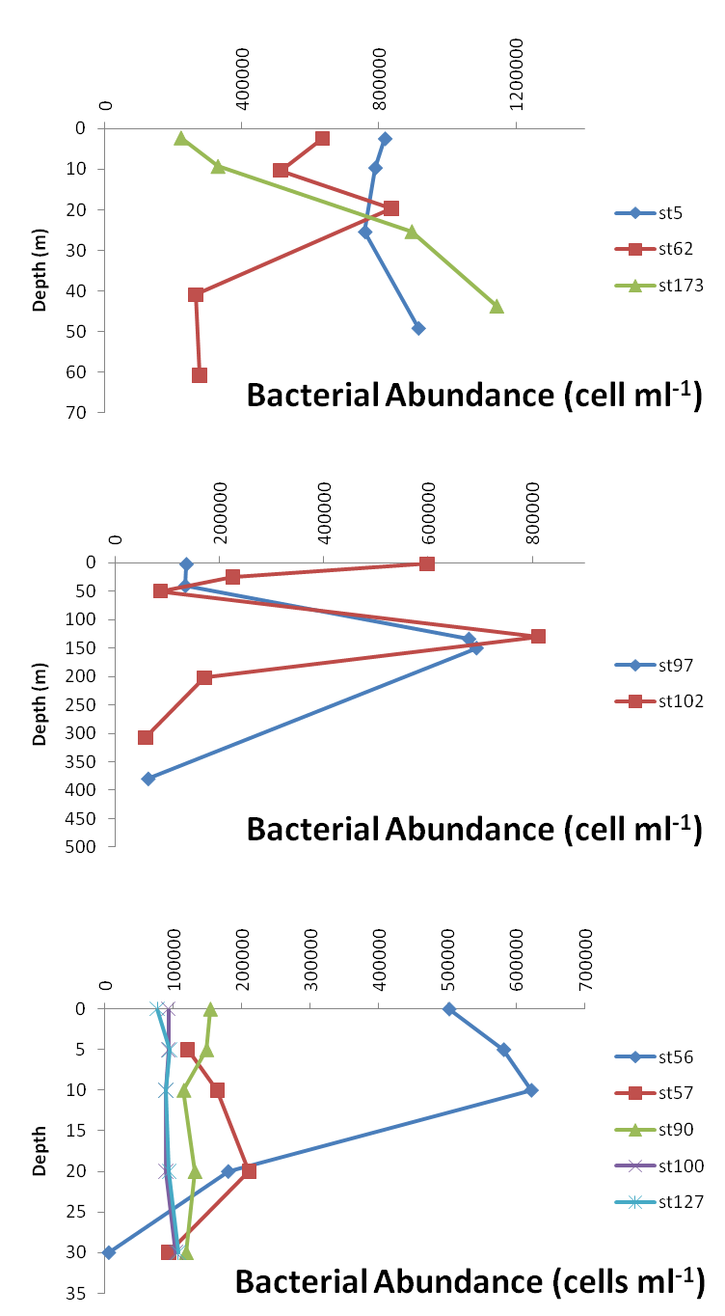
Figure 1. Bacterial abundance profiles at shallow water stations, deep stations, and water beneath the ice.

Different experimental assays were also run during the cruise:
Bacterial abundance and production was measured in incubations of N addition experiments (Arrigo and Mills).

Photooxidation experiments (see A. Matsuoka report for further details). Following photooxidation of organic matter by in situ deck incubations under natural sunlight, water was inoculated with bacteria (unfiltered water, 10% concentration) over photooxidized (light) and non- photooxidized (dark) waters, and incubated in the dark (30°F) for 8 days or until the stationary phase was reached. Samples were taken daily for bacterial abundance and production (4 experiments) and bacterial diversity (1 experiment). Preliminary results point, in line with ICESCAPE 2010 results, to a first growth phase where bacterial growth was prevented by the presence of organic matter photoproducts, after which bacterial abundance and activity reached similar levels on both photooxidized (light) and non-photooxidized (dark) organic matter treatments

Biodegradation experiments
To determine the response of bacterial communities to different natural organic matter sources, two mid-term biodegradation experiments were performed using waters from surface at station 73 (exp 1) and 150 m at station 102 (exp 2). Water was filtered by 1 µm to remove phytoplankton and grazers, letting only free-living bacteria grow. Additions (10% vol) of 0.2 µm filtered seawater were made in triplicate setting up the following treatments: Control (filtrate addition from the same experimental water), phytoplankton (filtrate added from surface waters of station 54 (12 µg l⁻¹ Chl a), rich in phytoplankton-derived organic matter, and terrestrial (filtrate added from surface waters of station 13, Kotzebue Bay, rich in terrestrial-derived organic matter. To study the sensitivity of bacteria to temperature when growing on diferent organic matter sources, all treatments were incubated at two temperatures (30°F and 40°F) for 10 days. Bacterial abundance, production and diversity, nutrients and DOC were monitored during the incubations. Preliminary results point to a minor effect of organic matter quality on bacterial activity and diversity, likely due to limitation by inorganic nutrients (exp 1) or to high initial organic matter supply (exp 2). This caused, conversely, a high stimulation of bacterial activity when growing at 10°F higher, that reached values of up to 20 x 10⁶ cells per ml (2 orders of magnitude higher than average in situ values), demonstrating high sensitivity to temperature changes.
Study of the variability in absorption coefficients of coloured dissolved organic matter of the Arctic Ocean as a function of environmental factors

Atsushi Matsuoka
Villefranche
Group Members:
Marcel Babin (U. Laval) – not in attendance
Annick Bricaud (LOV) – not in attendance

Overview
The CDOM absorbance has been measured using a liquid core waveguide system, UltraPath (WPIInc.,http://www.wpi-europe.com/products/spectroscopy/ultrapath.htm). The CDOM absorbance was measured from 200 to 720 nm with 1 nm increments using 2m optical pathlength for most samples. In terms of comparison to a traditional spectrophotometer which has 10 cm optical pathlength, we used 10 cm pathlength of UltraPath.

Sampling
A summary of samples collected during ICESCAPE 2011 can be found in Table 1. Samples were collected into pre-rinsed glass bottles covered with aluminium paper. Those samples were filtered immediately after collection, in dim light, using 0.2 μm Millipore filters pre-rinsed with 200 ml of Milli-Q water. Filtered samples were then pumped into the sample cell of the Ultrapath instrument. Absorbance spectra were measured with reference to a salt solution (the salinity of the reference was adjusted to that of the sample as far as possible), prepared with Milli-Q water and granular NaCl calcinated in advance (i.e., NaCl was calcinated by placing in an oven at 400 degree C for 4 hours). Between each measurement, the sample cell was cleaned several times, successively with detergent, high reagent grade MeOH, 2 M HCl, and Milli-Q water. The cleanliness of the tube was controlled using a reference value for the transmittance of the reference water.

Table 1. Samples collected and experiments performed during ICESCAPE 2011.

Sampling
Platform | Type of sample | Number of stations | N
Healy, Rosette  (Niskin bottles) | Water | 92 | 421
Small boat | Water close to the ice | 15 | 15
Sea Ice base | Water in melt pond, within the sea, and under the ice | 4 | 10
Total |  | 111 | 446

Table 1. Continued.

Experiment
Platform | Type of experiment | Parameter | Treatment | Remarks
Incubation pool | Photo-oxidation | CDOM | Light and dark | Triplicates each for both at 5 stns
 |  | Bacteria | Light and dark | Triplicates each for both at 5 stns
 |  | DIC | Light and dark | 1 sample each at 4 stns.
 |  | Nutrients | Light and dark | 1 sample each at 5 stns.

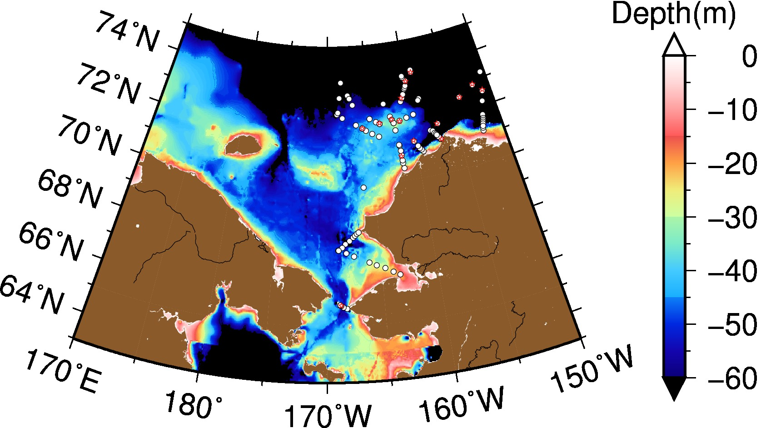

Figure 1. Sampling stations. Black circles represent stations using CTD/Niskin. Red stars represent stations using the ASB.

Temperature differences between reference and sample were minimized as far as possible, but could not be always avoided. As absorption coefficients of pure water depend on temperature, this can result in an underestimate of absorption coefficients mostly over 700 nm (mainly apparent on log-linearized spectra) for some samples. No temperature correction was applied to absorption spectra in the data file, but the slope of spectra was calculated using the value at 700 nm as baseline, which minimizes temperature effect on the absorbance among samples. The presence of microbubbles in the sample cell was also avoided as far as possible by using a peristaltic pump. When not totally removed, these microbubbles induced a significant absorption, detectable in the infra-red, and the corresponding absorption spectra were discarded.

Calculation
Absorption coefficients of CDOM were calculated as follows:

where 2.303 is a factor for converting base e to base 10 logarithms, OD_{CDOM}(λ) denotes optical density of CDOM (unitless), and l is an optical pathlength (in m). 2m optical pathlength was used consistently for the absorption measurement. The CDOM absorbance was measured from 200 to 735 nm with 1 nm increment using 2m optical pathlength for all samples. In addition, we used 10 cm in terms of comparison to a traditional spectrophotometer which has 10 cm pathlength.

Note:
The same protocol for measurement of CDOM absorbance was used for a previous BIOSOPE, MALINA, and ICESCAPE 2010 cruises. The detailed methodology is documented in Bricaud et al. [2010] and Matsuoka et al. [to be submitted].

References
Bricaud, A., Babin, M., Claustre, H., Ras, J. and F. Tieche (2010). Light absorption properties and absorption budget of South East Pacific waters. Journal of Geophysical Research.
Matsuoka, A., A. Bricaud, R. Benner, and J. Para, R. Sempere, and M. Babin, Tracking the transportation of colored dissolved organic matters in western Arctic waters: relationships with hydrography of the Arctic Ocean, to be submitted.

Sea Ice Physical and Optical Properties

Don Perovich
Cold Regions Research and Engineering Laboratory

Group Members:
Chris Polashenski (CRREL)
Melinda Webster (UW)

Observations
The overall goal of the ice physics work is to obtain a dataset describing the state and spatial variability of the morphological and optical properties of the melting first year ice in the Chukchi and Beaufort Seas. There were two broad classes of ice activities: on-ice measurements at individual floes and observations made while the ship was in transit.
On-ice observations were made at 9 ice stations (Table 1) and consisted of surveys and point measurements of sea ice morphology and optics. The morphology component included measurements of melt pond properties and profiles of ice thickness. Pond studies focused on understanding pond drainage and the spatial variability of pond coverage. The morphology of individual ponds, including their size and depth, was documented. Ice cores were taken for measurements of vertical profiles of temperature, salinity, density, and crystallography. Ice thicknesses were measured where holes were drilled for core sampling and for optics. In addition, surveys of ice thickness were conducted at several stations using an electromagnetic induction sensor. The surveys were 1000 to 2000 m long, with the survey pattern depending on the size and morphology of the individual floe. The thickness surveys were designed to estimate an ice thickness distribution for each floe. An ice core from each site will be shipped home to the laboratory for further optical measurements and analysis.
The optical observations were designed to provide a detailed characterization of the upwelling and downwelling components of the spectral radiation field from just above the surface through the ice and into the upper few meters of the ocean. Spectral albedos, transmittances, and vertical profiles of in-ice irradiance were measured. Transmitted vector and scalar PAR were also measured. Optical observations were made at sites selected to encompass the full range of ice types and surface conditions encountered on the cruise. Special attention was paid to investigating the spatial variability of light transmitted through bare and ponded ice. Figure 1 presents spectral albedos and transmittances for bare and ponded ice measured at Station 56. Transmitted PAR values are also plotted. Transmittances at visible wavelengths were large for melt ponds and even for bare ice more than 10% of the incident visible sunlight was transmitted.
An ice watch characterizing the ice conditions at two-hour intervals was conducted while the ship was in transit in the ice. The ice watch was made in cooperation with the Clark University team (Frey, Kelly, Meyer, Wood). A standard observational protocol was used and the ice type, ice thickness, ice concentration, and pond fraction were recorded for the primary, secondary, and tertiary ice types encountered. Additional information including the state of melt, sediment content, algae concentration, and fauna present was also collected. Photographs of ice conditions were taken in conjunction with each ice watch. These data provide a broad spatial overview of the properties of the ice cover in the Chukchi Sea in June and July.
In-transit measurements were also made of absolute incident spectral solar irradiance and spectral reflectance of open ocean. The incident spectral irradiances were measured under sky conditions ranging from clear skies to complete overcast with fog. These observations will assist in determining the solar input to the ice – ocean system.

Preliminary Findings
- Light transmission through both bare and ponded first-year ice was large.
- Transmitted PAR and visible light through ponds is 3-10 times greater than through bare ice
- The transition in transmitted light moving between bare ice and ponded ice occurs over a length scale of 2 to 4 times the ice thickness.
- Ice thickness increased from the ice edge inwards demonstrating the impact of ocean heating on bottom melt.
- Unlike last year, very few false bottoms were observed.

Table 1. Summary of ice observations at Ice stations
Ice Station | Station | Latitude (N) | Longitude (W) | Ice cores | Drill holes | EM thickness | Spectral albedo | Spectral transmittance | Transmitted PAR
1 | 55 | 72 37.94 | 168 43.47 | X | X | X | X | X | X
2 | 56 | 73 09.90 | 168 29.14 | X | X | X | X | X | X
3 | 57 | 73 43.02 | 168 15.83 | X | X | X | X | X | X
4 | 90 | 72 57.46 | 160 45.95 | X | X | X | X | X | X
5 | 100 | 73 41.82 | 160 16.83 | X | X | X | X | X | X
6 | 101 | 73 50.04 | 159 04.46 | X | X | X | X | X | X
7 | 127 | 72 32.72 | 153 49.08 | X | X | X | X | X | X
8 | 128 | 72 50.11 | 151 53.49 | X | X | X | X | X | X
9 | 129 | 73 10.95 | 150 26.70 | X | X | X | X | X | X
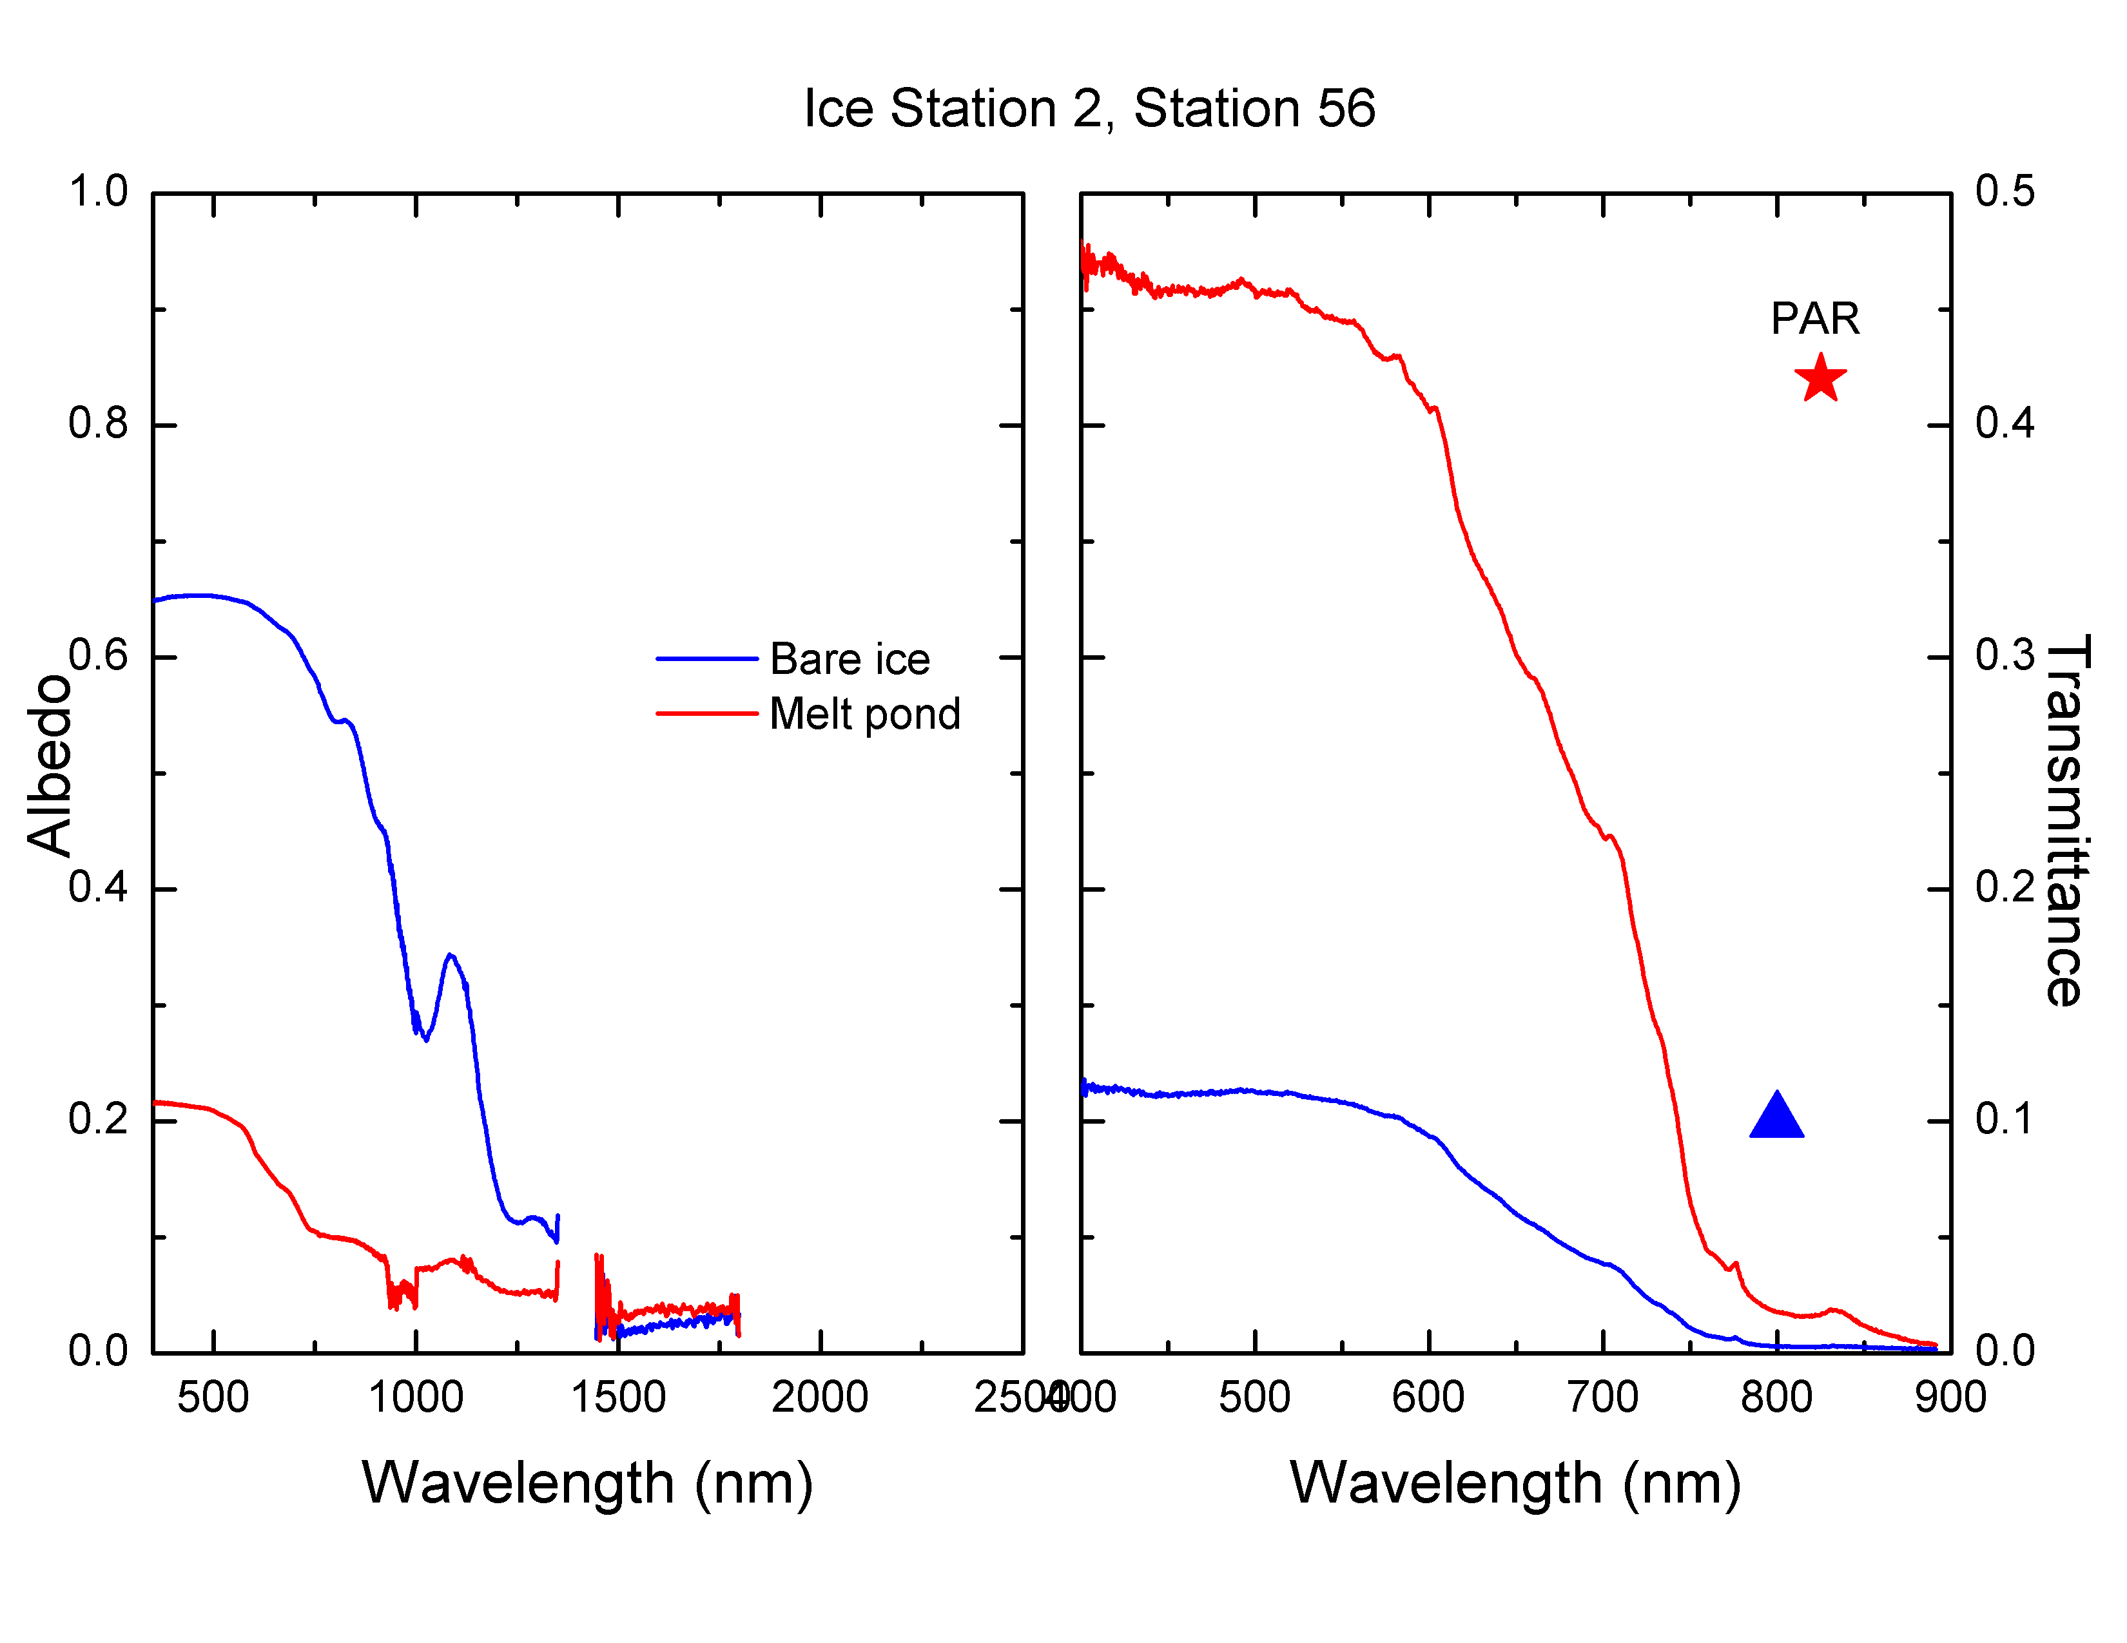

Figure 1. Spectral albedos and transmittances measured for bare ice and ponded ice at Station 56. The symbols denote transmitted PAR.
Phosphorus Dynamics and Particle export

Claudia Benitez-Nelson
University of South Carolina

Group members:
Sharmila Pal
Melissa Bennett

Particle export
Our goal is to quantify the vertical export of particulate carbon in the Chukchi Sea and establish a mass balance model.
We collected samples for total ²³⁴Th at all of the full stations. Total ²³⁴Th samples were collected and processed according to the MnO₂ co-precipitation technique (Benitez-Nelson et al. 2001, Pike et al. 2005). Briefly, 4 L seawater samples were collected from each depth using 30 L Niskin bottles. The samples were immediately acidified to a pH of ~2 with concentrated HNO₃, and spiked with ²³⁰Th, which acted as a yield monitor to trace precipitation efficiency. After equilibration for twelve hours, samples were treated with concentrated NH₄OH to increase the pH to ~8, followed by the addition of KMnO₄ and MnCl₂ to form the MnO2 precipitate. The MnO₂ precipitate preferentially scavenges on the ²³⁴Th, leaving the parent ²³⁸U in solution. After 8-12 hours, the precipitate was filtered onto a 0.7 µm 25 mm quartz (QMA) filter. The QMA filters were allowed to air dry for several hours, and prepared for beta counting. The samples were directly counted on a five-sample gas flow proportional low-level beta counter (RISO National Laboratories, Roskilde, Denmark) that measured the beta activity of the high energy ²³⁴Th daughter, 234mPa (Emax = 2.3 MeV). A final background count will be obtained after six half-lives (144 days) to correct for background and interfering beta emitters.
After final counting, samples will be prepared for ICP-MS ²³⁰Th tracer recovery analysis (Pike et al. 2005). The MnO₂ precipitate will be dissolved in 8 M HNO₃/10% H₂O₂ solution and an internal standard of ²²⁹Th will be added (Pike et al. 2005 and Buesseler et al. 2001). Samples will be sonicated and allowed to stand overnight, and subsequently purified using anion exchange column chromatography. The eluent will be evaporated to dryness, brought up in 5% HNO₃ / 0.5% HF, and filtered through a 0.2 µm HT Tuffryn membrane syringe filter into 2 ml ICP-MS vials. The isotope ratios of ²³⁰Th to ²²⁹Th will be determined by ICP-MS at Woods Hole Oceanographic Institution.

Particle Samples
We deployed a large volume in-situ McLane Pump to collect sinking particles. Greater than 200 L of sea water were pumped at a rate of 8 L min-1 through a 55 µm 150 mm diameter Nitex screen followed by a 0.7 µm 142 mm QMA. The filter housing in the pump results in an even distribution of filtered material across the QMA filter (Buesseler et al. 1995). Immediately after pump recovery, the Nitex screen was rinsed with 0.2 µm pre-filtered surface seawater onto a 25 mm diameter, 1 μm nominal pore size Ag filter. Losses of particulate C or Th to solution, or retention on screen after gentle rinsing has been documented to be small (Buesseler et al. 1998) and is ignored when assessing ratios of material rinsed off of the screens. The filter was dried, and prepared for beta counting as described previously for total ²³⁴Th. For the 142 mm QMA filters, 20 sub-samples (25 mm diameter punches) were obtained from each filter using a template, and pressed into one filter under a hydraulic press. The pressed filters were then mounted together in one riso cup, and beta counted directly.
Particulate carbon analysis will be done on the “swiss cheese” portion of the 142 mm QMAs (three 8mm replicates) and Ag filters (whole filter) with a Perkin Elmer 2400 Elemental CHN analyzer. From these measurements, the C/²³⁴Th ratio was determined, which can then be used to derive an empirical carbon flux.
In addition to the water column sampling, we also collected 24 bulk surface sediment samples from the Van Veen grab.

Phosphorus and SPM:
Our second project is to understand phosphorus dynamics and speciation in the Chukchi Sea.
We sampled for DOP, TPP and SPM at 95 stations. These measurements were done simultaneously with other core nutrient measurements such as, POC, PON, pigments, Chl a, and DOC.
TPP samples were filtered through a 0.7 µm GFF filter (acid washed, and combusted). We collected the first 30 ml as DOP. We filtered 1-2 L of seawater for each sample. TPP filters were kept frozen until further analysis.
SPM samples were collected by filtering 1-2 L of seawater through a pre-weighed GFF filter. Samples were rinsed thoroughly with DIW and dried at 60°C for one hour.

Bio-optical, Biological and Biogeochemical Measurements of Balch Group

William Balch
Bigelow Laboratory for Ocean Sciences

Group members:
Bruce Bowler (Bigelow)
Laura Lubelczyk (Bigelow)
Michael Stephens (Colby College)

Our measurements during Healy 1101 were centered around the biomineralizing phytoplankton, the coccolithophores and diatoms, both important for ballasting sinking carbon and fueling the biological pump. Our measurements included running a continuous underway system focused on hydrographic and bio-optical properties and measuring discrete water samples for a variety of variables. The Balch group sampled from 101 CTD stations during the cruise, typically taking water from 8 of the 12 Niskin bottles for “full” casts. Of those 8 bottles, 7 were usually from the euphotic zone and one from deeper in the water column. We also sampled the top Niskin bottle of numerous CTD casts for calibration samples for the underway system. All Niskin samples were subsampled for particulate inorganic carbon (CaCO₃ or PIC), biogenic silica (BSi), particulate organic carbon (POC), particulate organic nitrogen (PON), and coccolithophore counts (to be processed ashore using polarized light microscopy. The technique for coccolithophore counts is identical to the Canada Balsam technique for enumeration of calcite particles (Haidar & Thierstein 2001) except we use Norland #74 brand optical adhesive instead of Canada Balsam. The surface and chlorophyll maximum depths were sampled for scanning electron microscope and prepared for analysis ashore. These same depths were sampled for “live” microscopy using the Filter Freeze Transfer technique (Hewes and Holm-Hansen, 1983), with samples filtered on 0.4um polycarbonate filters prior to transfer and then samples examined using an AO-Spencer Model 10 microscope equipped with epifluorescence polarization optics. For the full CTD cast near local apparent noon of each day (the “productivity cast”), we also sampled for calcification and photosynthesis rates. Particulate inorganic carbon was measured on 0.2L seawater samples filtered onto 0.4um pore-size polycarbonate filters, rinsed with potassium tetraborate buffer [Poulton et al., 2006] and biogenic silica was measured by filtering 0.5L seawater onto 45mm 0.4μm polycarbonate filters, stored and measured according to Brzezinski et al. [1989]. For a number of ice cores, we examined for the presence of the calcium carbonate mineral, ikaite (unstable above temperatures of 4ºC). We accomplished this by filtering for PIC in parallel ice-core melt samples either warmed to room temperature or maintained <4ºC. These will be processed ashore.
The Balch lab bio-optical underway system was run continuously over the course of the trip. It was started on 26 June and shut down on 27 July. This system has been described elsewhere (Balch et al. 2008). Basically it measures temperature, salinity, chlorophyll a fluorescence, and backscattering at 531 nm (using a WETLabs ECOVSF sensor aimed into a specially-designed container which minimizes wall reflectance, hence maximizing the light scattering signal associated with marine particulate matter). First, the system measures backscattering of 531 nm light with raw seawater (pH=8.1) running through the system for one minute. After 60 seconds of data collection (or whatever time period was set in order to achieve statistically-significant measurements), the acid controller injected 0.2 µm-filtered, 10% glacial acid into the seawater stream, passing through a mixing coil to thoroughly mix it with the seawater, upstream of the ECOVSF. This reduced the pH to 5.5, below the dissociation point for calcium carbonate. A pH sensor downstream of the sample chamber measured the pH constantly. Once the pH dropped to pH 5.5, the backscattering was re-measured for an equivalent period of time after which the acid additions stopped and the pH re-equilibrated and the entire cycle repeated. The difference in backscattering between raw seawater and acidified seawater represented “acid-labile backscattering” (b_{b}’), which can be directly related to the concentration of suspended calcium carbonate (Balch et al. 1996).
The Balch lab bio-optical underway system had a separate flow loop that passed through a WETLabs ac-9, to measure spectral absorption and attenuation. In the flow path to the ac-9 was a solenoid that diverted the seawater stream through a 1µm filter, then a 0.2 µm filter prior to running the water through the ac-9. Every two minutes, the solenoid would alternate between filtered and unfiltered seawater, thus providing absorption and attenuation (at 9 spectral wavelengths across the visible spectrum) for raw and filtered seawater. In turn, this allows calculation of the absorption and attenuation of total suspended particles and dissolved organic matter. The difference between raw and dissolved ac-9 measurements represented particulate absorption and beam attenuation. Calibrations of the complete underway system were performed approximately weekly over the cruise as well as a final calibration after shut down. These calibrations are used to estimate biofouling corrections during each operation period. The protocol was to run 0.2um filtered RO water from the ship’s Milli-Q system, under pressure, through the entire flow path prior to cleaning (“a dirty calibration” which provides the endpoint for estimating the optical contribution of biofouling). Then the system is carefully disassembled and cleaned, reassembled and a “clean calibration” performed (which represents the beginning calibration for the next operation segment, with no biofouling. Post cruise, the biofouling corrections are interpolated between the initial clean calibration and the following dirty calibration.
Two additional instruments were added to the flow-through system for this cruise, a WETLabs CDOM fluorometer for measuring the fluorescence of colored dissolved organic matter. This was plumbed directly before the chlorophyll fluorometer. Also, a Satlantic SUNA nitrate sensor was plumbed just downstream of the chlorophyll fluorometer. This device estimates the concentration of nitrate from the characteristic peak in UV absorption (Ogura and Hanya 1967).
At the daily “local-apparent-noon” cast, samples were taken for measuring primary production and calcification from the 30L Niskin samples (with Silicone O-rings). Water was sampled from 6 light depths: 38.6%, 21.1%, 11.7%, 3.5%, 1.9% and 0.3%. Estimation of those light depths was performed based on the percent light as measured by the scalar PAR sensor aboard the CTD, scaled to the above-water downwelling PAR irradiance measured from the superstructure of CGC Healy. Given that standard depths were typically sampled (surface, 10m, 25m, 50m, 100m plus the chlorophyll fluorescence maximum), the percent of surface PAR was estimated at each standard depth, then the closest Niskin bottle to each target light depth was chosen for productivity incubation. Often, the water column was only 30-40 m, hence it was common that Niskin bottles were sampled for multiple light intensity incubations. Water samples for incubation were transferred from Niskin bottles to incubation bottles inside the ship’s enclosed hanger. Water samples were pre-filtered through 200 μm nitex mesh to remove large grazers. Incubations were performed in 70 mL polystyrene tissue culture bottles that were previously thoroughly cleaned with 10% HCl, then ethanol, 4 rinses with ship’s distilled water and finally 3 rinses of polished reverse-osmosis water, then rinsed 3x with each sea water sample prior to filling. Photosynthesis and calcification were measured using the microdiffusion technique (Paasche & Brubak 1994) with modifications by Balch et al. (2000) (see also Fabry (2010). ¹⁴C bicarbonate (60-100 μCi) was added for each water sample. Incubations were performed in triplicate (with an additional 2% formalin sample (final concentration) used as a killed control) in simulated in situ conditions on-deck, corrected for both light quantity (extinction using bags made of neutral-density shade cloth) and quality (spectral narrowing) using blue acetate bag inserts. Bottle transfers between the CTD hanger and radioisotope van were always done in a darkened themal cooler to reduce light and temperature shock to the phytoplankton. Deck incubators consisted of a white plastic tub open to sky light, chilled using surface seawater from the ship’s flowing sea water system. The daily PAR was measured using the ship’s PAR sensor set on top of the ship’s meteorological mast. All filtrations were performed using 0.4 μm pore-size polycarbonate filters. Filters and sample “boats” were placed in scintillation vials with 7mL of Ecolume scintillation cocktail. Samples were counted using a Beckman-Coulter LS6500 scintillation counter with channel windows set for ¹⁴C counting with calibration checked with a sealed ¹⁴C standard. Counts were performed for sufficient time to reach 2% precision or 20 minutes for samples with lower counts. Blank ¹⁴C counts were always run for scintillation cocktail as well as the phenethylamine CO₂ absorbent. Standard equations were used for calculating primary production and calcification from the ¹⁴C counts with a 5% isotope discrimination factor assumed for the physiological fixation of ¹⁴C-HCO3 as opposed to ¹²C-HCO₃. Aerial integrations of carbon fixation to the base of the euphotic zone were based on the PAR attenuation measured during the CTD cast. Chlorophyll concentrations used to normalize the calcification and production estimates were kindly processed by the Arrigo group.

Total samples processed
The Balch group sampled all daily productivity casts as well as a full cast daily near the 0300h sampling when possible. Underway samples were also taken at 38 additional locations (when the ship was steaming) to calibrate the along-track system. Nutrient samples were taken at underway stations and run by Susan Becker (SIO chemist) in order to provide calibration for the Satlantic SUNA nitrate sensor attached to the underway system. A summary of the total samples processed is given in Table 1.

Table 1. Station type and number of stations and where variables were measured or sampled during the ICESCAPE 2011 cruise to the Chukchi and Beaufort Sea.
Station Type |  | # | PIC | BSi | CC | CHN | SEM | Calc /PSY | Light Mic | Ikaite
CTD cast |  | 101 | 275 | 275 | 275 | 275 | 72 | 26 | 50
Underway calibration |  | 38 | 38 | 38 | 38 | 38 | 38 |  | 2
Ice cores |  | 9 | 9 | 2 | 2 |  |  |  | 4 | 9
Under Ice water samples |  | 9 | 63 | 63 | 63 |  |  |  | 14
Sediment from VanVeen grab |  |  |  |  |  |  |  |  | 13
Abbreviations: CHN- particulate organic carbon and nitrogen; PIC- particulate inorganic carbon; BSi- biogenic silica; CC- Coccolith counts; SEM- Scanning Electron Microscopy; Calc/PSY- simulated in-situ calcification/photosynthesis measurements; Light Mic- Light microscopy using FFT technique

Preliminary Results
Overall, the coccolithophore populations were more important to the south, in the Bering Sea than in the Arctic. This was made more obvious when we ran across a concentrated coccolithophore bloom, 50km across, at 60.5°N x 168.5°W (Fig. 1; Fig. 3G-I). As we worked our way further north, the abundance of coccolithophores decreased to low, but measurable, concentrations. While ¹⁴C calcification rates were generally on the low side, we were impressed to find easily measurable calcification rates at the Chukchi hot spot ice stations, well under the ice sheet. As calcification rates go, they were high at the hot-spot (integrated calcification rates of almost 10 mg C m⁻² d⁻¹), but not when compared to the enormous integrated primary production rates at the hotspot stations (~3 g C m⁻² d⁻¹) (Fig. 2). Thus, calcification represented ~ 0.4% of the total primary production. In more equator-ward latitudes, calcification typically represents 2-5% of the total carbon fixation in non-bloom situations and 50% or higher in blooms. The mere fact that there were populations able to calcify, 100 km into the ice sheet, under a meter of ice, is remarkable.
The surface underway system showed the aerial extent of the cold, low salinity water of the Chukchi and Beaufort Sea (Fig. 1). Surface salinities at the Chukchi hotspot were notably saltier, suggesting the influence of deeper, nutrient rich water there that might be fueling this impressive hotspot feature. The surface chlorophyll fluorescence values spanned an impressive four orders of magnitude during the cruise. Highest values were observed at the Hotspot (77°N), the warm, saline waters of Kotzebue Sound (67°N), and in the Bering Sea (56°N). Ultraclear waters, with low chlorophyll concentrations were seen in the Beaufort Sea, under the ice. CDOM fluorescence was highest off of Kotzebue Sound (only measured on the return portion of the trip due to instrument difficulties on the early part of the trip on our way north). CDOM fluorescence was also high at the hotspot (likely generated by the enormous algal release there) and off the Coalville River (Fig. 1). Acid-labile backscattering from PIC was spotty and typically of low concentration but but it was clearly measurable in the Bering Sea (61ºN), Kotzebue Sound and at the Chukchi hotspot.
We brought along a compound microscope on ICESCAPE 2011 equipped with polarization optics and epifluorescence and used the Filter Freeze Transfer Technique (Hewes and Holm-Hansen, 1983; see above) to concentrate particle assemblages for photomicrography. Because manual microscope counts are laborious they could only be performed on two samples per productivity station. But the FFT technique allows one to document the abundant larger organisms with large spines, large Cosinodiscus cells, 100-200 micrometer chains of diatoms, too large to pass through most optical imagers). Photomicrographs were taken, usually in quadruplet, one in bright field, one using cross-polarized illumination (to visualize birefringent coccoliths as well as other birefringent particles), blue (480 nm) excitation for chlorophyll fluorescence and green (550 nm) excitation for accessory pigments and phycobiliprotiens. The latter illumination required time exposures, not trivial on a moving ship or while breaking ice!).
The results showed a rich diatom assemblage at the Chukchi hotspot (Fig. 3A-C) with few plated coccolithophores. Dinoflagellates were an important part of the plankton assemblage throughout the ICESCAPE 2011 stations. At most of the ice stations, the dinoflagellate Polarella glacialis (only recently described as extant in Antarctic and Arctic ice (Montresor et al., 1999; 2003) was found in relatively high abundance. They appeared to dominate the algal biomass in many ice core samples during ICESCAPE 2011, and in one station altered the optical properties of the ice, given the presence of their significant MAAs, with strong absorption in the UV (see work of Kristie Wood and Karen Frey). Along with the abundant diatom assemblages, the coccolithophore bloom in the Bering Sea appeared to be dominated by a Gephyracapsa species, based on the birefringence pattern of the coccoliths, some of which had a central “bridge” element (Fig. 3H). Populations were well plated. Emiliania huxleyi appeared to be present in other more northerly samples, and this will be confirmed with SEM analysis. These high-resolution, 3-5 MByte images also were handy for emailing to taxonomists for positive identification during the cruise and they will represent a taxonomic resource for identification of other important species as ICESCAPE 2011 results are worked up in the future. Quantitative counts of coccolithophorids will be performed at Bigelow Laboratory using our automated birefringence microscopy and image analysis protocols.

Data archival
The data collected from this voyage will be archived with the NASA SEABASS data respository once all samples are processed.

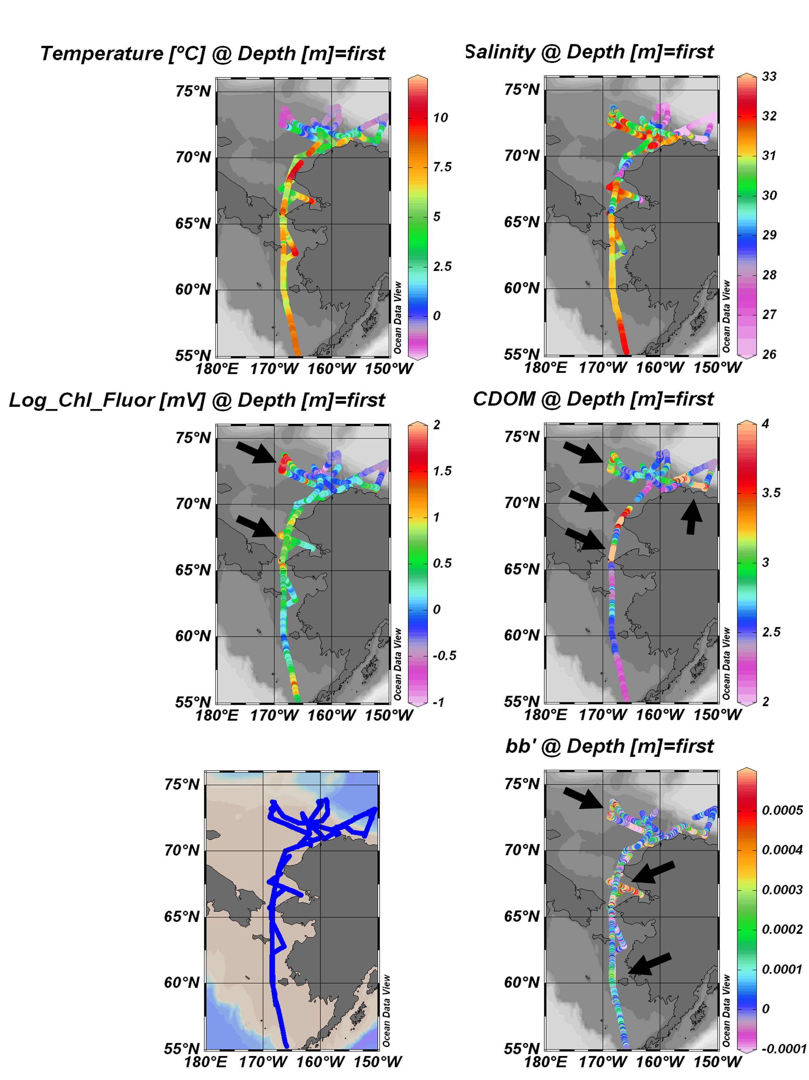

Fig. 1- Ocean Data View plots for ICESCAPE 2011 showing surface temperature (ºC), salinity (PSU), chlorophyll fluorescence (mV), CDOM fluorescence (mV), and acid-labile backscattering (b_{b}’; m⁻¹). Arrows point to features described in text. Ship track shown on lower left.

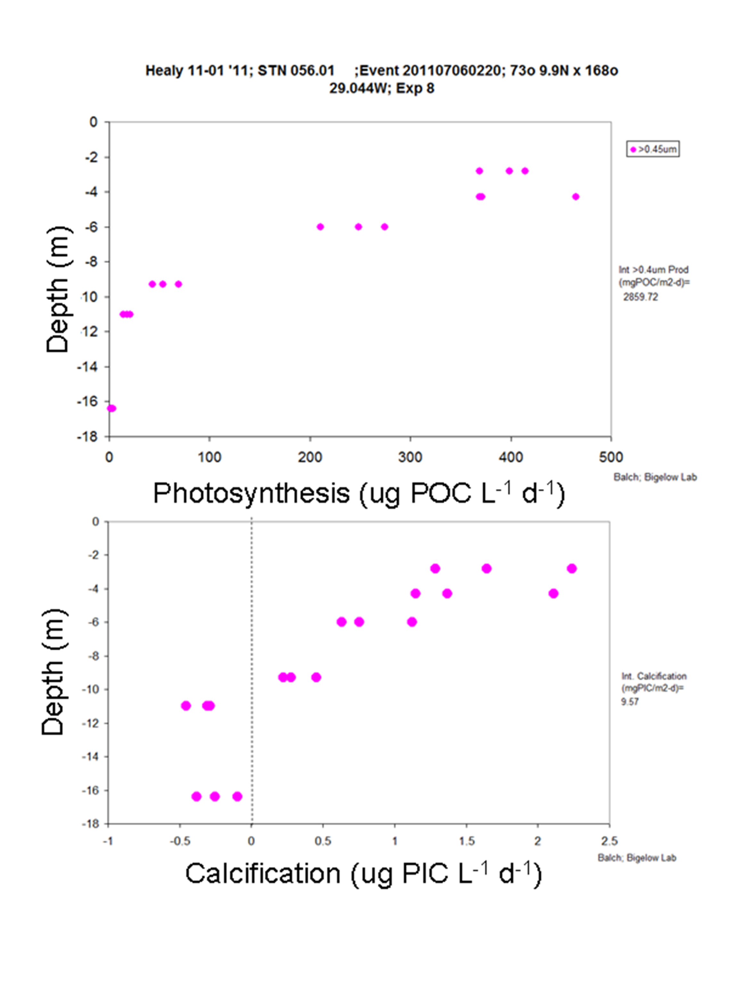
Fig. 2- Vertical profiles of simulated in situ photosynthesis (top) and calcification (bottom) at the Chukchi hotspot station (station 56.01). Measurements made using the microdiffusion technique (see text). Integrated values are given at right of plots. Calcification estimates done in triplicate. Negative calcification values represent samples with calcification not significantly different from zero based on formalin blanks at each depth.

Fig. 3- Examples of photomicrographs made at productivity stations and underway samples. All images here shot with a Canon EOS Ti Rebel camera (plus a 2X magnification lens in the camera port. Images A-C are from station 056.01, 1.5 m. 200X magnification. For size reference, images are 375 µm tall x 575 µm wide. Images D-F are taken from 61-70 cm within an ice core at station 127. 400X magnification. For size reference, images are 187 µm tall x 281 µm wide. Images G-I are taken from underway sample AF at 61°N (depth 7m) during transit south at end of cruise. 400X magnification. Right-most pictures used bright field illumination exposure times typically >1/50 sec. Panels B and H used polarized illumination to highlight any PIC in the water (seen as bright spots against a dark background). These used time exposures of 1-2 seconds. Panels C, E, and I used blue excitation and panel F used green excitation (with time exposures of 1.3 seconds).

References
Balch W, Poulton A, Drapeau D, Bowler B, Windecker L, Booth E (2011) Zonal and meridional patterns of phytoplankton biomass and carbon fixation in the Equatorial Pacific Ocean, between 110ºW and 140ºW. Deep -Sea Research II 58:400-416
Balch WM, Drapeau D, Fritz J (2000) Monsoonal forcing of calcification in the Arabian Sea. Deep-Sea Research II 47:1301-1337
Balch WM, Drapeau DT, Bowler BC, Booth ES, Windecker LA, Ashe A (2008) Space-time variability of carbon standing stocks and fixation rates in the Gulf of Maine, along the GNATS transect between Portland, ME and Yarmouth, NS. Journal of Plankton Research 30:119-139
Balch WM, Kilpatrick K, Holligan PM, Harbour D, Fernandez E (1996) The 1991 coccolithophore bloom in the central north Atlantic. II. Relating optics to coccolith concentration. Limnology and Oceanography 41:1684-1696
Brzezinski, M.A., and D.M. Nelson (1989), Seasonal changes in the silicon cycle within a Gulf Stream warm-core ring, Deep -Sea Research I, 36, 1009-1030.
Fabry VJ, Balch WM (2010) Direct measurements of calcification rates in planktonic organisms. In: Riebeseil U, Fabry VJ, Hansson L, Gattuso J-P (eds) Guide to Best Practices in Ocean Acidification Research and Data Reporting. European Project on Ocean Acidification (EPOCA), Bremerhaven, Germany, p 185-196
Haidar AT, Thierstein HR (2001) Coccolithophore dynamics off Bermuda (N. Atlantic). Deep Sea Research 48:1925-1956
Hewes CD, Holm-Hansen O (1983) A method for recovering nanoplankton from filters for identification with the microscope: The filter-transfer-freeze (FTF) technique. Limnology and Oceanography 28:389-394
JGOFS (1996) Protocols for the Joint Global Ocean Flux Study (JGOFS) core measurements. Report No. Report no. 19 of the Joint Global Ocean Flux Study, Scientific Committee on Oceanic Research, International Council of Scientific Unions, Intergovernmental Oceanographic Commission, Bergen, Norway
Landry MR, Hassett RP (1982) Estimating the grazing impact of marine micro-zooplankton. Marine Biology 67:283-288
Montresor, M., G. Procaccini, et al. (1999). "Polarella glacialis, Gen. Nov., Sp. Nov. (Dinophyceae) suessiaceae are still alive!" Journal of Phycology 35: 186–197.
Montresor, M., C. Lovejoy, et al. (2003). "Bipolar distribution of the cyst-forming dinoflagellate Polarella glacialis." Polar Biology 26: 186–194.
Mueller JL, Austin RW, Morel A, Fargion GS, McClain CR (2003a) Ocean optics protocols for satellite ocean color sensor validation, Revision 4, Volume I: Introduction, background, and conventions, Goddard Space Flight Center, Greenbelt, MD
Mueller JL, Morel A, Frouin R, Davis C, Arnone R, Carder K, Lee ZP, Steward RG, Hooker SB, Mobley CD, McLean S, Holben B, Miller M, Pietras C, Knobelspiesse KD, Fargion GS, Porter J, Voss K (2003b) Ocean optics protocols for satellite ocean color sensor validation, Revision 4, Volume III: Radiometric measurements and data analysis protocols, Goddard Space Flight Center, Greenbelt, MD
Mueller JL, Pietras C, Hooker SB, Austin RW, Miller M, Knobelspiesse KD, Frouin R, Holben B, Voss K (2003c) Ocean optics protocols for satellite ocean color sensor validation, Revision 4, Volume II: Instrument specifications, characterization,and calibration. Goddard Space Flight Center, Greenbelt, MD
Ogura, N. and T. Hanya (1967). "UV absorption of the seawater in relation to organic and inorganic matter." International Journal of Oceanology and Limnology 1(2): 91-102.
Paasche E, Brubak S (1994) Enhanced calcification in the coccolithophorid Emiliania huxleyi (Haptophyceae) under phosphorus limitation. Phycologia 33:324-330
Poulton, A.J., R. Sanders, P.M. Holligan, T. Adey, M. Stinchcombe, L. Brown, and K. Chamberlain (2006), Phytoplankton mineralisation in the tropical and subtropical Atlantic Ocean, Global Biogeochemical Cycles, 20 (GB4002), doi:10.1029/2006GB002712.
Sieracki CK, Sieracki ME, Yentsch CS (1998) An imaging-in-flow system for automated analysis of marine microplankton. Marine Ecology Progress Series 168:285-296

ICESCAPE – Clark University

Karen Frey
Clark University

Group Members:
Christie Wood (Clark)
David Mayer (Clark)
Holly Kelly (U Md)

Onboard HLY1101, we collected samples under six major categories: (a) Oxygen isotope samples from CTD waters; (b) DOC and DON samples from CTD waters; (c) Sediment samples from Van Veen grabs; (d) Multiple parameters at each of the 9 ice stations; (e) Waters for photo-oxidation experiments; (f) Sea ice observations from the ship’s bridge. See the Perovich end-of-cruise report for further details re the sea ice bridge observations. More detail about categories (a) through (e) can be found below:

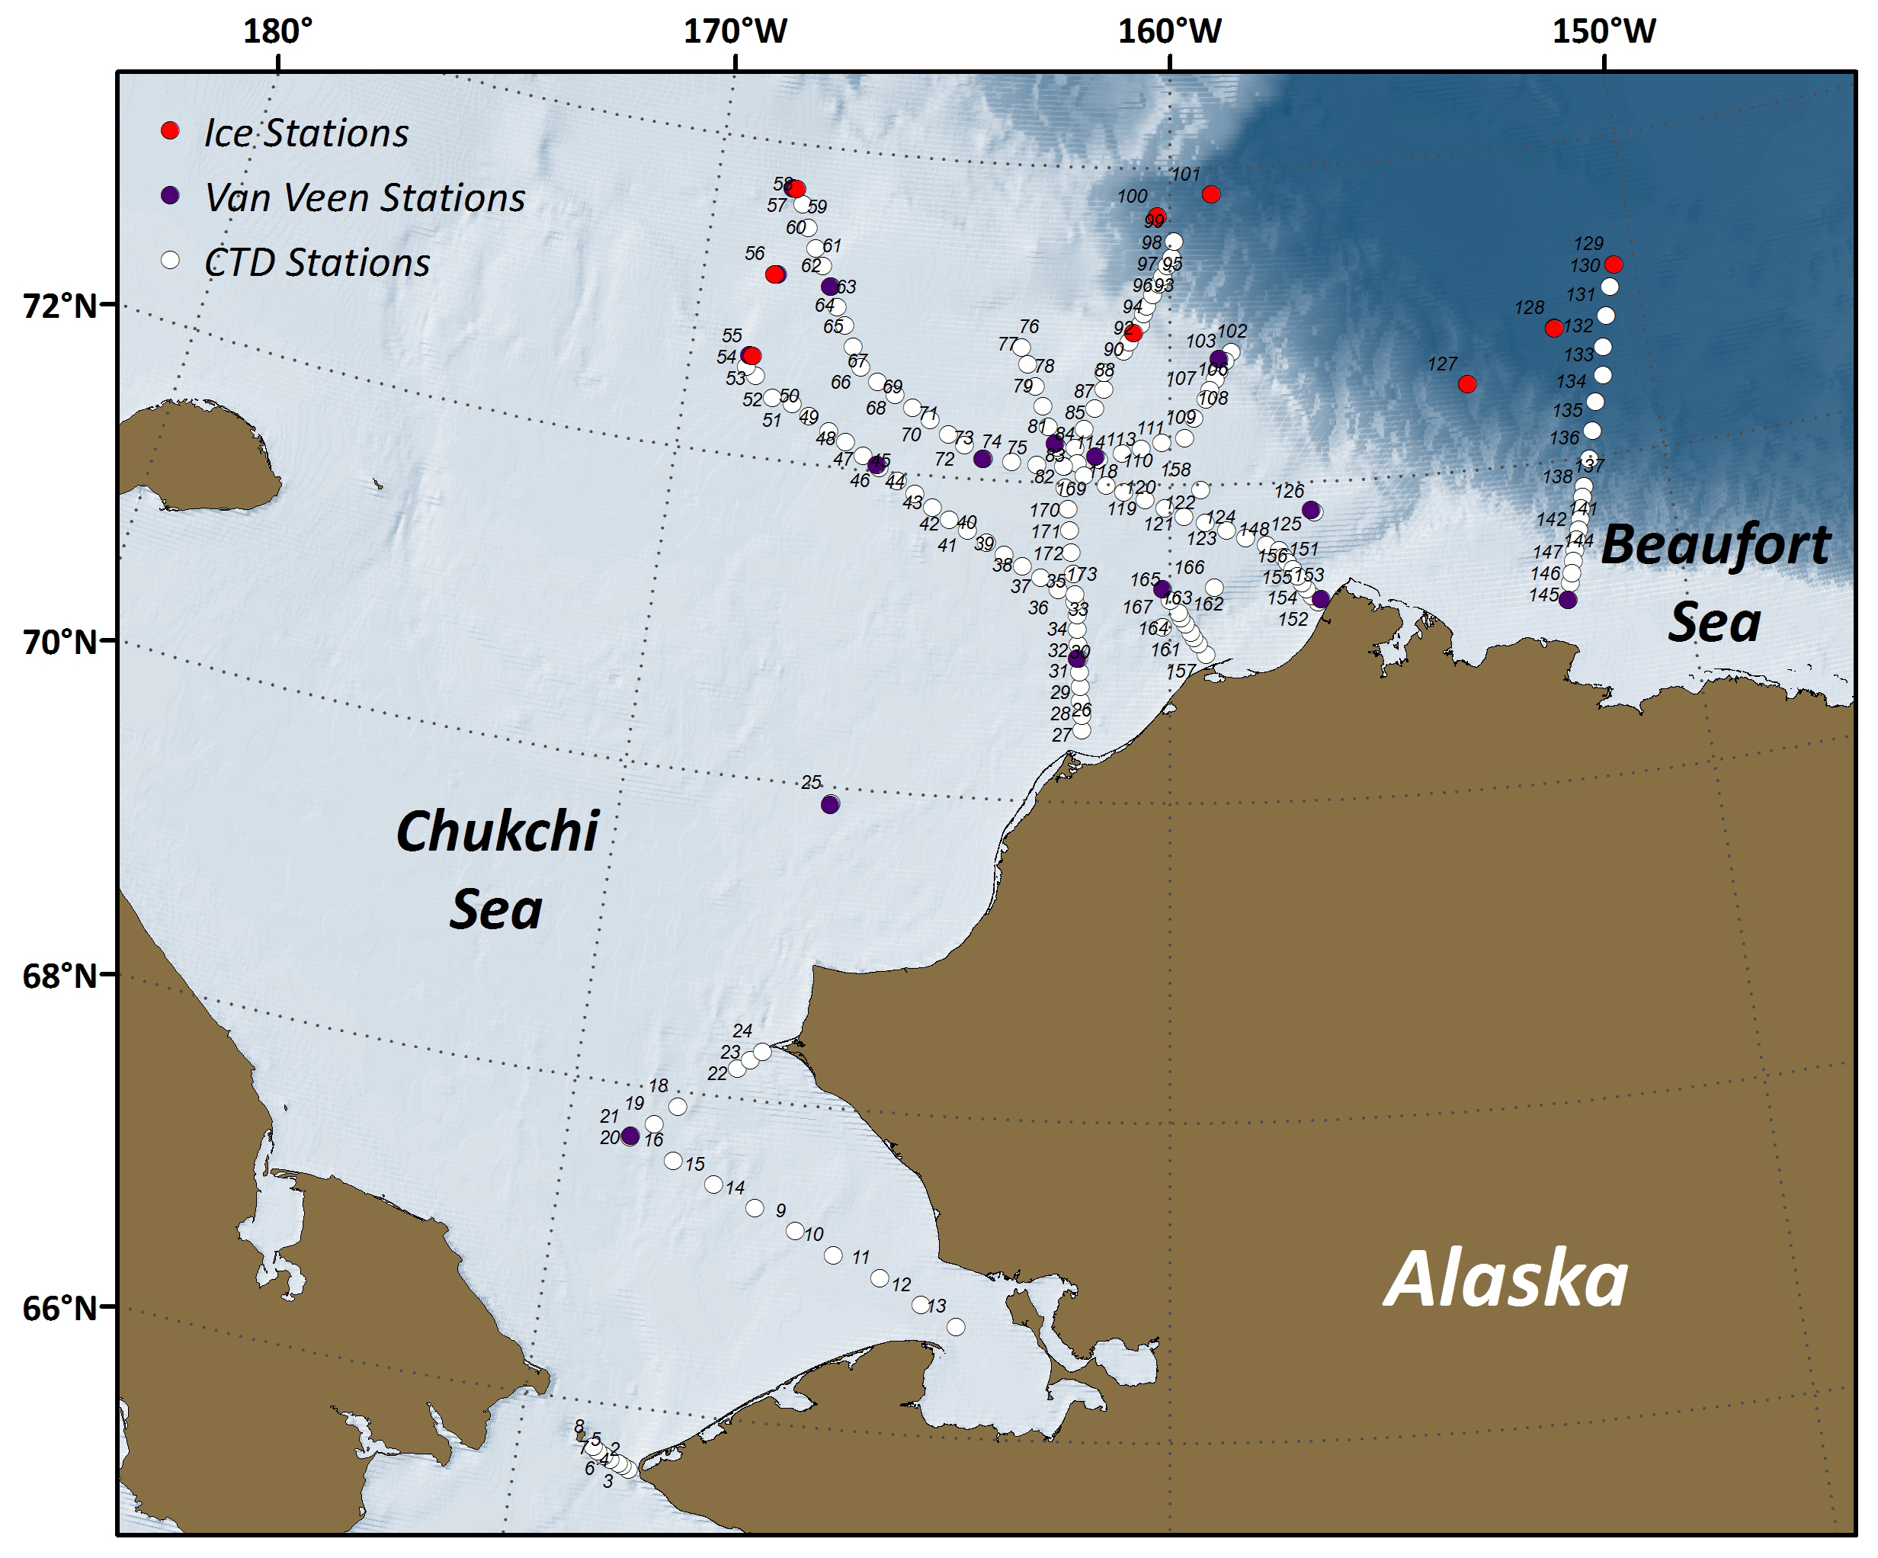
Figure 1. Locations of hydrographic (white), sea ice, and Van Veen grab stations.
- Stable Oxygen Isotope Ratios (δ¹⁸O)
Samples for oxygen isotope measurements were collected without headspace in 20 mL scintillation vials from every level at each of the 173 stations. In total, 898 samples were collected and subsequently stored in the dark in the main lab refrigerator. Samples will be taken back to the University of Maryland Center for Environmental Science for analyses on a stable isotope mass spectrometer. See Figure 1 for sample locations.

- Dissolved Organic Carbon (DOC) and Dissolved Organic Nitrogen (DON) Samples
Samples for DOC and DON were collected in 60mL bottles from every level at 107 of the stations (coinciding with each of the “non-chlorophyll only” stations). In total, 585 samples were collected and will be subsequently analyzed for DOC and TDN (through which DON will be derived by exclusion of the inorganic N nutrient species). Measurements will be performed on a Shimadzu TOC/N Analyzer.

- Sediment Samples
Sediment samples from the undisturbed top layer of a Van Veen grab were collected at full stations only when bottom depths were ≤200m (16 stations total, see table and figure for locations). Triplicate samples for sediment chlorophyll (1 cm³) (Frey group), samples for C-content/isotopes (Frey group), samples for Th-234 (3 cm³) (Pal/Benitez-Nelson group), samples for microscope analysis (Balch group), and samples for imaging analyses (Laney/Brownlee group) were collected at each site. Sediment chlorophyll concentrations were determined shipboard on a Turner Designs fluorometer, while C-content and C-isotopes will be determined once samples are shipped to home institutions.

Sediment Sampling Sites
Station No. | Date (ADT) | Latitude | Longitude | Depth (m)
20 | 6/30/2011 | 67.6825 | -168.9531 | 50
25 | 7/1/2011 | 69.8904 | -166.1989 | 46
31 | 7/2/2011 | 70.9030 | -161.7649 | 43
46 | 7/3/2011 | 72.0422 | -165.9260 | 47
55 | 7/5/2011 | 72.6364 | -168.7810 | 60
56 | 7/6/2011 | 73.1641 | -168.4261 | 68
57 | 7/7/2011 | 73.7187 | -168.3386 | 150
62 | 7/7/2011 | 73.1319 | -167.2754 | 65
73 | 7/8/2011 | 72.1325 | -163.8076 | 39
81 | 7/9/2011 | 72.2506 | -162.3430 | 38
103 | 7/14/2011 | 72.7932 | -158.9762 | 220
113 | 7/15/2011 | 72.1725 | -161.5142 | 33
126 | 7/16/2011 | 71.8232 | -157.1682 | 66
145 | 7/21/2011 | 71.1280 | -152.2940 | 27
152 | 7/22/2011 | 71.2605 | -157.0615 | 41
162 | 7/23/2011 | 71.3464 | -160.1373 | 47

- Ice Station Data and Samples
A total of 9 ice stations were visited over the course of HLY1101. A number of samples and datasets were collected at each of the sites, to include: (i) Under-ice water column and melt pond measurements; (ii) Under-ice water column handheld CTD profiles; (iii) Ice core measurements; and (iv) Under-ice optical measurements. In addition, our group contributed to under-way sea ice observations from the bridge (see Perovich end-of-cruise report for more details). See table below and figure for ice station locations and associated details:

Ice Station Sampling Sites
Station No. | Date (ADT) | Latitude | Longitude | Under-Ice & Melt Pond Waters | Ice Cores  (1 bare ice, 1 melt pond core), 10 cm sections | Optical Profiles (50m)
55-ice | 7/4/2011 | 72.6323 | -168.7245 | δ¹⁸O, Alkalinity/DIC, CDOM/FDOM/DOC/DON, Salinity, Nutrients, SPM, Chl-a | δ¹⁸O, CDOM/FDOM/DOC/DON, Salinity, Nutrients, SPM  (1 bare ice/1 melt pond core) | Bare Ice & Melt Pond Optics
56-ice | 7/5/2011 | 73.1650 | -168.4857 | δ¹⁸O, Alkalinity/DIC, CDOM/FDOM/DOC/DON, Salinity, Nutrients, SPM, Chl-a | δ¹⁸O, CDOM/FDOM/DOC/DON, Salinity, Nutrients, SPM  (1 bare ice/1 melt pond core) | Bare Ice & Melt Pond Optics
57-ice | 7/6/2011 | 73.7170 | -168.2638 | δ¹⁸O, Alkalinity/DIC, CDOM/FDOM/DOC/DON, Salinity, Nutrients, SPM, Chl-a | δ¹⁸O, CDOM/FDOM/DOC/DON, Salinity, Nutrients, SPM  (1 bare ice/1 melt pond core) | Bare Ice & Melt Pond Optics
90-ice | 7/10/2011 | 72.9577 | -160.7658 | δ¹⁸O, Alkalinity/DIC, CDOM/FDOM/DOC/DON, Salinity, Nutrients, SPM, Chl-a | δ¹⁸O, CDOM/FDOM/DOC/DON, Salinity, Nutrients, SPM  (1 bare ice/1 melt pond core) | Bare Ice & Melt Pond Optics
100-ice | 7/12/2011 | 73.6970 | -160.2805 | δ¹⁸O, Alkalinity/DIC, CDOM/FDOM/DOC/DON, Salinity, Nutrients, SPM, Chl-a | δ¹⁸O, CDOM/FDOM/DOC/DON, Salinity, Nutrients, SPM  (1 bare ice/1 melt pond core) | Bare Ice & Melt Pond Optics
101-ice | 7/13/2011 | 73.8340 | -159.0743 | δ¹⁸O, Alkalinity/DIC, CDOM/FDOM/DOC/DON, Salinity, Nutrients, SPM, Chl-a | δ¹⁸O, CDOM/FDOM/DOC/DON, Salinity, Nutrients, SPM  (1 bare ice/1 melt pond core) | Bare Ice & Melt Pond Optics
127-ice | 7/17/2011 | 72.5453 | -153.8180 | δ¹⁸O, Alkalinity/DIC, CDOM/FDOM/DOC/DON, Salinity, Nutrients, SPM, Chl-a | δ¹⁸O, CDOM/FDOM/DOC/DON, Salinity, Nutrients, SPM  (1 bare ice/1 melt pond core) | Bare Ice & Melt Pond Optics
128-ice | 7/18/2011 | 72.8352 | -151.8915 | δ¹⁸O, Alkalinity/DIC, CDOM/FDOM/DOC/DON, Salinity, Nutrients, SPM, Chl-a | δ¹⁸O, CDOM/FDOM/DOC/DON, Salinity, Nutrients, SPM  (1 bare ice/1 melt pond core) | Bare Ice & Melt Pond Optics
129-ice | 7/19/2011 | 73.1825 | -150.4450 | δ¹⁸O, Alkalinity/DIC, CDOM/FDOM/DOC/DON, Salinity, Nutrients, SPM, Chl-a | δ¹⁸O, CDOM/FDOM/DOC/DON, Salinity, Nutrients, SPM  (1 bare ice/1 melt pond core) | Bare Ice & Melt Pond Optics

  - Under-ice water column and melt pond measurements:
At each ice station, waters were collected at six depths: 0m (ice-water interface), 1m, 5m, 10m, 20m, and 30m. Additional waters were collected from a representative melt pond at each ice station. These waters were analyzed for CDOM, alkalinity, nutrients, chlorophyll-a, SPM, and salinity shipboard, while δ¹⁸O, DOC, DON, POM, and FDOM will be determined once samples are shipped to our home institution. In addition, 9 interface/0m waters were filtered and frozen for subsequent photo-oxidation experiments once samples are shipped to our home institution (also see section (e)). A total of 65 under-ice and melt pond samples were generated for the above analyses.

  - Under-ice water column handheld CTD profiles:
Under-ice water column CTD profiles were collected at each of the 9 ice stations. The CTD includes channels for temperature, salinity, fluorescence, and PAR. At minimum, four profiles were generated per station: (a) through the water sampling ice hole at the beginning of the ice station; (b) through a bare ice optics hole site; (c) through a melt pond optics hole site; and (d) through the water sampling ice hole at the end of the ice station (to provide some temporal context). Additionally, shallow (~10 m) transects of CTD casts were made at ice stations 127 and 129 over ~100 m and coordinated with Polashenski’s ice thickness transects.

  - Ice core samples and measurements:
Upon extraction of ice cores, photos were taken and temperatures were measured at 10 cm intervals (thanks to the Arrigo group). Ice core subsec tions (10cm) were then thawed at 4°C in a climate controlled chamber (typically ~24 hours). Upon completion of thawing, waters were filtered for CDOM, FDOM, DOC, and DON (0.2 μm) as well as SPM, POM (0.7 μm), and also collected for salinity, nutrients, and δ¹⁸O. CDOM, nutrients, and salinity were determined shipboard, whereas DOC, DON, FDOM, and δ¹⁸O will be determined once samples are shipped to our home institution. Both a bare ice and melt pond ice core were extracted for all the analyses above. A total of 9 bare ice and 9 melt pond cores were sampled for the constituents above (a total of 172 segments, each 10 cm in length).

  - Under-ice optical measurements:
At the 9 ice stations, optical measurements were collected from four instruments simultaneously. This system is a modified C-OPS system for under-ice optics, coined by BSI as “Ice-Pro” and “Ice-Pod”. The QCP under-ice reference and Ed0 surface reference are attached to a tripod and static, while the EdZ and LuZ instruments profile the under-ice water column. The four instruments collect data at the following wavelengths:

QCP (Under-Ice Reference): PAR only

Ed0 (Surface Reference): 320, 340, 380, 395, 412, 443, 465, 490, 510, 532, 555, 560, 625, 665, 670, 683, 710, 780, PAR

EdZ (Downwelling Profiler): 320, 340, 380, 395, 412, 443, 465, 490, 510, 532, 555, 560, 625, 665, 670, 683, 710, 780, PAR

LuZ (Upwelling Profiler): 320, 340, 380, 395, 412, 443, 465, 490, 510, 532, 555, 560, 625, 665, 670, 683, 710, 780, Natural Fluorescence

At each ice station, two 10” auger holes were drilled for measurements (one for the Icepod set-up and one for the IcePro deployment). A minimum of three profiles (~50m deep) per site were collected. At most sites, one bare ice site and one melt pond site were established (see above table for more detail). For more details of the Icepro/Icepod architecture, see photo below.

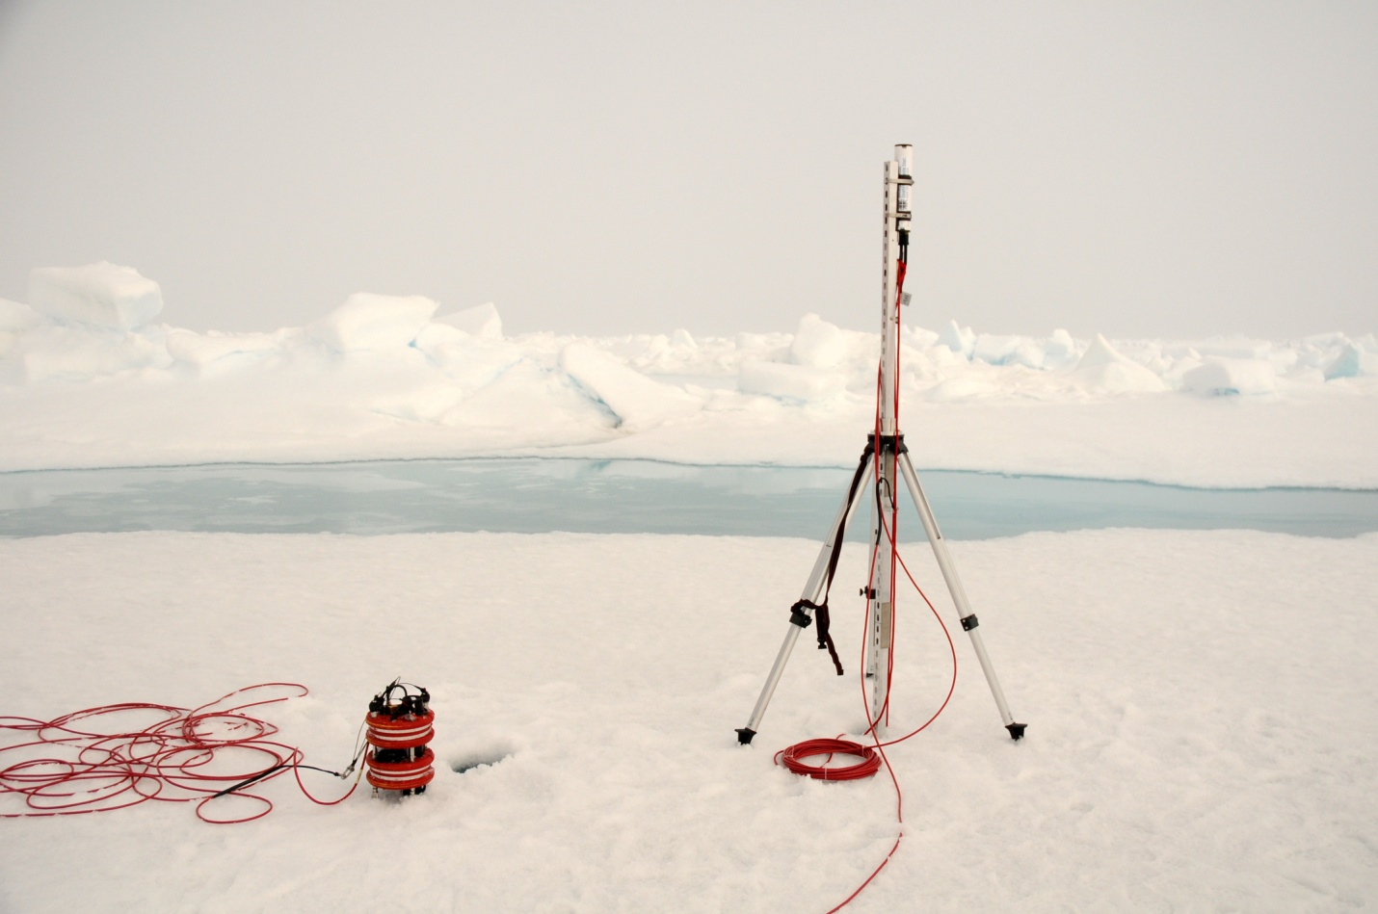
Ed0
QCP
ICEPOD
ICEPRO
EdZ
LuZ

- Waters for Photo-oxidation Experiments:
Waters were collected and filtered (0.2 mm) at a total of 21 stations (4 L per station) for subsequent photo-oxidation experiments that will utilize a photo-simulator in a controlled lab setting. These stations include interface waters at each of the 9 ice stations, surface waters at stations 2, 8, 9, 13, 20, 48, 81, 135, 145, and 152 as well as deep (~2169.3 m) water at station 137.

