SeaDAS Software Installation Instruction

SeaDAS Homepage: https://seadas.gsfc.nasa.gov/

Installation instructions: https://github.com/seadas/seadas-toolbox/wiki/SeaDAS-8.x-Download,-Installation-and-Run-Instructions

SeaDAS can be installed on Windows, MacOS and Linux. The Windows version is a bit limited since it does not include the OceanColor processing components. This should be ok for most students, unless you want to develop your own algorithm or do binning and/or mapping with certain files for your project.

These instructions were originally written for a previous version of SeaDAS. They should work for the most recent version of SeaDAS as well (v8.4.1).

If you get stuck somewhere in the install-process don’t hesitate to email me at gertvd@stanford.edu, a screenshot will be helpful to troubleshoot.

The SeaDAS installer files can be downloaded from https://seadas.gsfc.nasa.gov/downloads/

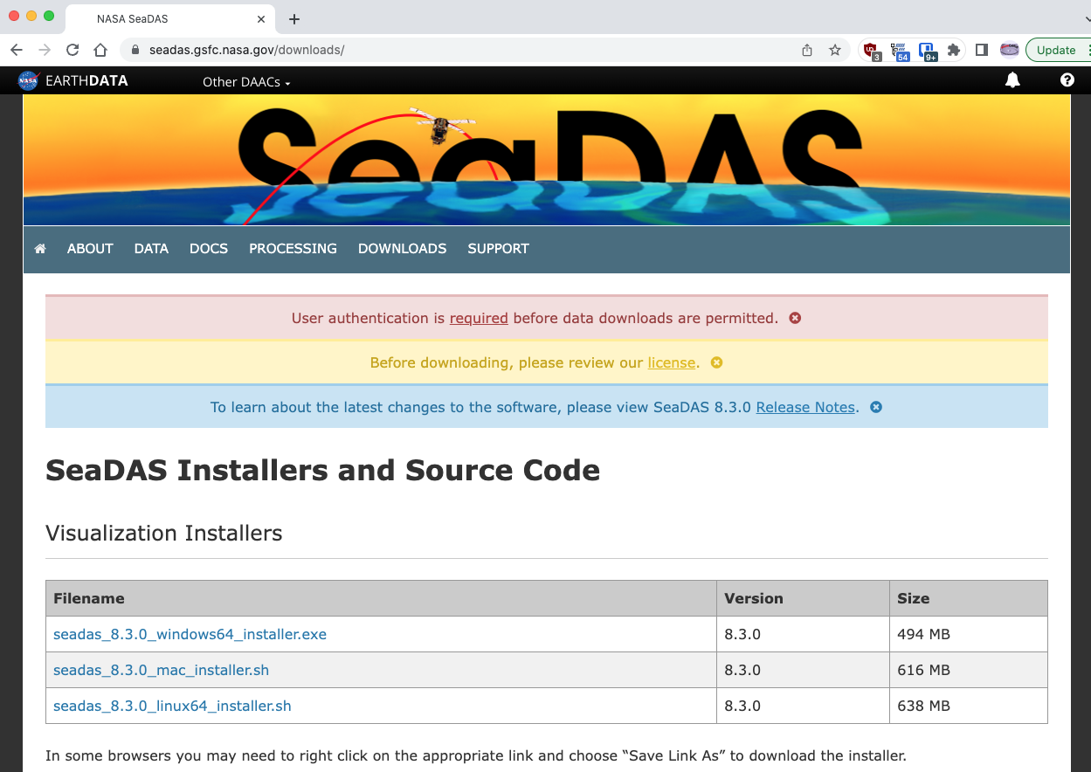

Install on MacOS:

The software needs about 7Gb of disk space. It is a two-step process. (1) install the SeaDAS software package, (2) install the SeaDAS processors

Step 1 – Install SeaDAS software package:
- Download the installer file named: seadas_8.4.1_mac_installer.sh from https://seadas.gsfc.nasa.gov/downloads/ (see screenshot above).

- The installer is a shell script (so don’t click on it). It has to be executed in a terminal window. To open Terminal, use the Command-SpaceBar key combination to open Spotlight Search, and start typing Terminal. Press return when you see Terminal.app or double click on the black thumbnail.

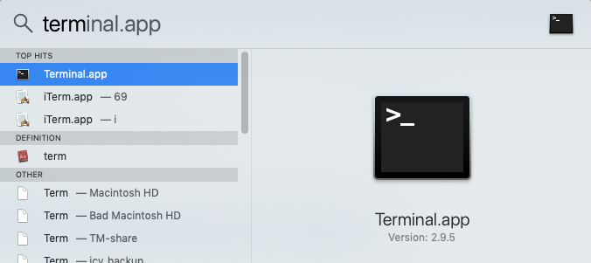

- Navigate to the Downloads folder by typing cd Downloads and run the installer by typing: sh seadas_8.4.1_mac_installer.sh
See screenshot below (typed portion in red box), other lines information after starting the installer.
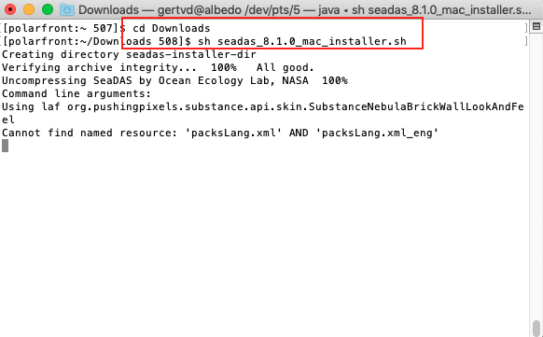

If it complains about not finding java or not able to execute java, make sure that you have downloaded the ‘mac’ installer and not the ‘linux64’ installer. Otherwise check if you have java installed by typing: java -version in the terminal window. If it can’t find java, you have to install java. See for example: https://www.andrewhoog.com/post/3-ways-to-install-java-on-macos-2023/ (I recommend the ‘brew’ method). Once installed, check java -version again, and if all ok, run the seadas installer again.

- After the SeaDAS Installer opens, follow the prompts: New Installation, Accept the license terms, select installation path (keep as is, or change it to something like: /Users/yourusername/seadas-8.4.1, or /Users/yourusername/Applications/seadas-8.4.1, or /Applications/seadas-8.4.1)

- Install OCSSW Data Processors from within SeaDAS. Start the SeaDAS software from Terminal. The seadas.app is located in the bin folder of your installation path (see 4), so type in Terminal ~/SeaDAS/bin/seadas if your installation path was /Users/yourusername/SeaDAS (~ = /Users/yourusername). You can also do a Spotlight search for seadas and open it that way (easier). Once you see the SeaDAS icon in the Dock you can right click on it, select Options -> Keep in dock, so you can open it the easy way next time.

Step 2 – Install SeaDAS Processors:

- On the SeaDAS downloads page it states additional requirements for Mac with Apple silicon or ARM64 (M1, M2, … chips). Follow instructions on how to install gcc12, jpeg-turbo and XQuartz.
- Back to SeaDAS: Select under the SeaDAS-Toolbox Menu Item: Install/Update OC Processors:

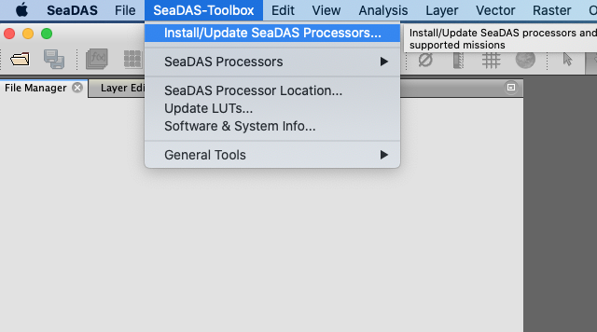

- Select under OCSSW Tag the latest tag (different from screenshot below). Select under Mission Data only ‘aqua’ and ‘seawifs’ for now (these are the only ones needed for the labs) and click on Run. Be patient, this will take awhile.

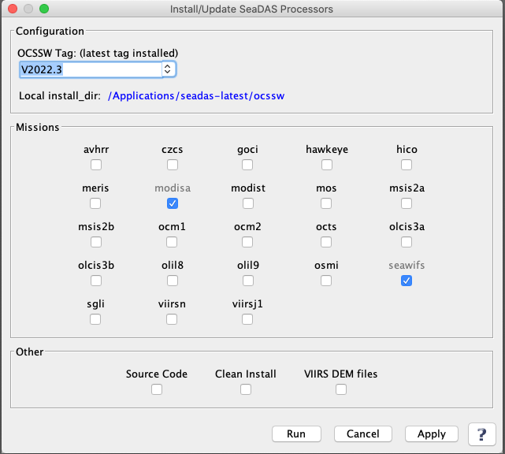

6a. If a message pops up with ‘execution exception’ and much more text ending with:
ModuleNotFoundError: No module named requests
Then you will have to install the python library Requests using the Terminal applications. Follow steps 6b-d below. If you don’t get this message, congratulations!, you have successfully installed SeaDAS!

If you get an error message mentioning xcrun or git (not pip) see Step 6e.

6b. Open a Terminal window (do a Spotlight search for Terminal or open it from the Applications -> Utilities folder) and enter the command:
python3 -m pip install requests
You also might need to install the Chardet package:
python3 -m pip install chardet
6c. If you get the error ‘/usr/bin/python3: No module named pip’ then you will first have to install pip. To install pip, still in Terminal, go to your Downloads folder by typing:
cd Downloads
Download the pip install script with curl by typing:
curl https://bootstrap.pypa.io/get-pip.py -o get-pip.py
Install pip by typing:
python3 get-pip.py
After pip successfully installs try to install requests and chardet again by typing:
python3 -m pip install requests
python3 -m pip install chardet

6d. When you see that Requests has successfully installed, rerun the Seadas Processing Software Installer again (see above, step 6). Hopefully now it will complete with no errors. If that is the case, congratulations, you did it! If not…:

Compare the python3 version SeaDAS is using to the default version.
Check your default version:
In Terminal, type: which python3
Check the SeaDAS version:
Go to SeaDAS-Toolbox -> Software & System Info
Look for Python3 Directory in the first section (at the end usually).
Are the SeaDAS and Terminal version the same?
It might be that your Terminal says something like miniconda or anaconda and SeaDAS /usr/bin/python3. If so try one of these 2 hopefully solutions:
- Easy: In Terminal install Requests (and Chardet) as:
/usr/bin/python3 -m pip install requests
(note that /path/to/python3 should look identical to the SeaDAS version)
- More difficult: Edit your ~/.bash_profile. If you use Anaconda/Miniconda Python insert the following line in bold in the conda_setup section:
if [ $? -eq 0 ]; then
eval "$__conda_setup"
export PATH="/Applications/anaconda3/bin:$PATH"
else
(where /Applications/anaconda3/bin is the location of python3 in Terminal).
If it still fails, contact me….

6e. If you get an error message like:
execution exception: java.io.IOException: install_ocssw.py failed with exit code 1.
Check log for more details.
xcrun: error: invalid active developer path (/Library/Developer/CommandLineTools), missing xcrun at: /Library/Developer/CommandLineTools/usr/bin/xcrun
Error - git is either not installed or not in the PATH.
Then there might be a problem with your Xcode (Mac developers tools) install. To fix this type the following in the Terminal window:
xcode-select –install
If that doesn’t work, contact me…

Take a look at Seadas-Toolbox -> SeaDAS/System Info as well. Check if it finds your
python3 and Java. When emailing me it will help if you include this output.

Info on pip and Requests:
Pip:
https://pip.pypa.io/en/stable/installing/
Requests:
https://requests.readthedocs.io/en/master/user/install/

Install on Windows:

- Download the Windows installer (seadas_8.4.1_windows64_installer.exe) from https://seadas.gsfc.nasa.gov/downloads/
- After download has completed open the file. If you get a security warning, click Yes, to allow this app to make changes.
- Follow the prompts of the SeaDAS Setup Wizard.
- Run SeaDAS!
- If the application window is small, drag lower right corner to make bigger
- Unfortunately, the OceanColor processing components cannot be installed on Windows. You will see the following message when you hover over the OCSSW Menu item and all entries are greyed out. See screenshots below.

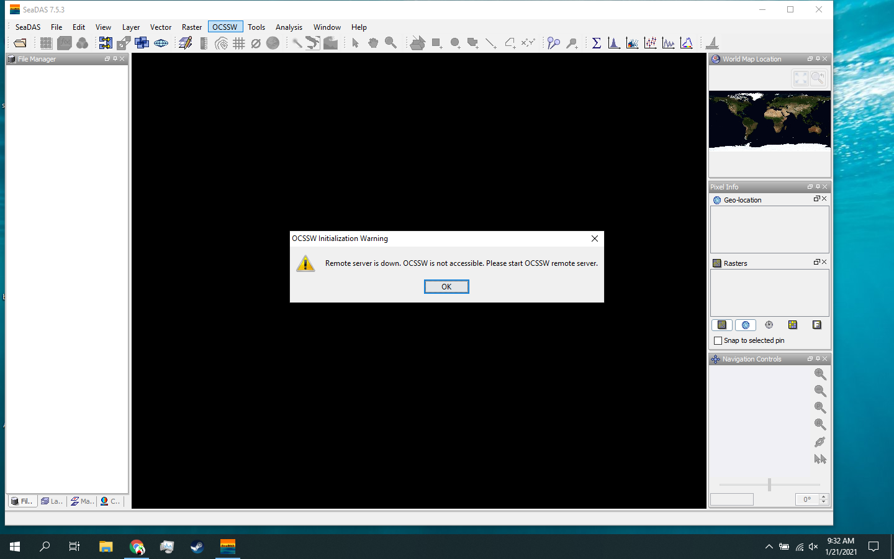
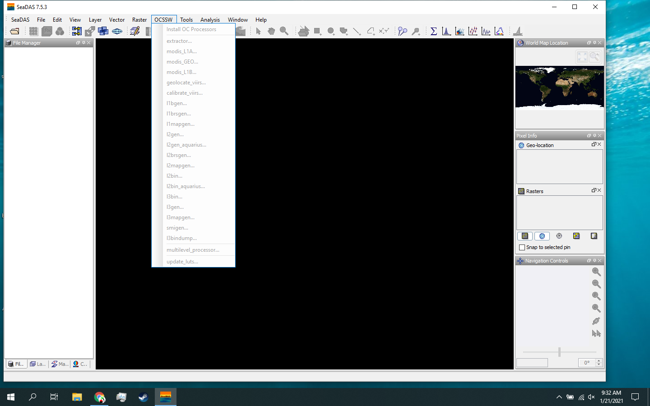

- However, if you really need them and you feel adventurous there is a way to make it work by using a virtual machine on your PC. See https://seadas.gsfc.nasa.gov/client_server/ for more information.

Need more help, let me know.

Gert van Dijken
gertvd@stanford.edu

