Activity 4: Ocean Iron Fertilization

Presentations: Tuesday, June 6 2017 in ESS151

A commercial firm is considering fertilization of regions of the ocean with iron over the next 10 years in order to help slow the rise of atmospheric CO₂ concentrations. They have hired us to evaluate the potential benefits and costs of iron fertilization in the following three regions:

1) Subarctic Pacific (group 1)
2) Subtropical North Pacific (group 2)
3) Southern Ocean (group 3)

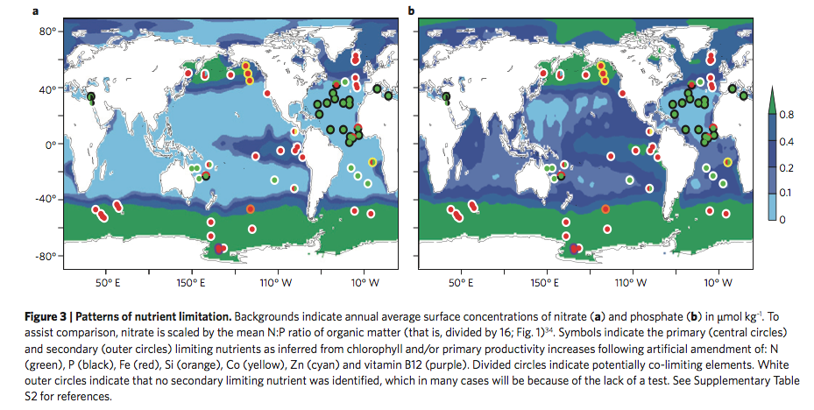
(Figure from Moore et al., 2013)

In your presentation:

- Briefly introduce the relevant chemical, physical, and biological features of your region and summarize current thinking on what limits primary production there.

Provide a reasoned and quantitative (where possible) assessment of the:

- Best chemical form and timing of iron delivery. Justify your choices vs. other alternatives.

- Potential effectiveness in reducing atmospheric CO₂—how much CO₂ could be drawn down on the short time scale (1-10 year, during fertilization), and the fate of that CO₂ on longer (~100-1000 year) time scales (after fertilization has stopped).

Discuss:

- Potential geochemical impacts (e.g., altered deep ocean O₂ levels, nutrient distributions and nutrient supply, DIC and pCO₂ concentrations—think both locally and more broadly).

- Potential ecological impacts (e.g., altered productivity, species composition, health of fisheries—think both locally and more broadly).

- Uncertainties

- Final recommendation

You will have ~15 minutes for your presentation plus ~ 5 minutes for questions and discussion. Please hand in any relevant calculations along with your presentation on June 6th.

Resources:

Helpful references posted on Canvas under ‘Activity 4 Materials’

Moore et al., 2013 Nature Geoscience 6: 701-710
Moore et al., 2004 Global Biogeochemical Cycles 18: GB4028
Boyd et al., 2007 Science 315: 612-617
Martin et al., 1994 Nature 371: 123-129
Smetacek et al., 2012 Nature 487: 313-319
Strong et al., 2009 Oceanography 22: 236-261

