You may download ODV to your own computer for free from
http://odv.awi.de/

- To complete this exercise, you will need the CTD data from a past years cruise on coursework (download bottlefile.csv).
- Open ODV.
  - Click Choose File
    - Click open
      - Find your downloaded bottlefile
    - Hint* if you can’t see .csv files, make sure “Files of type” option is listed as Data Files (*txt, *.csv, *.04x)

  - Spreadsheet file properties window will open
    - Change Column separator: from TAB to “,” (comma)
    - Click okay

  - Metadata/Data Variables window will open
    - Move lat and lon variables out of data variables box
    - Click okay

  - Collection Properties will open, click okay

  - Meta Variable Association window will open
    - Associate Lat with Latitude
    - Associate Lon with Longitude
    - Click okay

HOPEFULLY THE FILE HAS SUCCESSFULLY LOADED

Zoom into your area of study by right clicking and using the zoom features. Try out zoom versus auto zoom in/out.

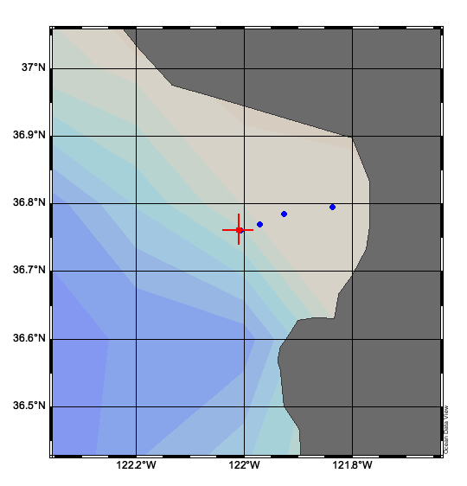
We want to create additional plots. The surface map plot has already been created by ODV.

You will explore how to visualize oceanographic data you will be collecting in the field. Below are instructions on how to make plots 1 through 5.

- Scatter plot of temperature (y axis) versus salinity (x axis) with chlorophyll as a z variable.
- Scatter plot of temperature (x axis), depth (y axis), no z variable
- Section plot of temperature
- Section plot of salinity
- Section plot of chlorophyll a

First to create a Template:
Go to VIEW
- click Window Layout
  - Right click to create and resize windows
    - 3 section plots,
    - 2 scatter plot,
    - 1 map (already created, just resize)
  - Once you are happy with your template, right click and accept changes

To create your figures:
Right click on surface map:
- MANAGE SECTION
  - DEFINE SECTION: click on stations in sequential order forming a line
    - Section properties window will pop up
      - Section Coordinate should be distance
      - No bathymetry (unless station bottom depth exists)
      - Click Ok

Right click on each window individually
- PROPERTIES
  - DATA
    - SCOPE:
      - Select Scatter for TS diagram (click okay) (1 window)
      - Select SECTION for Section plots (3 windows)
        - Right click to set X (derived section distance), Y (Depth), Z (Temperature, Salinity, Chlorophyll a)
    - DISPLAY STYLE (for section plots)
      - Click Gridded Field
      - Select a gridded option (averaging or DIVA)
- Or right click to set Y (temp), X (salinity) , Z (chlorophyll) variables and adjust ranges

To Save,
Save canvas as saves your figures.
Save view as saves your file so that you can continue to work on it later.

An example of the exercise figures are below

QUESTIONS:
- Based on your figures, at what depth would you define the mixed layer depth. Explain your reasoning.

  - What factors affect the depth of the mixed layer?

  - How does mixed layer depth impact the light availability to phytoplankton?

    - Why is light an important driver of phytoplankton (primary production)?

    - Describe the difference between the mixed layer depth and the euphotic depth?

  - How does mixed layer depth impact the nutrient availability to phytoplankton?

- Chlorophyll a is shown as a concentration in ug L⁻¹. Describe the difference between a rate (such as primary production) and biomass (such as chlorophyll a).

3. Water masses have distinct temperature and salinity signatures. Why might it be helpful to plot biological variables (such as Chl a) on temperature salinity plots (like the one you made for this class)?

4. If nutrient data were available, where do you think we’d expect to see the highest nutrients? (In deep waters where there is no Chl a?, In shallow waters where there is higher Chl a? elsewhere?) Explain your hypothesis.

