Lab 4: ORDERING, DOWNLOADING, AND PROCESSING DATA

Objective: Get acquainted with the different kinds of satellite data:
- Where can I find them?
- How do I access them?
- What does this name mean?
- Understand the differences in data levels.

This lab shows you where you can access data for your future projects. Explore the sites and familiarize yourself with where and how you can order data.

Satellite data are available at different processing levels:
- Level 0 data are unprocessed instrument data
- Level 1A data are unprocessed instrument data with ancillary information
- Level 1B data are processed to sensor units (e.g., brightness temperature)
- Level 2 data are derived geophysical variables (e.g., chlorophyll concentration)
- Level 3 data are geophysical variables that are mapped on a grid.
- Level 4 data are model output or results from the analysis of (often multiple) lower level products
- * You will mainly be using Level 2 and 3 data in this class
  - More information can be found here:
    - https://oceancolor.gsfc.nasa.gov/resources/docs/product-levels/
    - https://www.earthdata.nasa.gov/learn/earth-observation-data-basics/data-processing-levels
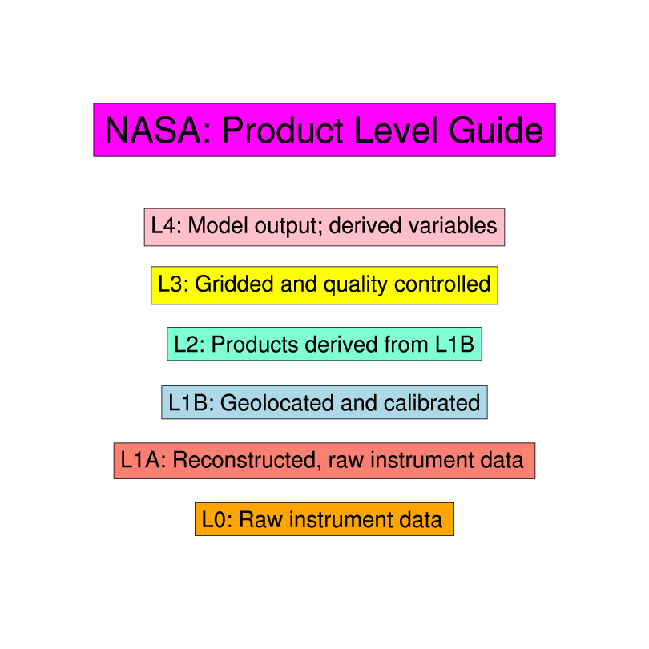

Part I: Searching and Accessing Data

SeaWiFS data can be ordered from the OceanColor website at NASA's Goddard Space Flight Center: https://oceancolor.gsfc.nasa.gov/ . Go to this website so you can see how to download data in the future. From the landing page, either scroll down and click the “Find Data” box, or click “Data > Find Data” in the upper toolbar to be redirected to various data browsing tools. To search for data from the SeaWiFS mission, scroll down to the box labelled “If you know the mission name…”. From here, we can select “File Search”, “Level 3 & 4 Browser” or “Earthdata Search”. Earthdata search is a newer feature from NASA, that will allow us to browse multiple data types and levels using the same search functionality. The Level 3 & 4 Browser is a similarly useful tool that specifically includes level 3 and 4 products. For now, select “Earthdata Search” to find level 1 and 2 data.

Note: throughout this lab, I am going to demonstrate search tools using an example search near Australia in 2013. Consider choosing your own spatial region and time period for the search. This could be a nice way to explore a region/time period you are interested in studying in your final project!

Level 1 and 2 data:
- When you first open Earthdata search, the site will offer you the option to take a short “tour.” This is useful and highly recommended! The tour will show you where search bars are located, how to navigate the map, and how to begin searching for images

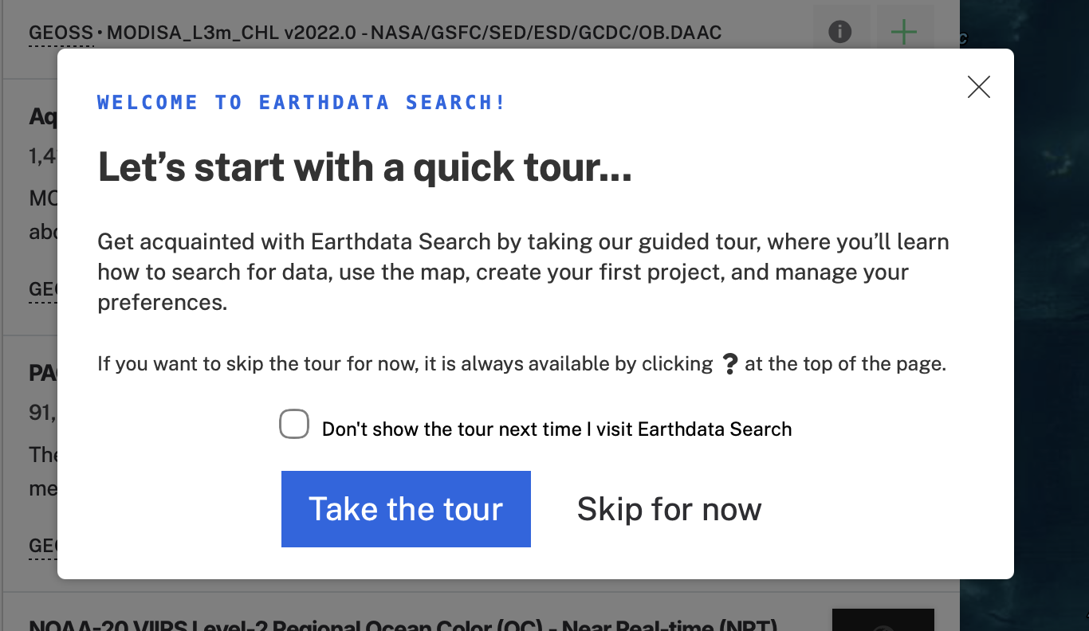

- After taking the tour begin by finding a level 2 image, using the filters at the left.
  - First, open the “instruments” dropdown in the far-left menu and pick a sensor. It may take a second for your selection (titled: “Matching Collections”) to appear. In the example, I am selecting a MODIS image, but you can choose any mission that has available level 2 data.

    - NOTE: the small numbers to the right indicate available datasets (“Collections”), not available images.

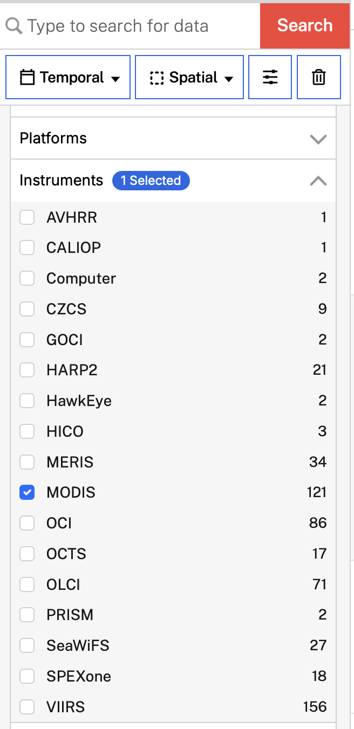

    - Side note: Look at all these other cool instruments available for your final project datasets!!!

  - Next, collapse the instruments dropdown by clicking the up arrow, and expand the “Processing Levels” dropdown. Note that levels 1-4 are available through Earthdata search. For now, click “2 – Geophys. Variables, Sensor Coordinates”

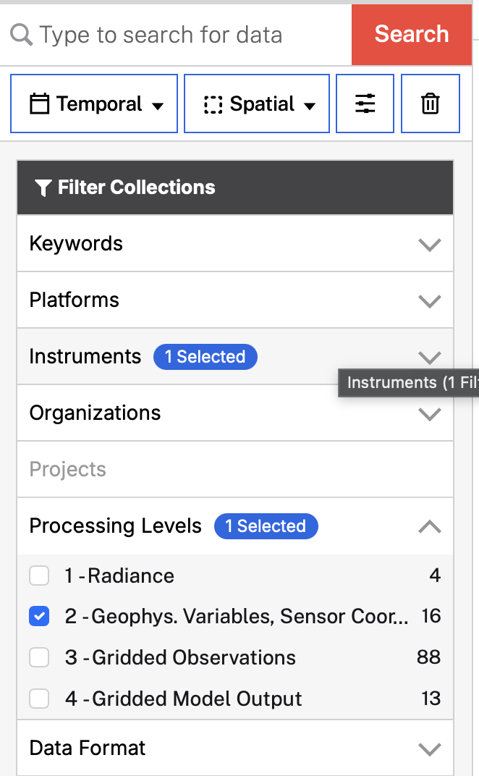

  - After a second, your “Matching Collections” will update to only include level 2 data.
    - Again, the small number next to the processing level selection indicates the number of matching datasets/collections, each of which contain many images!

  - We will now specify a date range using the “Temporal” dropdown menu at the upper left, just under the search bar. Click “Temporal” then enter a start date and end date for the search and click “Apply”.
    - I am using the 1-week (8-day, midnight to midnight) period beginning on Friday, May 17, 2013, and ending Saturday, May 25, 2013.

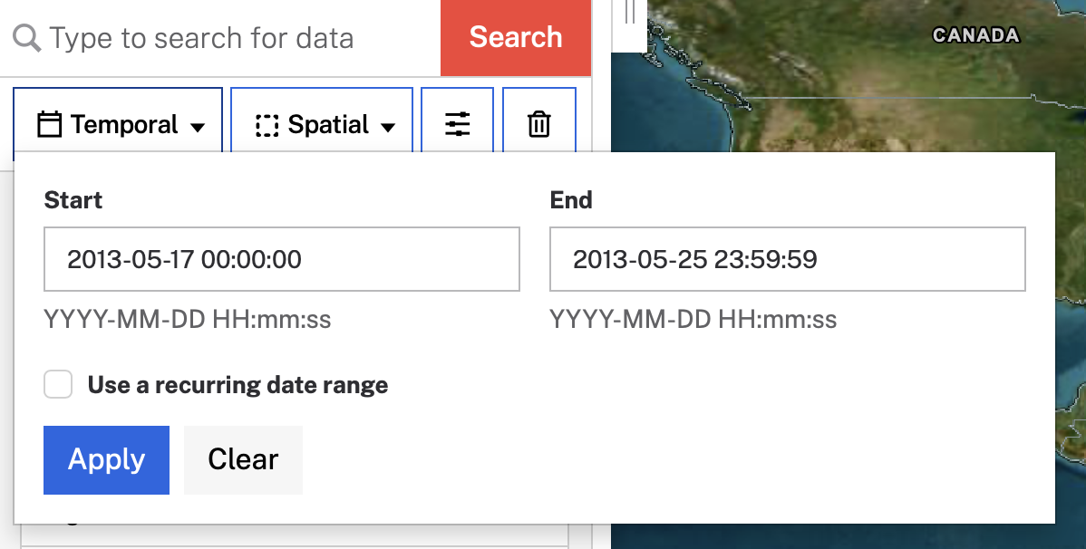

  - TIP: Next we are going to limit our search to a spatial region; this will require looking at the map to the right of the filter/search tools. To give yourself a little more space to view/draw on the map, click the tab to upper right side of the “Matching Collections” panel. When you hover your cursor over it, “Collapse panel” will appear. To bring your “Matching Collections” panel back, just click this tab again.

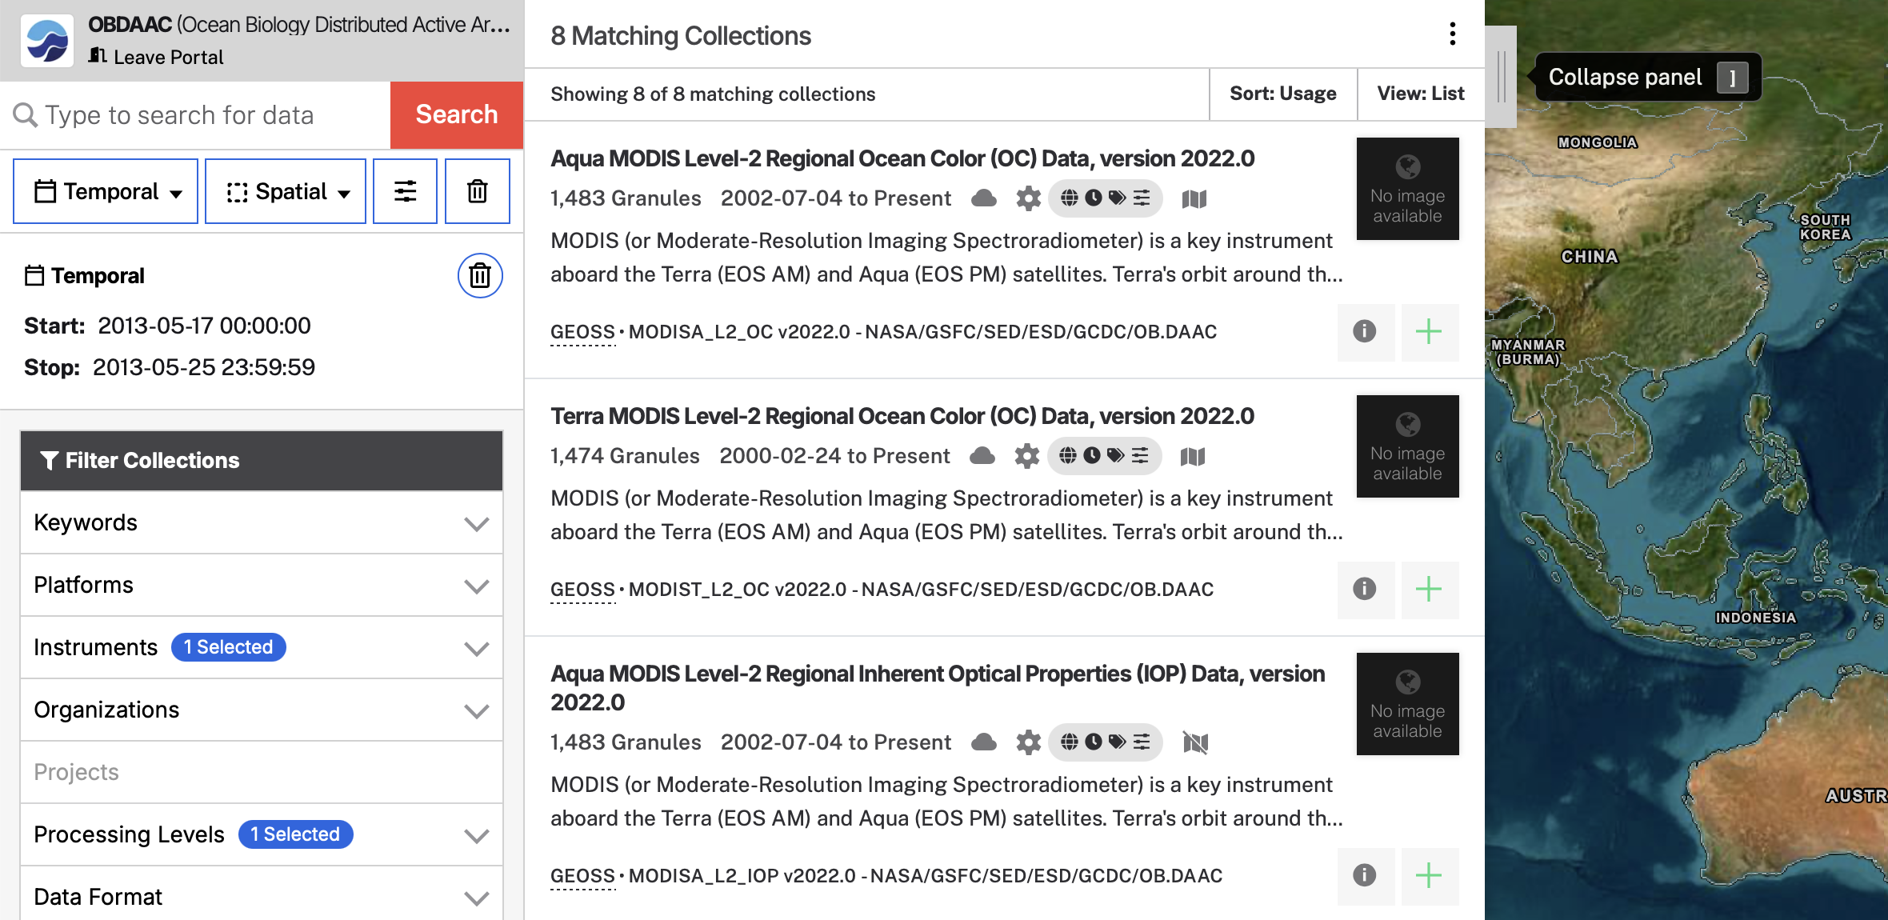

  - Let’s limit our search to a region. To begin, click the “Spatial” dropdown just to the right of temporal. You will be given multiple different options for drawing or setting boundaries of a search region:

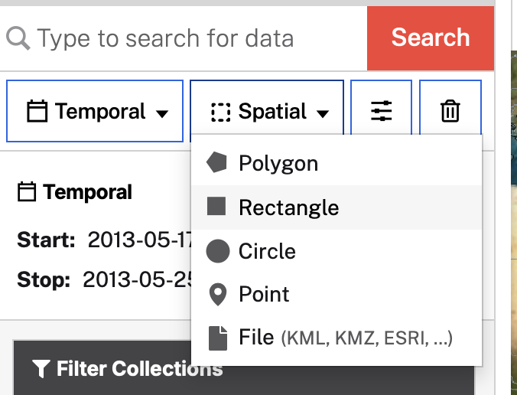

  - Feel free to experiment with different shapes. For this example, I will use “rectangle”.
    - “File” may be a useful feature for your later projects, if you have a defined region of interest generated in an outside program (e.g. a saved SeaDAS mask).

  - After picking a spatial selection tool, use the tool to outline your region of interest on the map to the right. If you need more map space, collapse the “Matching Collections” Panel
    - NOTE: the polygon, rectangle, and circle tools all require at least 2 clicks to draw a shape. Your first click starts the drawing, then you can move your cursor around to get a preview of the shape. When you are satisfied with the shape, click again to finalize the selection.
      - Polygon requires multiple clicks, with each click at a vertex. Click back on your original point to close the polygon.
      - Rectangle uses your first click as a corner of the shape, and your second sets the opposing corner.
      - Circle uses your first click as the center of the shape, and your second sets the radius.

  - I have drawn a rectangle roughly centered on Australia:
    - My first click was the northwest corner of the rectangle, and my second was the southeast corner.

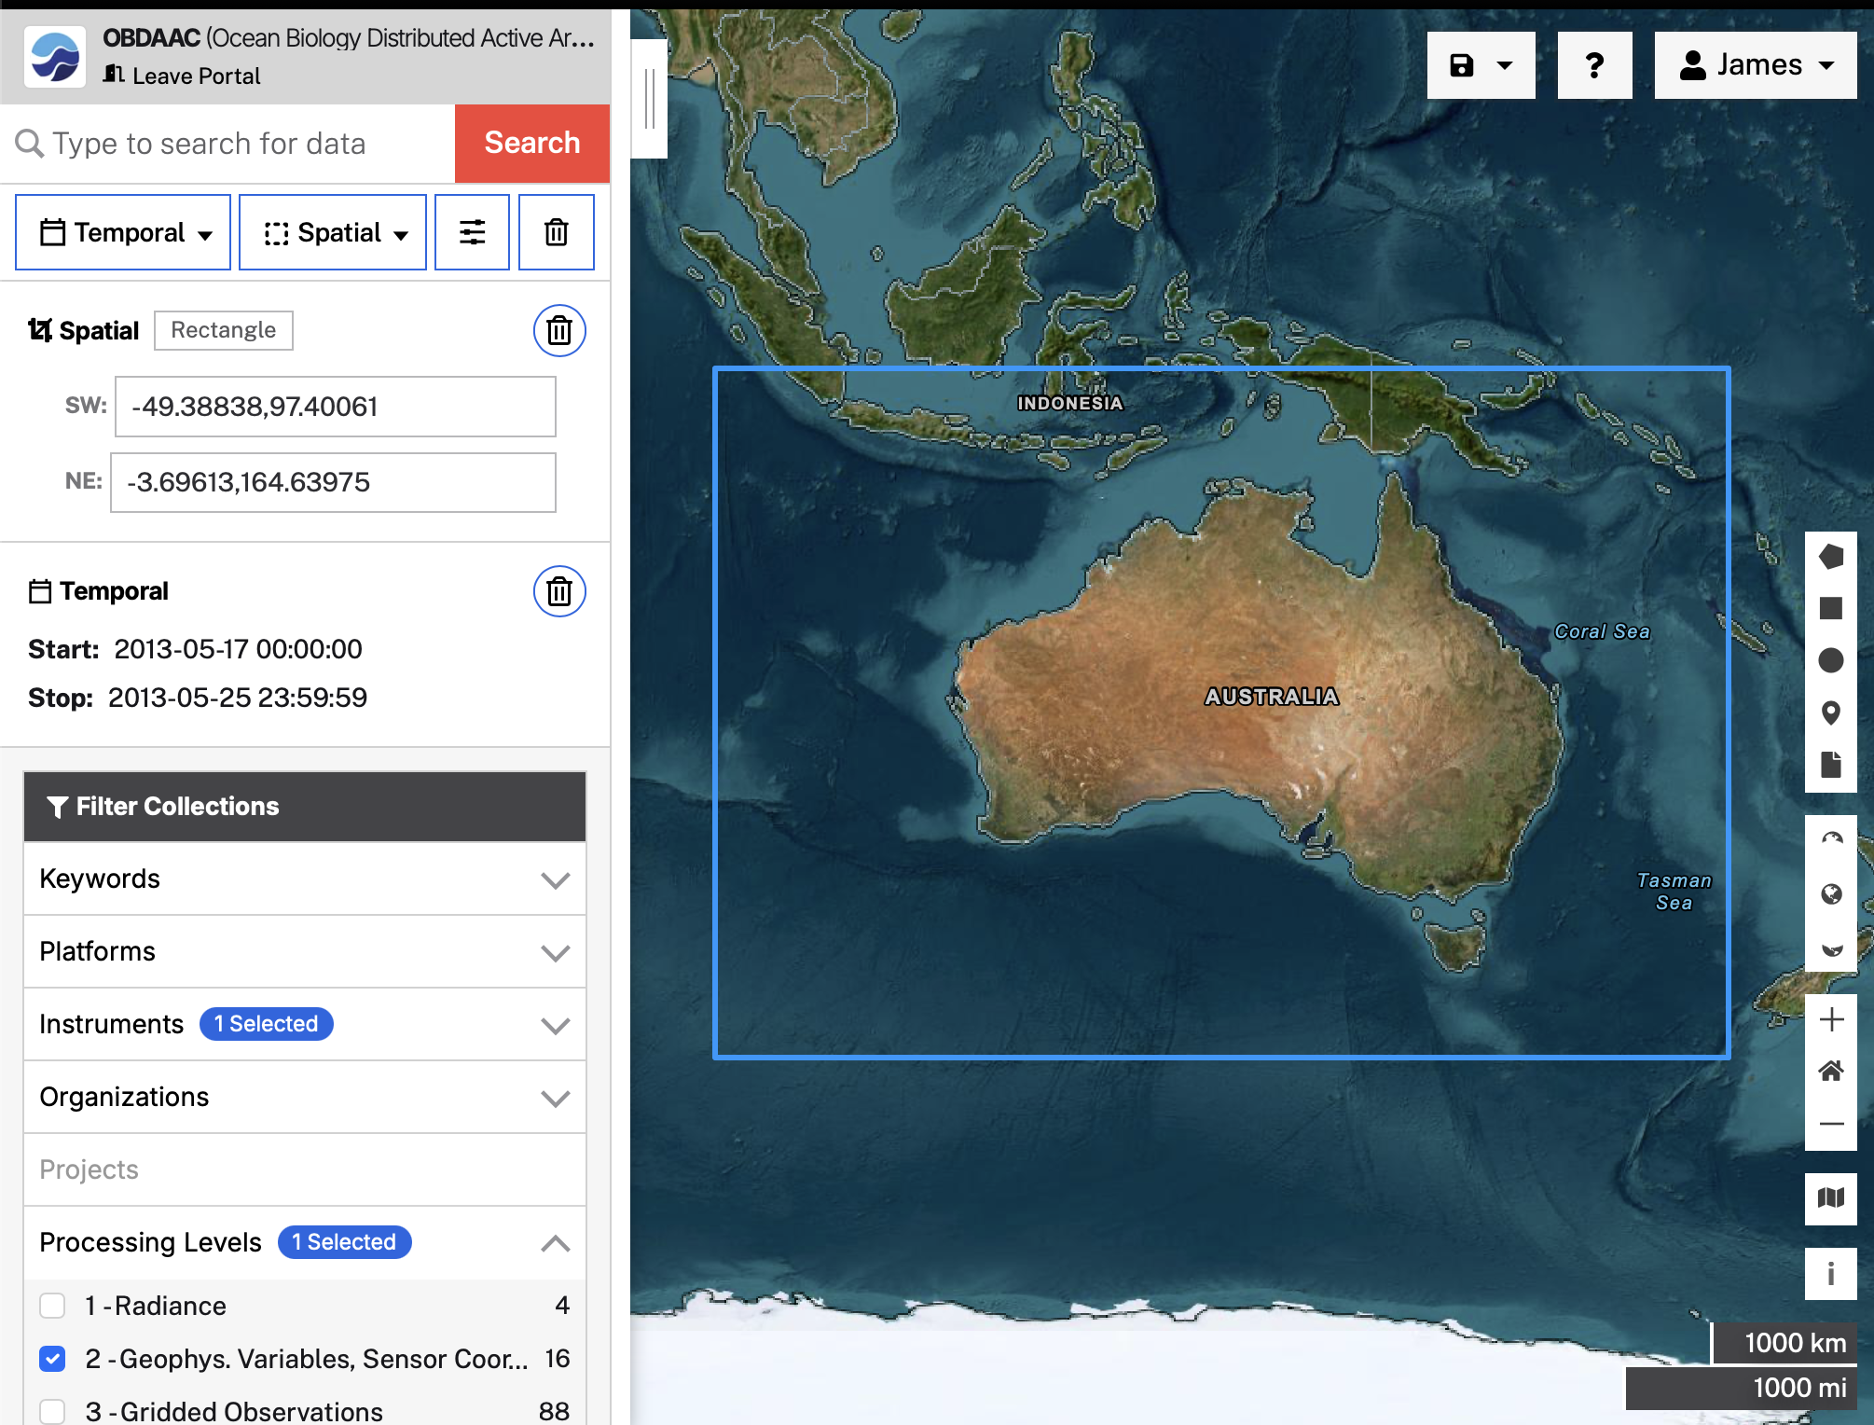

  - If you need to modify your selection, you can tweak the bounds by editing the numbers in the “Spatial” box. If you would like to fully redraw your selection, click the garbage can icon on the right side of the “Spatial” box in the toolbar, then repeat the step above to try again.
    - NOTE: DO NOT CLICK the trash can in the upper right of the toolbar (next to the three sliders icon) – this will delete all of your selections so far.
  - When you are happy with your spatial selection, take a look at available datasets by expanding the “Matching Collections” panel once again:

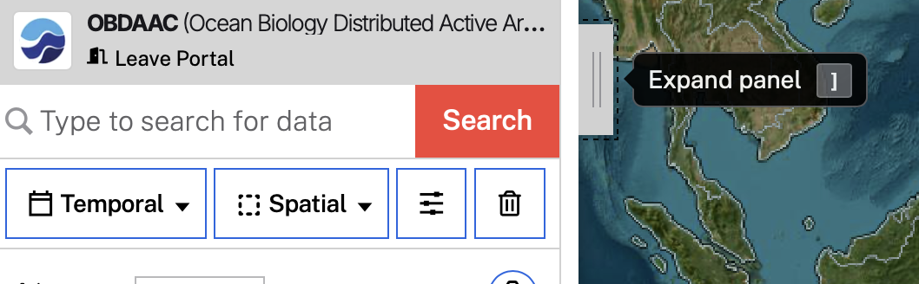

  - You should see “collections” of “granules” (images) in your region. If you do not see any images, make sure your chosen sensor was active during your selected date range.
    - For example: SeaWiFS stopped collecting data in 2010, so no granules will appear for this sensor if you are searching in 2013.

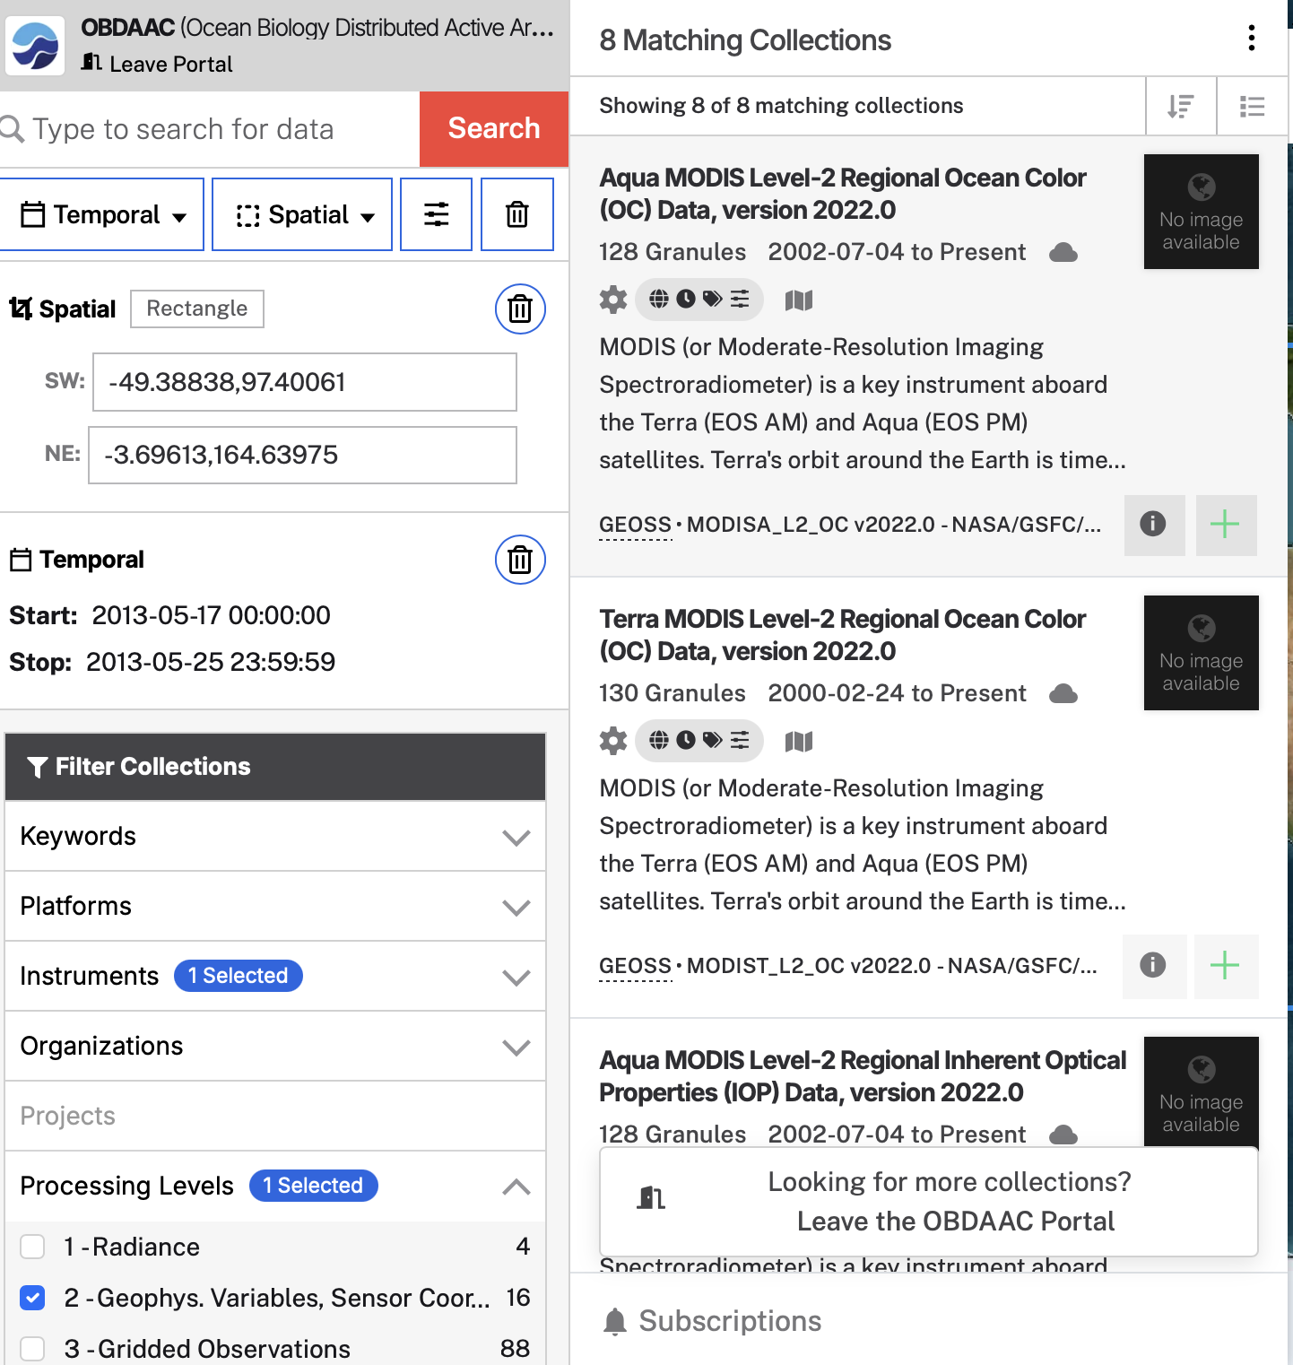

  - Scroll through and look at each collection. There will be a short description of the data included in the granules. Select a collection. For this example, I am selecting the Aqua-MODIS Level-2 Regional Ocean Color (OC) Data, version 2022.0 dataset. 128 granules (or images) overlap my selected region, during the date range I chose.
  - After clicking on a collection, I can see the granules (images) in that collection and have the option to download individual files, or the entire collection.

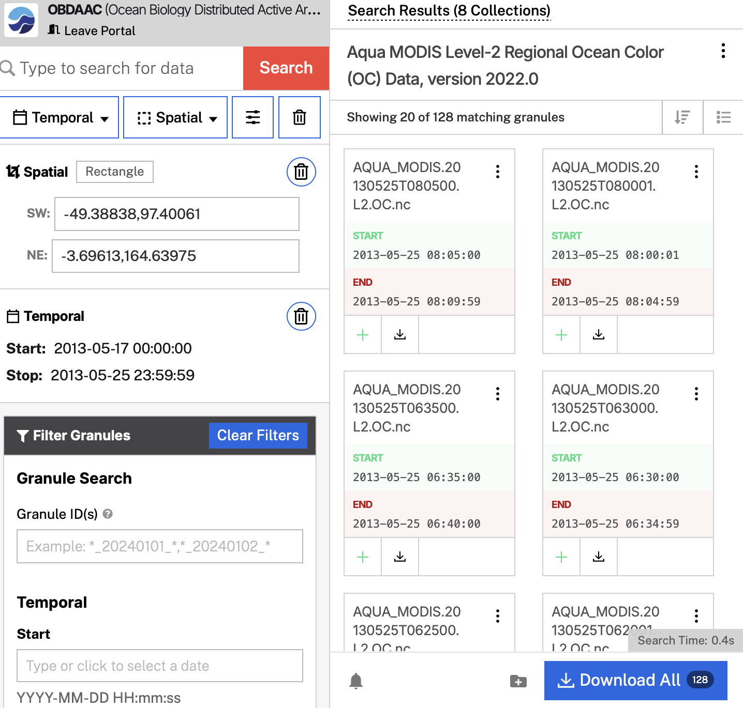

  - The map will also update to show a preview of the granules in the selected collection (I have minimized the ribbon for a better view here). NOTE: not all images in your selection are shown on the map – just the first 20 by default. If you scroll down through the collection, more images will appear on your map.

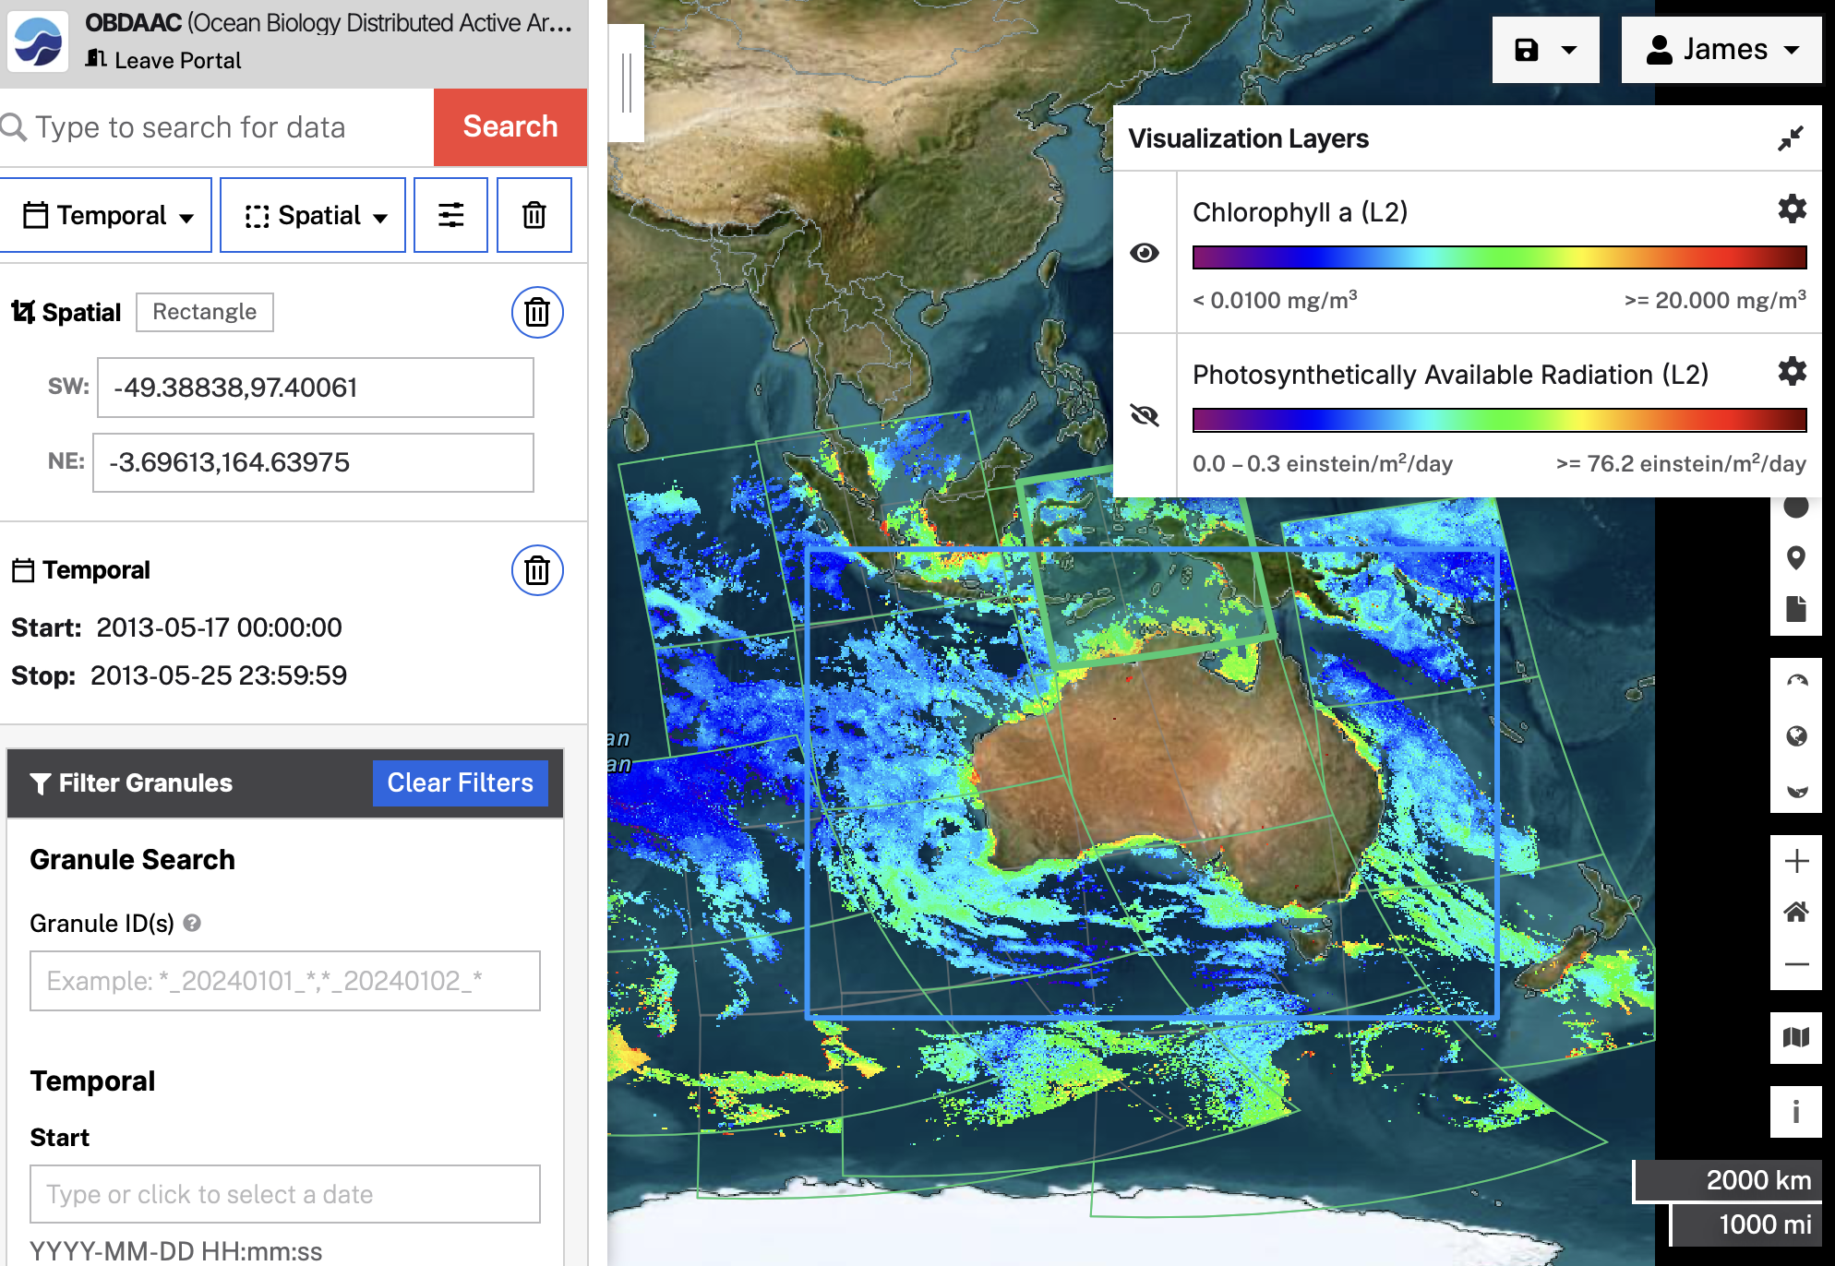

    - Note that the map is showing Chlorophyll a, and the PAR layer is hidden in this image
  - If you run your cursor over the image, you will see individual granules (images) outlined in light green. You can click on any particular granule, and the datafile associated with that image will be selected in the expandable ribbon as well.

- Now that we are looking at individual files, this is a good time to talk about Filename conventions for satellite images. You can tell a lot about an image from the file name! For level 2 files, naming conventions follow this pattern: sensor_satellite_ttt.yyyymmddThhmmss.L2.ppp.nc, where:
  - Sensor_satellite = SEASTAR_SEAWIFS, AQUA_MODIS, etc.
  - ttt = optional data type identifier (GAC, LAC etc.)
  - yyyymmddThhmmss = year, month, day, ‘T’, hour, minute, second of first scan line
  - L2 = level 2 image
  - ppp = product identifier (OC for ocean color, SST for sea surface temperature or IOP for inherent optical properties)
  - more information: https://oceancolor.gsfc.nasa.gov/resources/docs/filenaming-convention/
- For example, we can tell the following about the file: MODISA_L2_OC_AQUA_MODIS.20130525T080500.L2.OC.nc
  - MODIS Aqua Product
  - May 25, 2013, GMT Time 08:05:00
  - Level 2
  - Ocean Color Image
  - .nc indicates the file format netCDF4

- Scan the data that are available. Don’t forget that there may be more scenes than are shown. You can show more images by scrolling down through the list
- You can download files 1 by 1 by clicking the “Download Granule Data” button at the bottom of the thumbnail

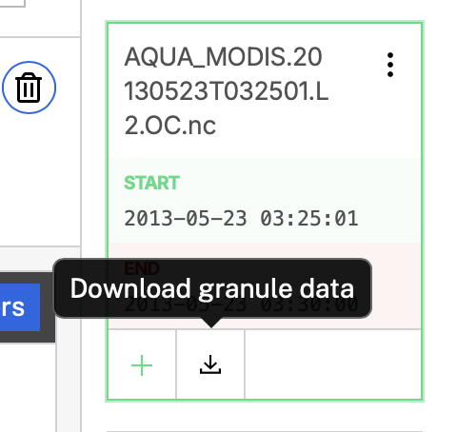

- You could also order all files in your search at once by clicking the blue “Download All” button (which can be a lot, and will take a lot of disk space and a long time to download and process)
- Alternatively (AND LIKELY THE BEST OPTION): You can add granules to a project, then download the project in one go. To add a granule to a project, click the green plus icon next to the download button on the thumbnail.

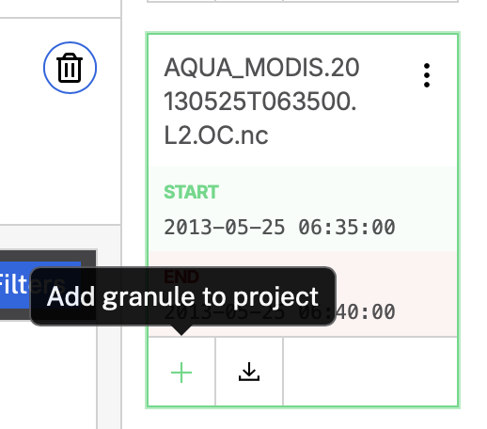

  - NOTE: as soon as you add a granule to your project, the green plus converts to a red minus. If you no longer want a granule in your project, just click this button to remove it

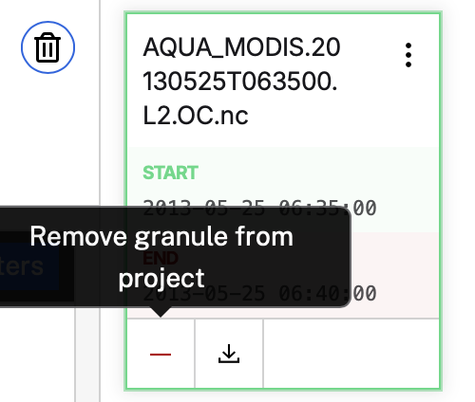

  - NOTE 2: as soon as you add a granule to a project, the “Download All” button swaps to “Download” and will just download the granules you have added to your project.

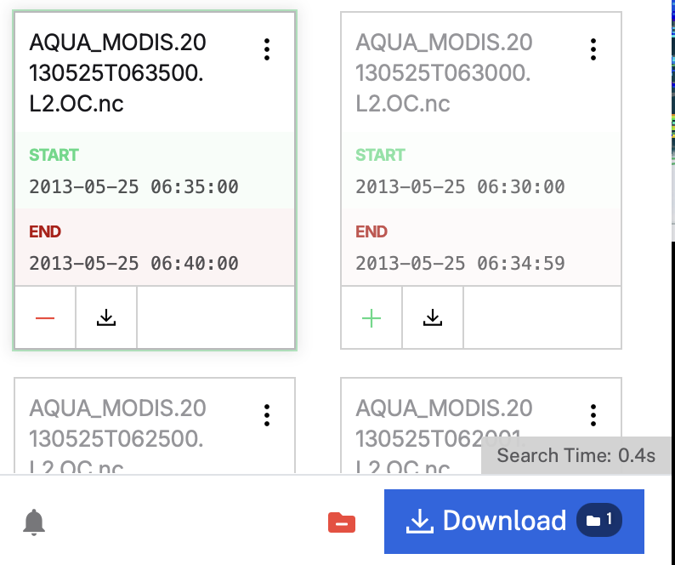

- Find a couple of images you like, add them to a project, and click “Download”

- This will open a new page where you are able to customize your download options. Because satellite datasets can be quite large, there are options to extract data from your selected granules (to shrink file size) and multiple different download methods available to you.

- Your first option will be “Choose how you want to download your data”
  - You will have the option to customize your data with Harmony – usually this means “Extracting” your data to fit the subset you specified in your original search.
    - Earthdata shows you all images/granules that overlap any part of your search. Harmony/Extraction will trim the image to just your selected spatial and temporal range and allows you to select a subset of variables to download.
    - This can be useful for very large granules, or datasets that include many unneeded variables, and helps to keep disc size down and download speeds high.
  - Because we are only downloading a few images with relatively few variables, I am going to select “Download all data”
  - Note: depending on the granules you use in your final project, Harmony/Extraction may be a useful tool. If you have questions about extraction, ask!

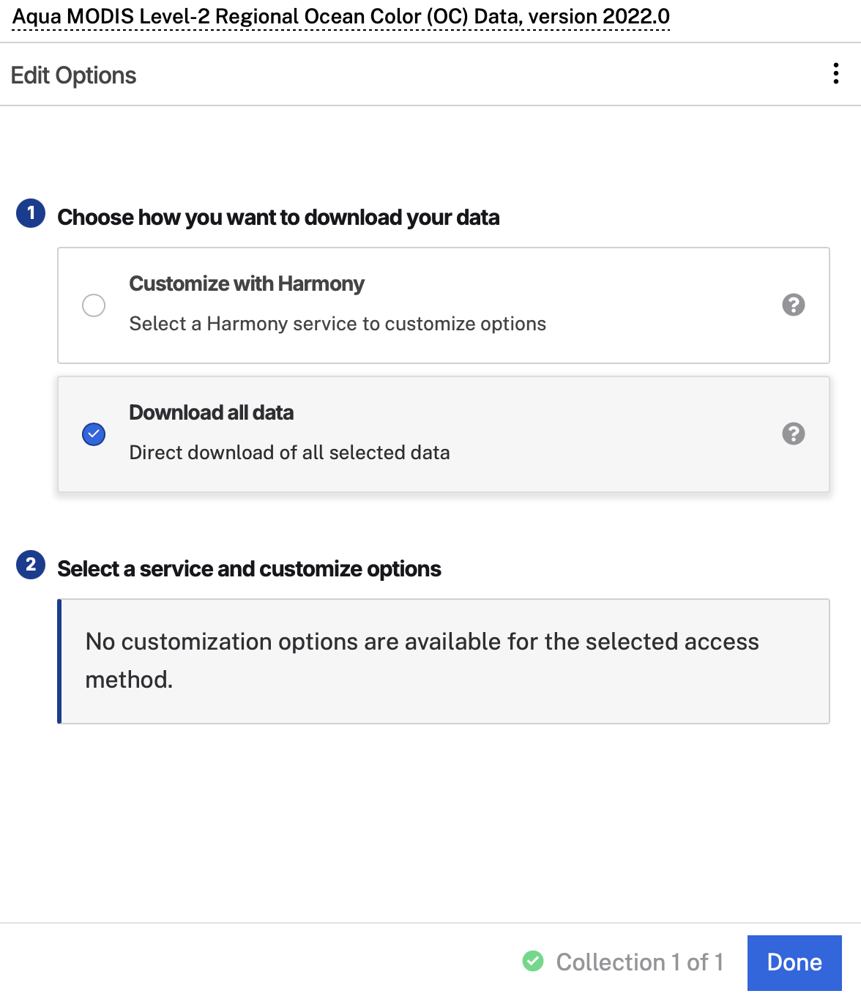

- Click “Done” and you will see a preview of the images in your project. I selected 3 granules along the eastern coast of Australia

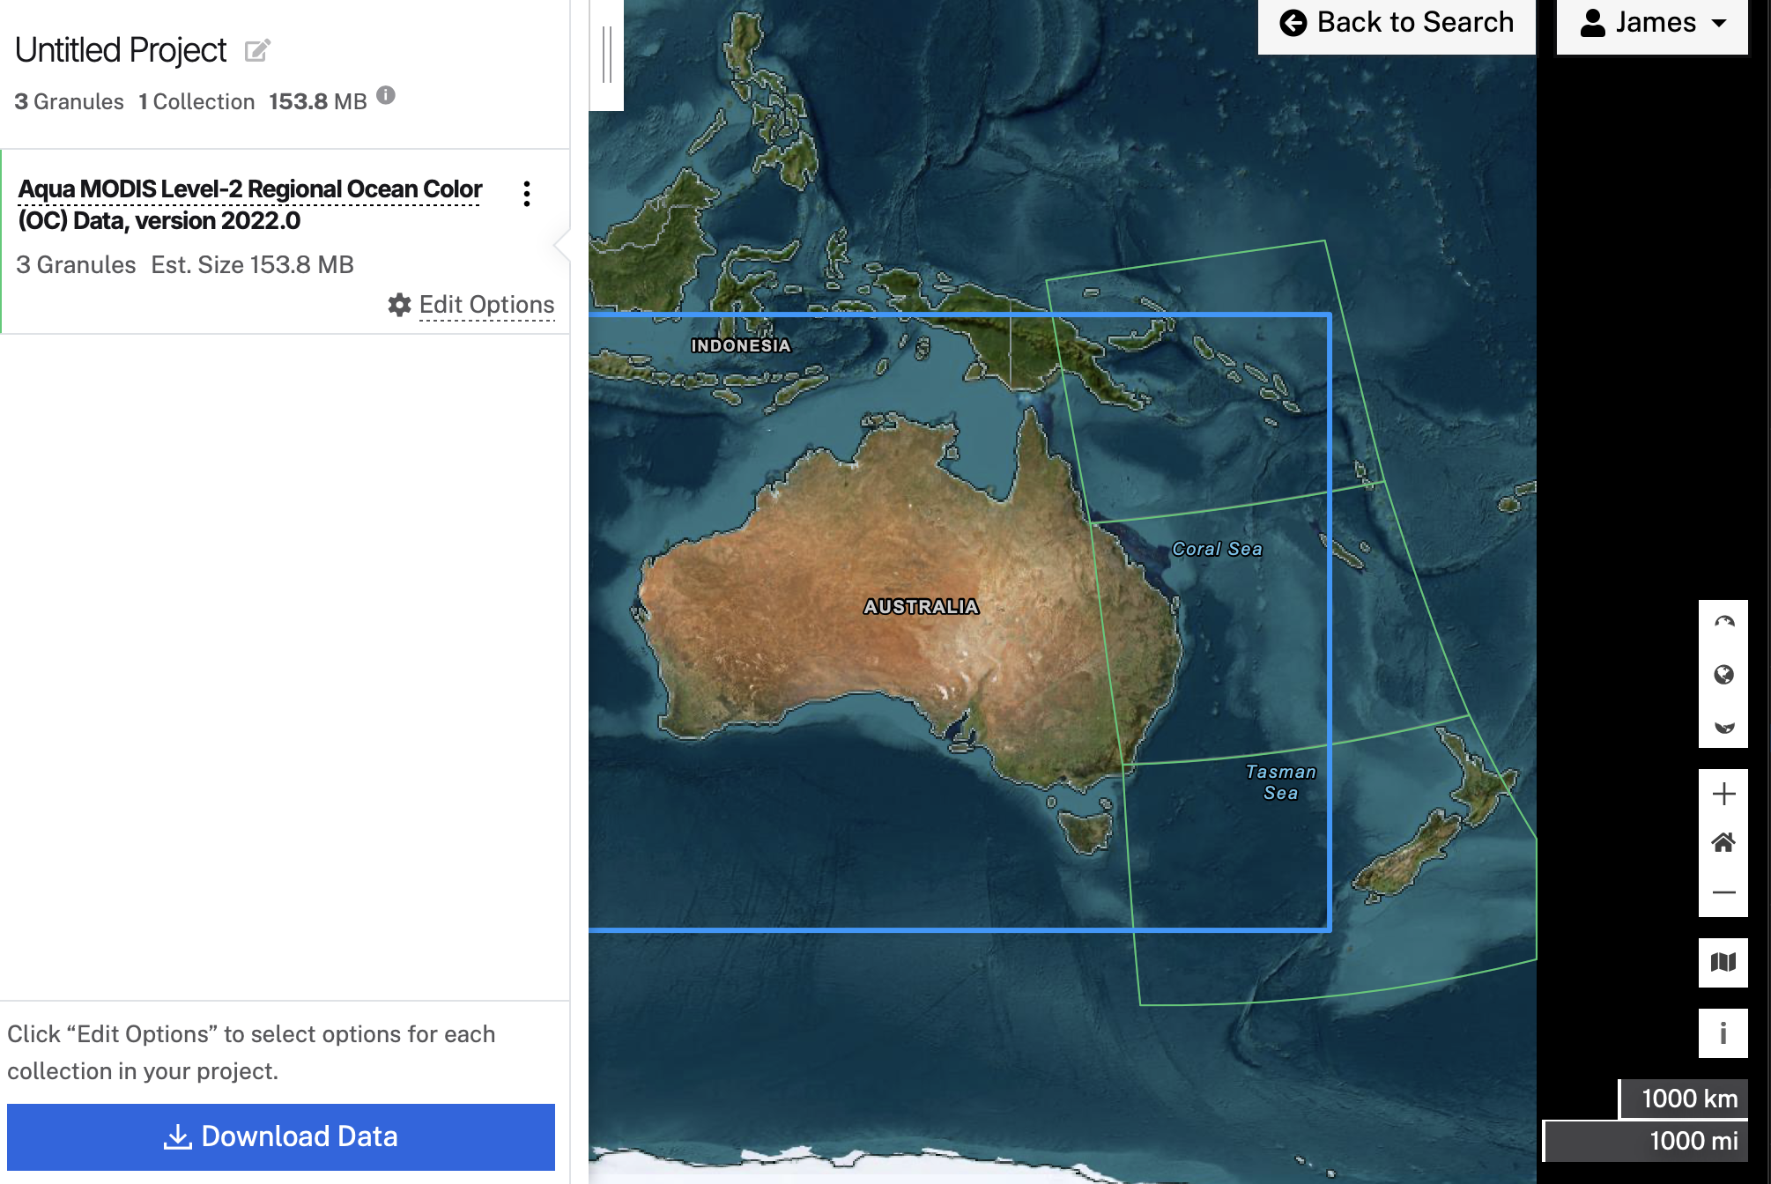

- If the preview looks correct, click “Download Files”
- This will open a new page that gives you options for how you would like to complete the download
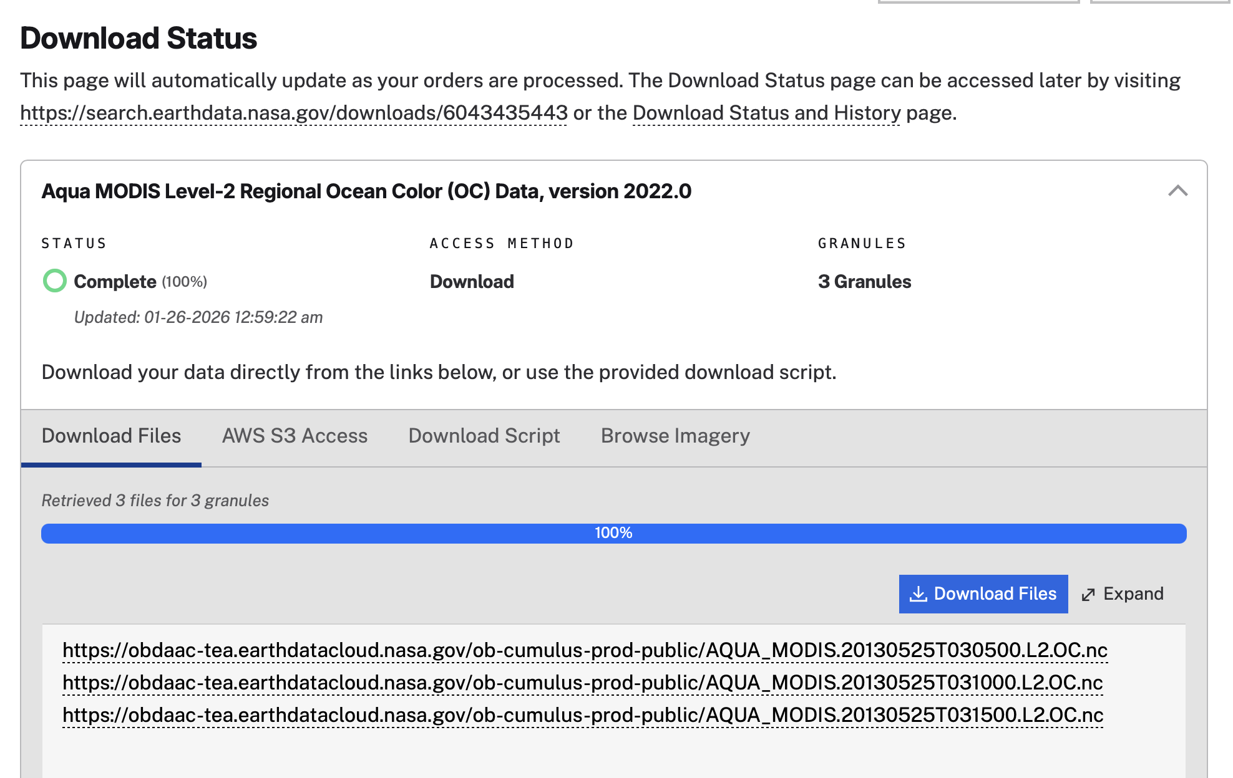

- If you click “Download Files”, this will prompt you to download a utility that will then allow you to directly download your files. You only have to download this utility once, and it makes image downloads quite straightforward. We recommend using it!
- Alternatively, you can download your files by copying the listed URL(s) into your address bar, one at a time. After you paste the URL into your address bar, the file will begin to download.
  - There are several other ways to download the files, especially if you are on Mac/Linux. See https://oceancolor.gsfc.nasa.gov/data/download_methods/, and select the “Download Methods” tab for additional details
    - My personal preferred method is to use curl from the terminal:
    - curl -OLn -b ~/.urs_cookies -c ~/.urs_cookies “URL”
- Once you have successfully downloaded your selected images, move them to a new directory and save them for later. We will come back to these!

Level 3 data:
Go back to the OceanColor website and under “Find Data” this time navigate to “Level 3 & 4 Browser”. Select your desired product, timescale, and resolution. To download data, click on the thumbnail of the image you want, and select “SMI” (standard mapped image) or “Bin” (binned). For this class, mapped SMI files will be easiest to work with. If you just want the image (no data) select “Images”.

Accessing SST data:
There are multiple SST products you can use for your final projects. We discussed AVHRR extensively in class, but that mission ended in 2023. GHRSST MUR is a very high-resolution Level 4 option, and NOAA/NCEI OISST is a slightly lower resolution Level 4 product that is a bit easier to work with.
NOTE: You don’t need to order anything now, this is a reference for your future projects

AVHRR Data – Mission ended in 2023:
http://www.nodc.noaa.gov/SatelliteData/pathfinder4km/

GHRSST Level 4 MUR (multiscale ultrahigh resolution (0.01 degree), multi sensor):
https://podaac.jpl.nasa.gov/dataset/MUR-JPL-L4-GLOB-v4.1

Optimally Interpolated SST data (OISST, 0.25 degree resolution):
http://www.esrl.noaa.gov/psd/data/gridded/data.noaa.oisst.v2.highres.html
OISST is also available from Earthdata/through PO.DAAC:
https://podaac.jpl.nasa.gov/dataset/AVHRR_OI-NCEI-L4-GLOB-v2.1

MODIS SST data:
- From Earthdata Search, you can download SST images the same was as ocean color images above. You simply scroll through the MODIS Collections until you find the SST products:
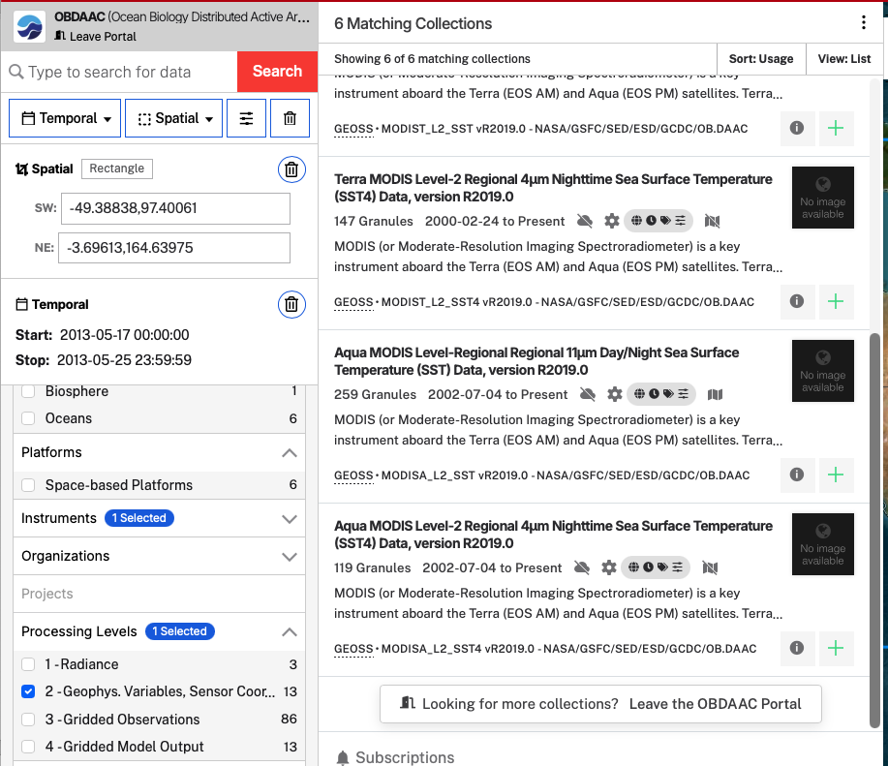

Accessing other data:

The new SeaDAS is an ‘add-on’ to SNAP (http://step.esa.int/main/toolboxes/snap/ , formerly known as BEAM https://bcdev.github.io/beam/about.html ), an open-source toolbox for viewing, analyzing and processing remote sensing data, made available by the European Space Agency. SeaDAS can easily read most files in netCDF or HDF format.

Here are some examples of L3 data products available and where you can find them:

SSM/I Sea Ice Concentration:
- Climate Data Record (CDR) - Long term time series using a combination of algorithms updated every 3 months stretching back to 1978:
https://nsidc.org/data/g02202/versions/6
- Near Real Time (NRT) - Data from the most recent 3 months, designed to fill the temporal gap between CDR updates:
https://nsidc.org/data/g10016/versions/4

Aquarius Wind Speed:
https://podaac.jpl.nasa.gov/dataset/AQUARIUS_L3_WIND_SPEED_SMIA_7DAY_V5

AVISO Level 4 Absolute Dynamic Topography
https://podaac.jpl.nasa.gov/dataset/AVISO_L4_DYN_TOPO_1DEG_1MO?ids=Measurement:ProcessingLevel:DataFormat&values=Sea%20Surface%20Topography:*4*:NETCDF

Sea Surface Height from Copernicus
https://data.marine.copernicus.eu/product/SEALEVEL_GLO_PHY_L4_NRT_008_046/description

Aquarius Sea Surface Salinity
https://podaac.jpl.nasa.gov/Aquarius?tab=mission-objectives&sections=about%2Bdata

Ocean Surface Current Analysis (OSCAR)
https://podaac.jpl.nasa.gov/dataset/OSCAR_L4_OC_third-deg

National Centers for Environmental Prediction (NCEP) Surface Data
http://www.esrl.noaa.gov/psd/data/gridded/data.ncep.reanalysis2.surface.html

You can find many different satellite products easily at PO.DAAC (Physical Oceanography Distributed Active Archive Center). You can filter for data product, collection, level, and/or datatype (remember .nc, .netcdf, or .hdf tend to work best with this version of SeaDAS)

Supported Instruments
This following table lists the data product formats which are supported by BEAM using the reader modules provided in the standard installation. Information about the access to these products is given at http://www.brockmann-consult.de/beam/doc/help/general/BeamDataSources.html
Instrument | Platform | Formats
MERIS L1b/L2 | Envisat | Envisat N1
MERIS L3 | Envisat | NetCDF
AATSR L1b/L2 | Envisat | Envisat N1
ASAR | Envisat | Envisat N1
ATSR L1b/L2 | ERS | Envisat N1, ERS
SAR | ERS | Envisat N1
OLCI¹⁾ | Sentinel-3 | NetCDF/SAFE
SLSTR¹⁾ | Sentinel-3 | NetCDF/SAFE
MSI¹⁾ | Sentinel-2 | JPEG2000/SAFE
CHRIS L1 | Proba | HDF4
AVNIR-2 L1/L2 | ALOS | CEOS
PRISM L1/L2 | ALOS | CEOS
MODIS L2 | Aqua, Terra | HDF4
AVHRR/3 L1b | NOAA-KLM | NOAA, METOP
MSS | Landsat 1-5 | GeoTIFF
TM | Landsat 4 | GeoTIFF
TM | Landsat 5 | GeoTIFF, FAST
ETM+ | Landsat 7 | GeoTIFF
OLI, TIRS | Landsat 8 | GeoTIFF
SPOT VEGETATION | SPOT | HDF

A Note on Earthdata Search: You can use Earthdata Search to find all types of NASA data – including SST, ocean color, and many of the other products listed above!

- Throughout the first part of this lab, we have been using Earthdata search to find ocean color data (primarily by searching OB.DAAC – The Ocean Biology Distributed Active Archive Center).
- NASA has been working over the past few years to make multiple DAACs accessible through Earthdata Search (including PO.DAAC and others)
  - For more information on Earthdata and NASA’s web unification project, see here: https://www.earthdata.nasa.gov/about/web-unification-project
- If you opened Earthdata search through the ocean color website, you are only searching OB.DAAC. To search all available DAACS, click “Leave Portal” in the upper left corner, above the search bar:

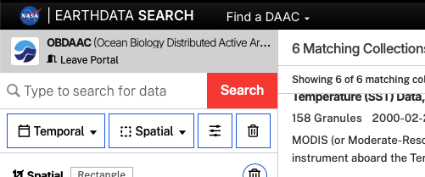

- Your temporal and spatial boundaries will be preserved, but you will gain access to far more instruments and collections as datasets from other DAACs are made available by the search:
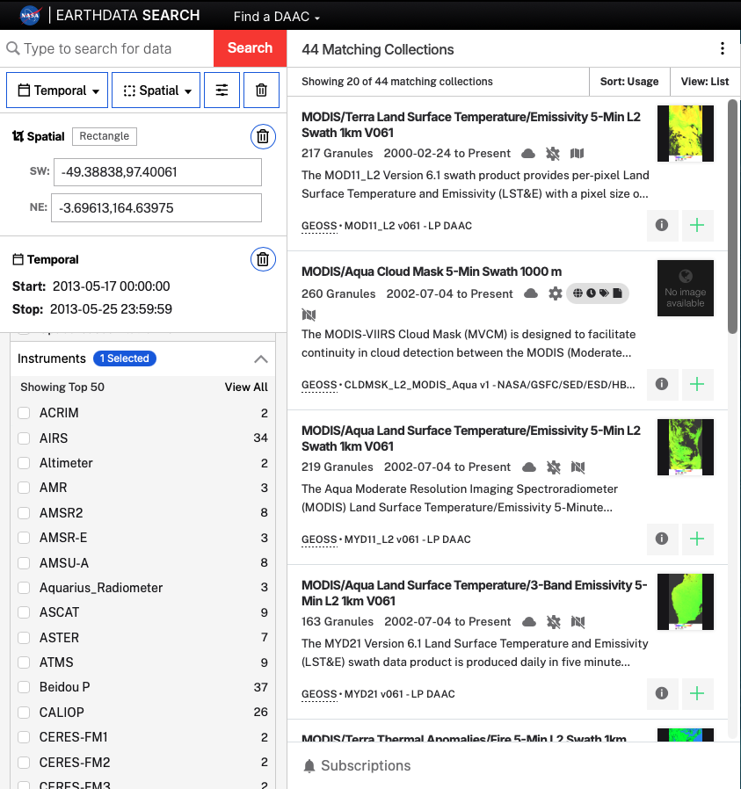

- When searching all DAACs the sheer number of datasets can be a little overwhelming. Keyword search filters are a super helpful tool that can really narrow down the collections you need to scroll through. For example, here I have selected Level 4 Sea Surface Temperature data using the Keyword and Processing Levels filters, and NCEI OISST is the first collection suggested:

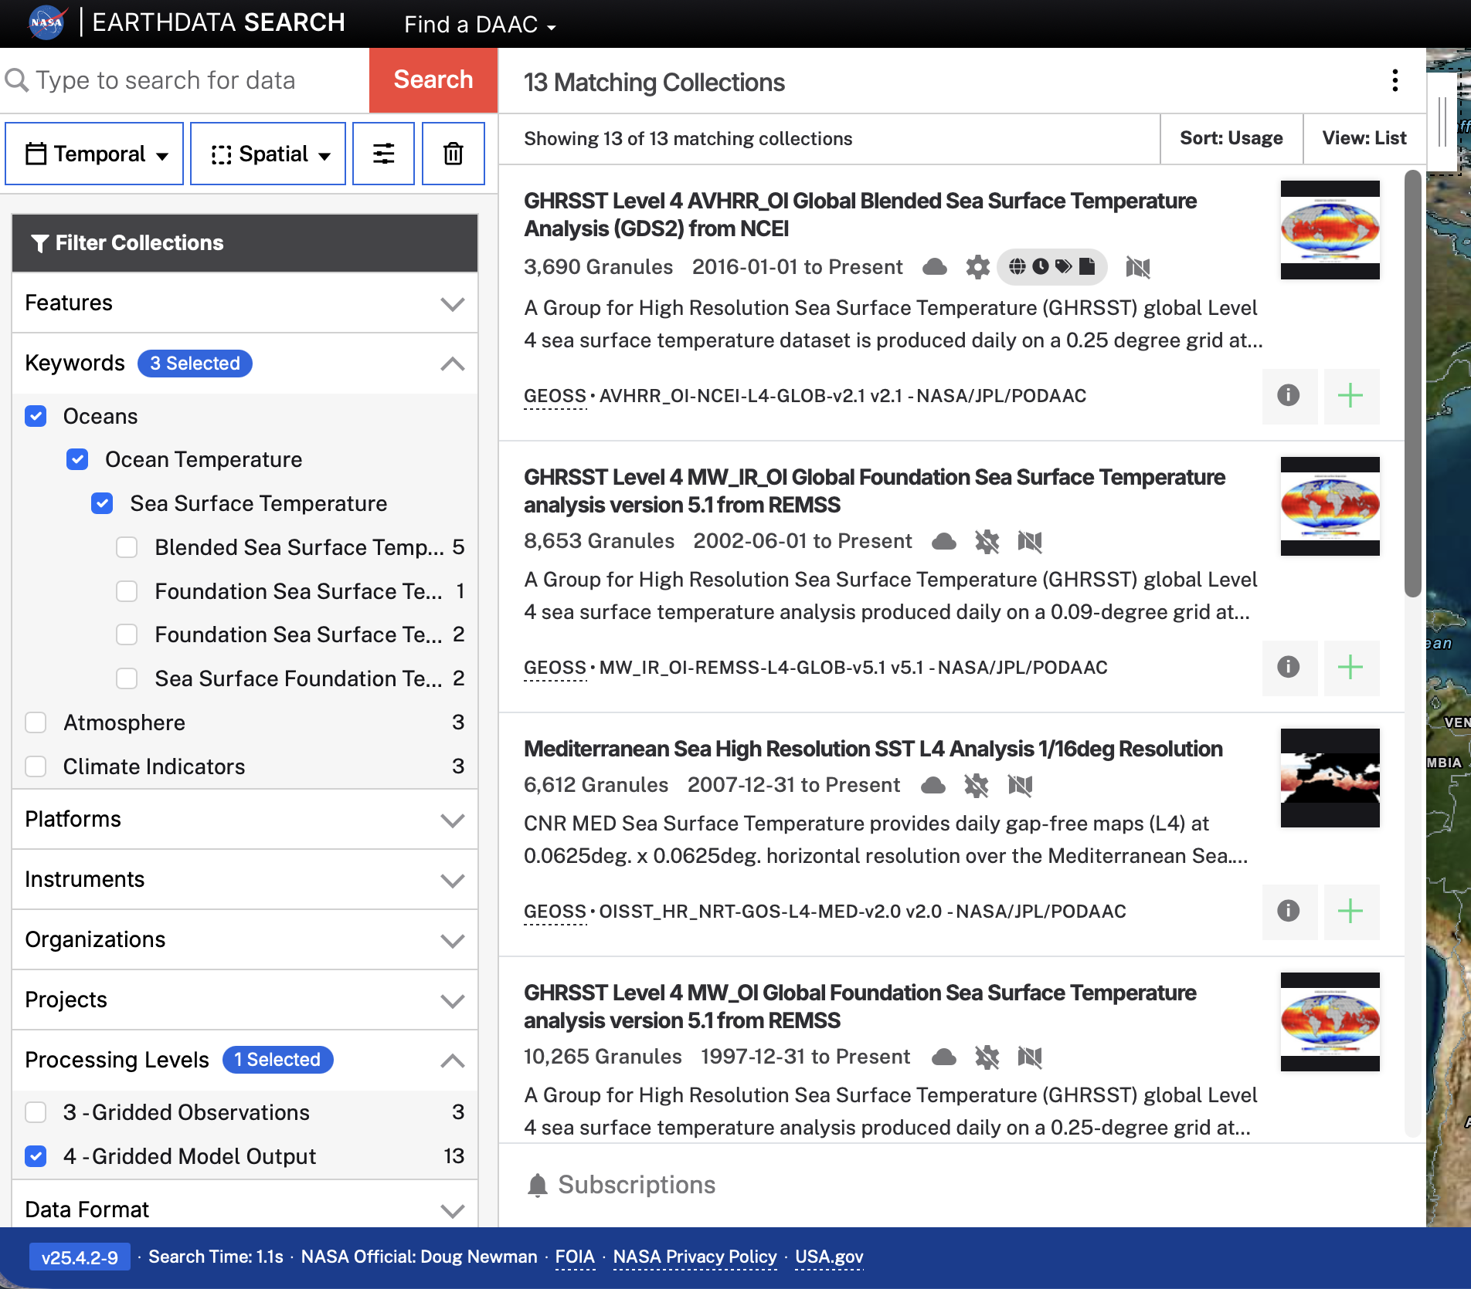

- Similarly, if you know what dataset you are looking for, type it into the search bar! Here I am using an “Oceans” Keyword filter and then have typed “MUR” into the search bar. The GHRSST MUR dataset is the first result:

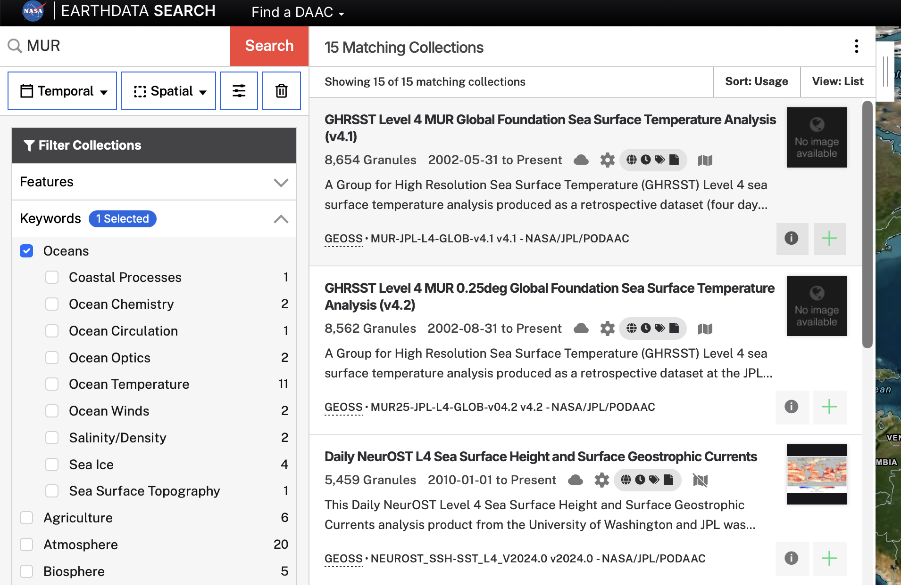
- Finally, if you want to learn more about the various DAACs and data available at each, click “Find a DAAC” above the search bar, and select your preferred DAAC:
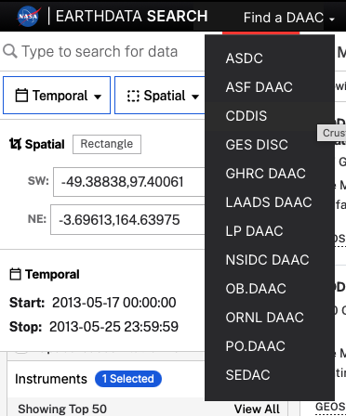

- This will open a landing page for that specific DAAC in a new tab (the OB.DAAC page should look familiar). At these landing pages, you can learn more about datasets available from each DAAC and open DAAC-specific Earthdata search features, similar to the OB.DAAC searches we were conducting earlier in the lab. Feel free to explore the various DAACs as you consider your final project ideas!
  - Some particularly useful DAACs for Ocean Research:
    - OB.DAAC – Ocean Biology
    - PO.DAAC – Physical Oceanography
    - NSIDC DAAC – National Snow and Ice Data Center

Getting Credit for this Lab:

To get credit for this lab, we are going to make you practice for your final projects. Open at least two of the level 2 images you downloaded earlier from Earthdata Search. Create a mosaic of these images, display a data band from the mosaic, add a land mask, gridlines, and a color bar, then save a picture of your scene (using the same method we used to save an image in lab 1 – right click > Export view as image > full scene).

Please attach the image to an email, and send to Prof. Arrigo arrigo@stanford.edu

If you have any questions, do not hesitate to ask!

