LAB 3 DATA EXERCISE: SHIP TRACKER AND SeaBASS CHALLENGE!

Here you will put skills you learned in LAB 1&2 to the test and get comfortable with analyses you may do for your independent projects.

PART I: Learning to use ship tracks

First before we start, finish up your MASKS from last week.

Then open the AQUA_MODIS.20151215T174001.L2.OC.nc file from last week’s lab that is in the Lab 2 L2 folder. Copy the SeaBASS shiptrack text file (SeaBASS_shiptrack_example.txt) as well from the Lab 3 folder to your own folder.

Comparing satellite images with datasets measured in the field is a common analysis. Today, we will be working with a dataset that was downloaded from the SeaBASS database. There are multiple shiptrack file formats that you can use for this type of analysis in SeaDAS.

NOTE: SeaDAS has a tendency to get stuck sometimes. Often the best remedy is to restart the program.

- While the east coast file is selected in the file manager (AQUA_MODIS.20151215T174001) with the chlor_a band displayed, import the file “SeaBASS_shiptrack_example.txt” by File > Import > Vector Data > SeaBASS Data

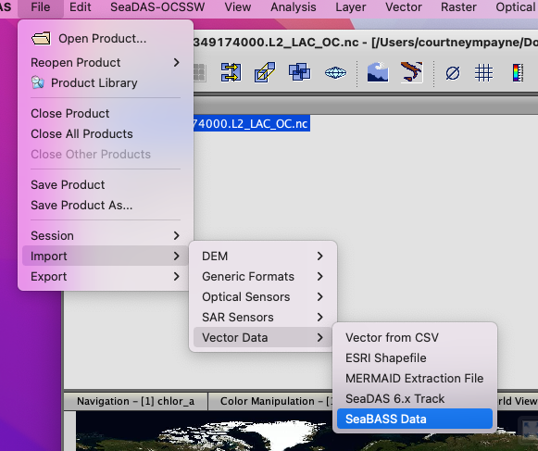
- In “File Manager” under “Vector Data”, double click the ship-track file to see the pixel position, lat/lon position, and the data held in the file.

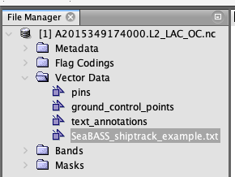

- In “Layer Manager” under “Vector data”
  - You can turn on/off the display of the points by checking/unchecking
  - You can edit the display (color/shape/opacity) of the markers by clicking the edit button while the layer is selected. Try changing he default color for Stroke from white to black, since the symbols are hard to see.
  - You can create a “Profile Plot” to see how the data varies over the shiptrack path
    - First, in File Manager select “chlor_a” band to use this data for the plot
    - Then, click the Profile Plot icon (or Analysis > Profile Plot)
    - To compare to ship data
      - Check “Use correlative data”
      - Choose your shiptrack data as the “Point data source”
      - And (if you have multiple in situ data types) choose which data field to compare
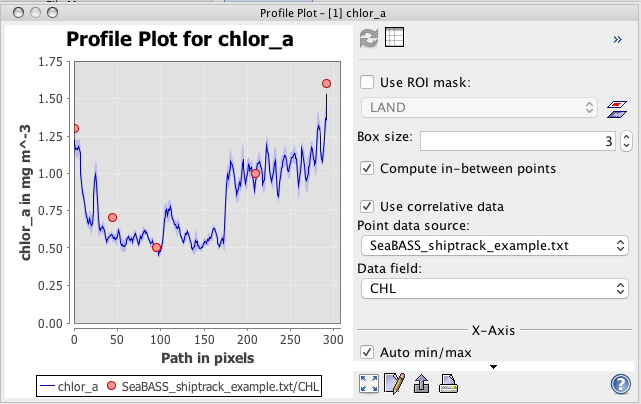

  - To compare how well the satellite data matches the in situ measurements, make a Correlative Plot

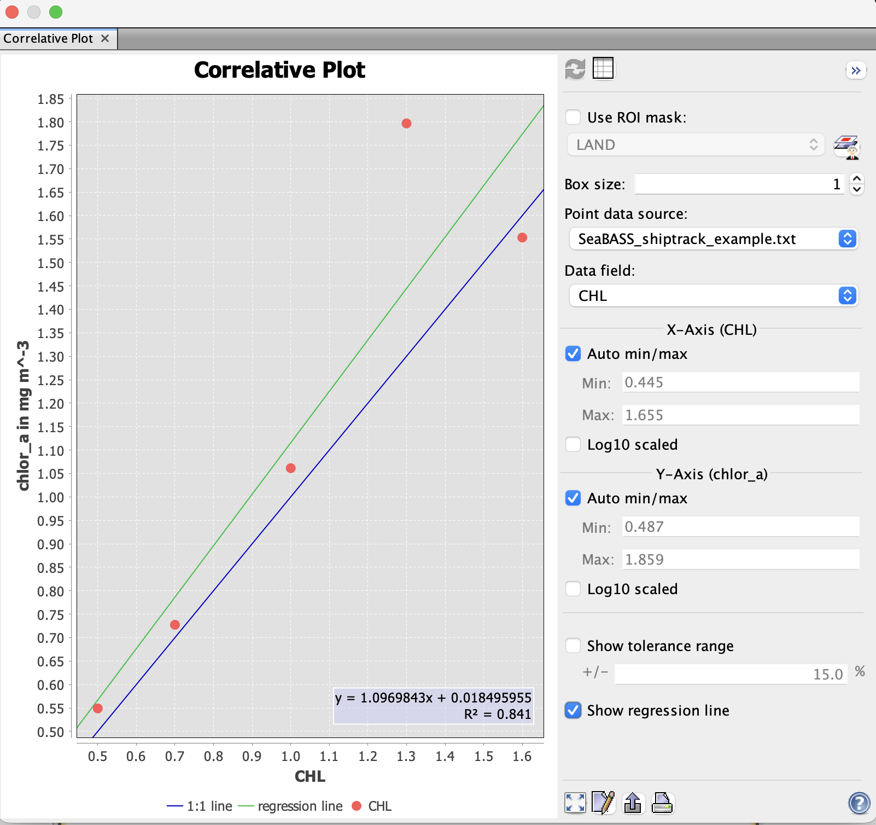

    - You can show regression statistics on the plot by checking “Show regression line”
    - For both correlative and profiles plots
      - You can export the plot as an image (.png file) by clicking export in plot view 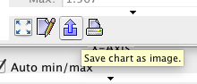
      - You can also display a table view while in the plot window 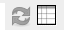
        - This data can be exported (and imported to excel, for example) by selecting the data (click on 1 line, then command-A to select all), right clicking and ‘Copy Data to Clipboard’. Open an Excel spreadsheet and paste the data

Data Extraction Reminder
To extract data from your satellite image, you can:
- Right click on the image to “Export Mask Pixels” and select a mask or shiptrack. This will generate a text file with data from all the bands from all the pixels within your mask ROI. Beware, this can be a very big file if you do a large mask!
  - You can also use File > Export > Other > Mask Pixels
- You can also select specific coordinates using the Pin tool (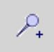), then export data from these coordinates using the above method.

PART II: SeaDAS Challenge

Now it’s time for you to use your new SeaDAS skills to work with real data! The “SEADAS_challenge” folder (that you copied into your personal directory) contains a monthly L3M MODIS ocean color image as well as Chl shiptrack data in SeaBASS format. This shiptrack data are from the Chukchi Sea in the Arctic Ocean (off the coast of AK) and collected during a cruise led by Kevin Arrigo on the icebreaker Healy.

Your task is to create an image of the Chukchi Sea that includes the shiptrack data. Whenever you’re working with L3 images, you use the Mosaic tool to project the images to the location you want.
Tip: Mosaic the image first, then plot your ship track over it. You will still use the File > Import > Vector Data > SeaBASS Data option to import the ICESCAPE shiptrack CSV file.

Here’s some tips for projecting images in the polar regions: Stereographic projection works well in the poles. Specifically, to project in the Chukchi, try these parameters to start (go to Raster > Geometric > Mosaicking):

NOTE: The Mosaicking glitch is still active, so when you swap over to “Map Projection Definition”, hit the tab key until projection options appear, then change your projection to “Stereographic North Pole”. Hit tab one more time and the “Projection Parameters” option will appear. Click it to change your central meridian. Remember to also change the Lat/Lon bounds of your mosaic. The options shown below work well for the Chukchi Sea:

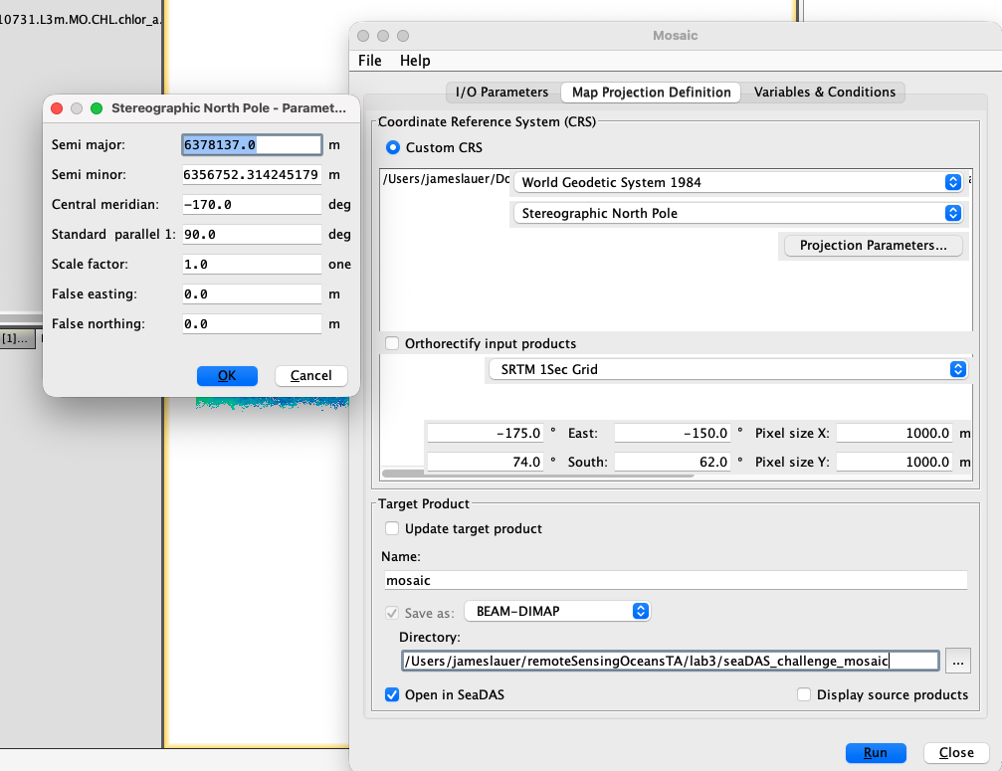

Try doing some data analysis using the techniques you learned above. Customize the image in the way you think looks best (changing grid lines, labels, etc.).
Save the image and the plots in your personal folder. Turn in the image to demonstrate your SeaDAS mastery and get credit for this lab!

Now that you’ve learned the basics, try practicing these SeaDAS techniques and considering how to use these in your final project. Also, don’t be afraid to use other menu options that have not been covered. Being familiar with the software and competent in methods for data analysis in SeaDAS is critical for success in your final projects! The course website home page has many helpful links to data, as well as instructions for batch processing (using the command line/PowerShell to process many images at once). Remember, you can always consult the TA, Gert, or the help section if you get stuck.

Next week, we will spend the lab learning how to use NASA’s Earthdata search tools to locate and download ocean color and other satellite products, so begin thinking about what you would like to find, and how you want to combine datasets!

