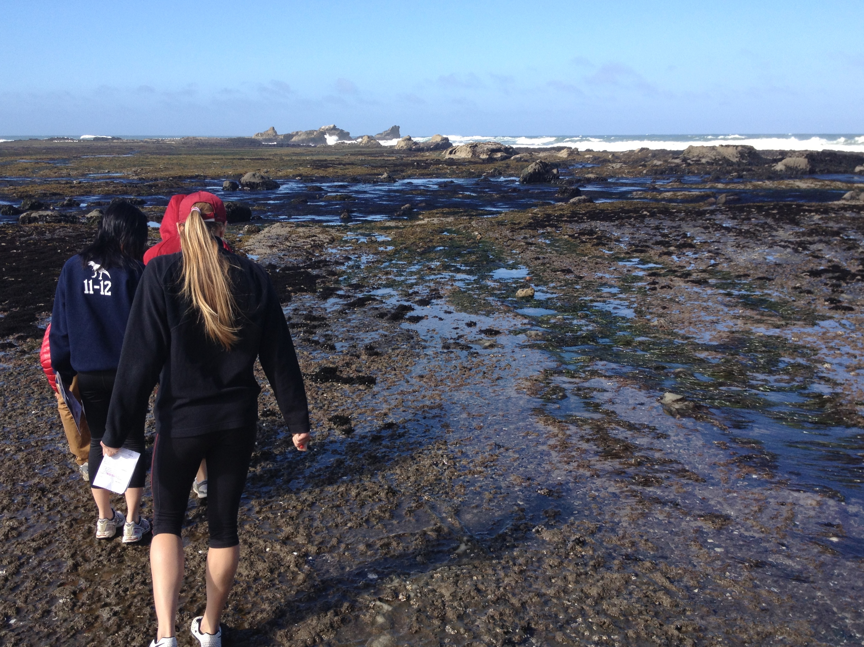
EARTHSYS/ESS 8: The Oceans
An introduction to the marine environment

Overview:
Instructors: Kate Lewis (kmlewis@stanford.edu, Mitchell B25)
Hannah Joy-Warren (hjoyw@stanford.edu, Mitchell B25)
Prof. Kevin Arrigo (arrigo@stanford.edu, Y2E2 141)
Course assistant: Amber Roberts (amberrr@stanford.edu)
Lecture: T/Th, 1:30 – 3:20 pm, McCullough 122
Office hours: Monday, 3:00 – 4:00 pm, Huang 218 (Amber)
Tuesday, 3:30 – 4:30 pm, Mitchell B25 (Kate & Hannah)
Thursday, 11:00 am – 12:00 pm, Y2E2 176 (Amber)
Website: http://ocean.stanford.edu/courses/EARTHSYS8
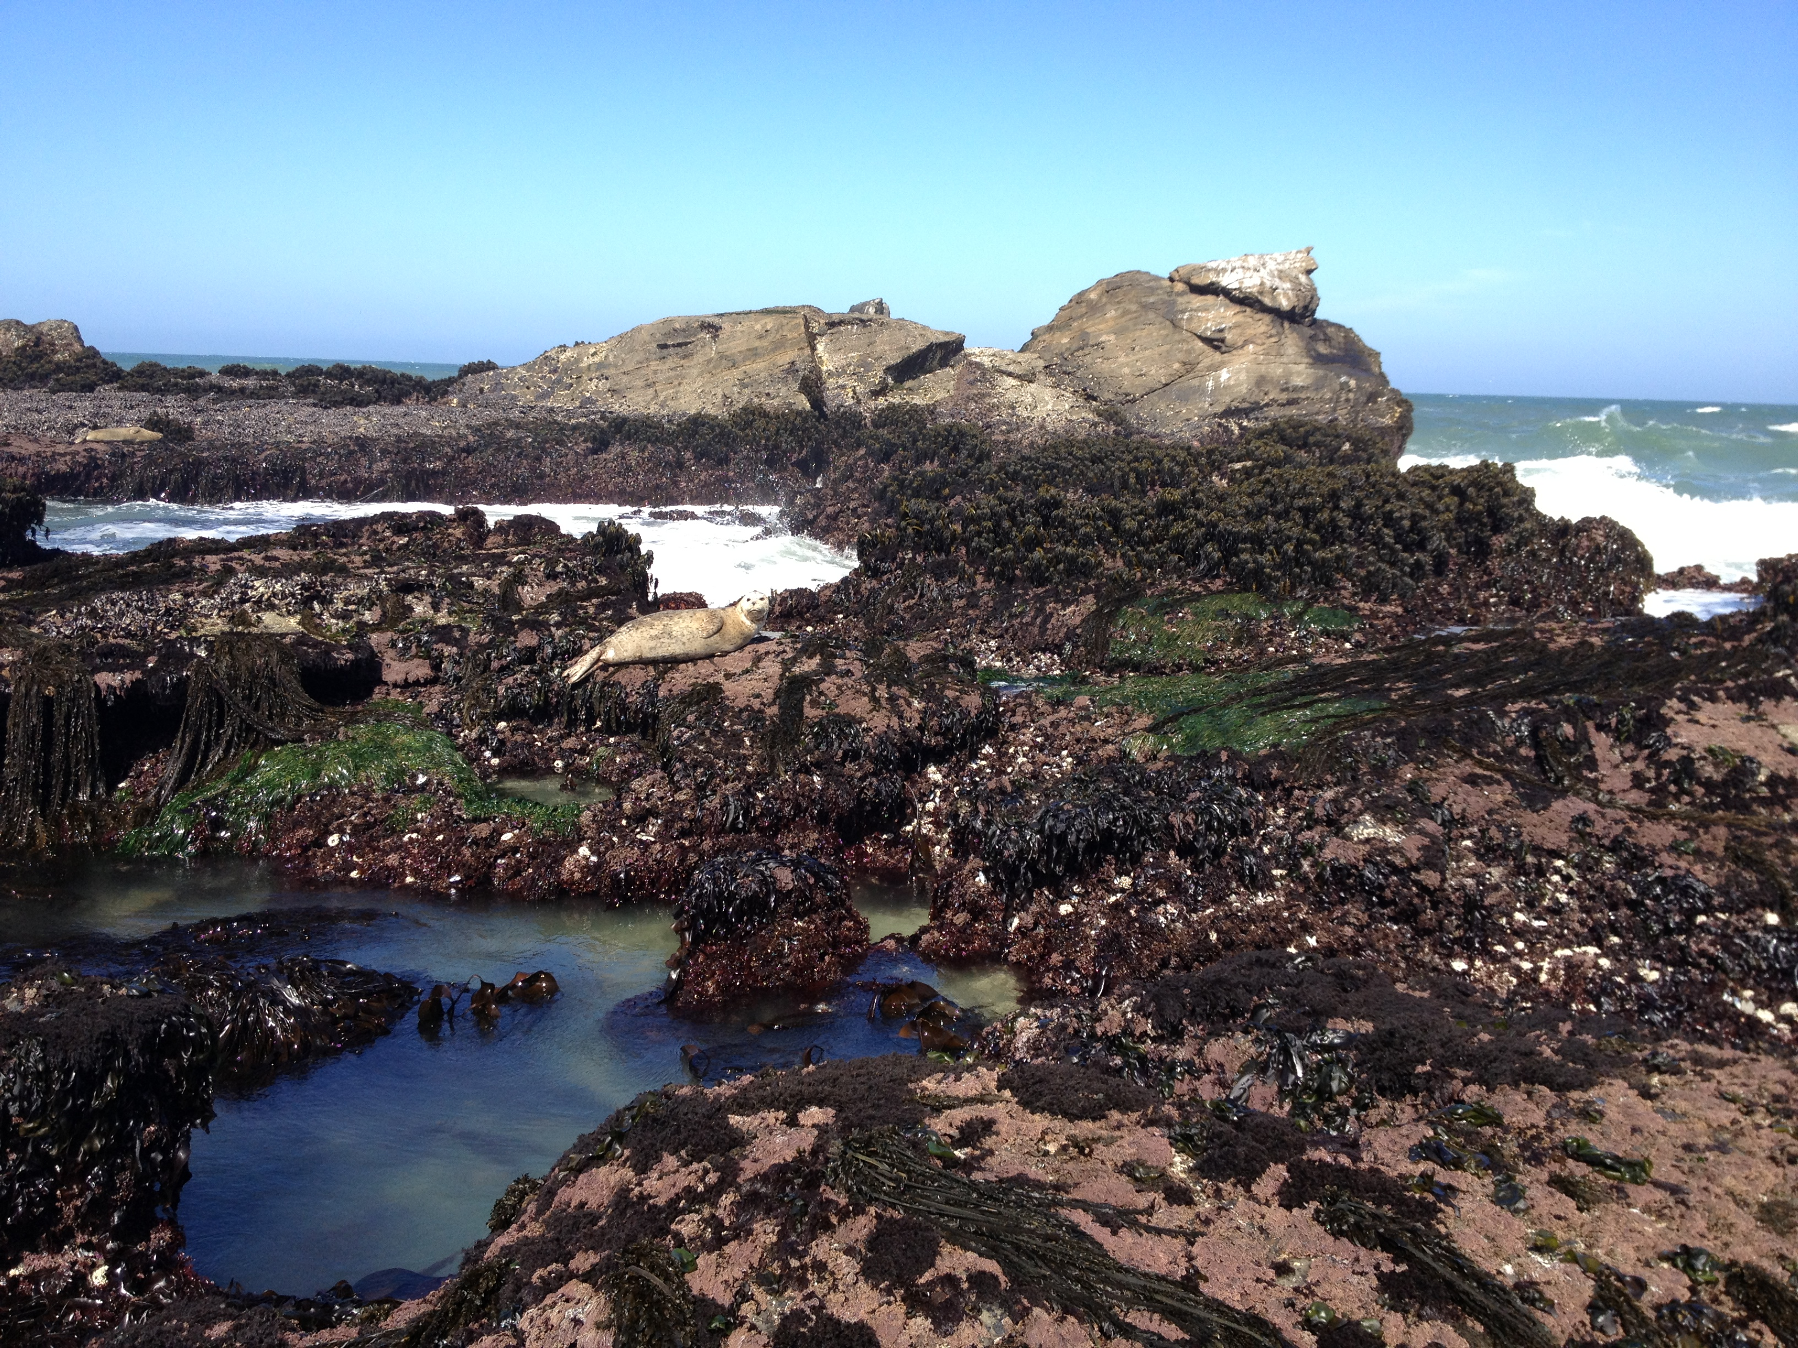
Textbook: Investigating Oceanography (1st or 2nd Ed)
by Keith Sverdrup & Raphael Kudela
Available on amazon and on reserve at Branner

Assignments and Grading:
Grade breakdown:
Reading feedback 15%
Participation 5%
In-class activities 25%
Midterm 25%
Final Paper 30%

Reading feedback
Submitting ‘Reading Feedback’ ensures that students read the assigned chapters thoroughly and helps the instructors identify elements of the reading that are challenging or confusing to address in more detail during the class lecture. Questions should consider concepts or synthesis, rather than simple definitions or answers that can be easily searched online. To get full credit for each day’s reading feedback, students must submit 1-3 thoughtful questions per assigned chapter by 8 pm the day before the lecture through the form on the course website. For example, on April 6 the lecture covers Chapters 2 and 3. Students must submit 1-3 questions for Chapter 2 and 1-3 questions for Chapter 3 by 8 pm on April 5 to receive full credit. Reading feedback form can be found on the class website.

Participation
Students are expected to attend and participate during class lectures and group activities. If you must be absent, please notify instructors to arrange to make up the in-class materials/assignments.

In-class activities
There are four in-class activities to reinforce lecture and reading materials. Students work in small groups to complete the activities and turn in a single document (listing all group member’s names) via email to the instructors. All students must contribute equally and work through all parts of the assignment together. Materials for in-class activities will be posted on the website prior to class.

Midterm
The midterm (May 9) is a combination of multiple choice and short answer questions that highlight the student’s understanding of the main learning goals of the first half of the course.

Final paper
The goal of the final paper is to provide an in-depth analysis of a relevant oceanography topic (chosen by the student) that incorporates recent research as well as fundamental concepts. The proposed topics will be presented and discussed in class (May 16) and the ‘research paper workshop’ (May 23) is aimed to help students incorporate primary literature and current research into their analysis papers. Details of the final paper proposal and assignment will be discussed further in class (May 11).

Submitting Assignments & Late Policy
All assignments are due electronically before the start of class on the day that it is due (with the exception of the ‘reading feedback,’ which is due at 8 pm the day before class). Title the document as “lastname_assignmentname” and email to both Kate Lewis (kmlewis@stanford.edu) and Hannah Joy-Warren (hjoyw@stanford.edu). Any late assignment loses 10% off the final grade for every class period (for example, if the assignment is due Tuesday but is turned in Tuesday at 5 pm, the assignment will lose 10%; if the assignment is due Tuesday and turned in after class on Thursday, the assignment will lose 20%).
In-class activities are group assignments that are designed to be finished within the class period. Each member of the group must contribute equally to the assignment. A single document with the names of each student should be emailed to both Kate and Hannah. If your group does not finish the in-class assignment by the end class, the activity will be due before the next lecture period.
Any students who register for class late have 2 weeks after the date they join class to make up all assignments for full credit.

Learning goals:
Broadly, the goal of this course is to introduce students to an integrated perspective of biological (marine organisms), physical (circulation, tides, waves), chemical (constituents of seawater), and geological (seafloor) oceanography. Throughout the course we consider the impacts of human activities on the ocean, including discussions on global climate change, marine pollution, overfishing and eutrophication. This course will enable students to achieve the following specific learning goals:

- Describe Earth’s internal structure, explain plate tectonics, and differentiate among the lithosphere, asthenosphere, and mesosphere.
- Identify the main elements of the seafloor and understand the formation and classifications of ocean sediments.
- Understand the physical properties of water, predict how temperature, pressure, and salinity impact density, and describe how energy is transmitted through seawater.
- Describe the chemical composition of seawater by understanding salinity, the major constituents of seawater, residence times, nutrients, and dissolved gases.
- Explain how the ocean and atmosphere interact by understanding Earth’s heat budget and atmospheric circulation.
- Distinguish between thermohaline circulation and surface currents in order to describe oceanic circulation patterns and features.
- Predict the formation and dispersion of waves and quantify wave characteristics.
- Model the Earth-moon-sun system, compare and contrast tidal patterns, and describe resultant tidal currents.
- Recognize the major types of coastal zones and beaches and describe how human impacts (dams, breakwaters, jetties) may interfere with the equilibrium of beaches.
- Differentiate the major environmental zones of the oceans and understand the flow of energy through trophic levels in food webs.
- Identify key planktonic organisms and, after working directly with satellite and in situ data, understand top-down and bottom-up controls on global patterns of productivity.
- Describe evolutionary adaptations of marine nekton, including invertebrates, fish, marine mammals, reptiles and birds.
- Characterize different benthic environments, including intertidal zone, coral reefs, hydrothermal vents and deep-sea floor, to predict the zonation of marine organisms.
- Evaluate the environmental problems posed by various human activities including pollution, eutrophication, oil spills and overfishing.
- Understand the role of the oceans in global climate change and predict what the oceans might look like in a warmer world.

Course schedule:
Week Date In class Reading*
1 April 4 Introduction
April 6 Earth Structure and Plate Tectonics; The Sea Floor and its Sediments 2, 3
2 April 11 Activity – Shape of ocean basins and bathymetry of the sea floor
April 13 Activity – Sea floor sediments
3 April 18 Physical Properties of Water; The Chemistry of Seawater 4, 5
April 20 Blue Planet – Seasonal Seas; The Atmosphere and Oceans 6
4 April 25 Ocean Structure and Circulation; The Waves 7, 8
April 27 Activity – Surface ocean currents and ocean-atmosphere interactions
5 May 2 Blue Planet – Tidal Seas; The Tides 9
May 4 Blue Planet – Coral Seas; Coasts, Beaches, and Estuaries 10
6 May 9 Midterm
May 11 The Living Ocean; Research Paper Discussion 11
7 May 16 The Plankton, Productivity, and Food Webs; Final Paper Topics Due 12
May 18 Activity – Primary productivity in the ocean
May 20 Tide Pool Field Trip (Optional – see below for details)
8 May 23 Research Paper Workshop – Outlines Due; Blue Planet – Deep Seas
May 25 Blue Planet – Open Ocean; The Nekton: Swimmers of the Ocean 13
9 May 30 The Benthos: Living on the Sea Floor; Peer Editing – Draft Due 14
June 1 Environmental Issues 15
10 June 6 Blue Planet – Frozen Seas; The Oceans and Climate Disruption 16
Final Paper Due
June 8 No Class

* The assigned reading is to be read for the class period listed and the reading feedback form is due by 8 pm the day before the lecture. For example, on April 6 the lecture covers chapters 2 & 3 so the reading feedback form is due by April 5 at 8 pm.

Field Trip
Our trip to Fitzgerald Marine Reserve is scheduled for Saturday, May 20, 2017. Unfortunately, there are no low tides during our class period, so the field trip is scheduled for a weekend morning. For that reason, the field trip is optional. We had a great time last year (we spotted many seals, whales and tide-pool critters) and it was the highlight of the quarter for most students. More details about logistics to come!

Students with documented disabilities
Students who may need an academic accommodation based on the impact of a disability must initiate the request with the Office of Accessible Education (OAE). Professional staff will evaluate the request with required documentation, recommend reasonable accommodations, and prepare an Accommodation Letter for faculty dated in the current quarter in which the request is being made. Students should contact the OAE as soon as possible since timely notice is needed to coordinate accommodations. The OAE is located at 563 Salvatierra Walk; Phone: 650-723-1066; Web site:
http://studentaffairs.stanford.edu/oae
If you are a student with a documented disability who needs special accommodations for exams, please talk to the instructors as soon as possible.

Stanford Honor Code
Students must follow Stanford University’s Honor Code and the Fundamental Standard:
https://communitystandards.stanford.edu/student-conduct-process/honor-code-and-fundamental-standard

