EESS 8: The Oceans
Activity 1
The Shape of Ocean Basins and the Bathymetry of the Sea Floor
Summary: In the ocean, the shape of the sea floor varies based on physical, geological, and biological processes that occur on different temporal and spatial scales. In turn, the shape of the sea floor controls the physical and biological processes that happen there. For example, currents and tides are largely controlled by the overall shapes of the ocean basins, as well as by the smaller scale shapes of ocean ridges and seamounts. Similarly, biological processes are controlled by ocean depth and terrain. In this activity, we explore the ocean basins and the sea floor and discuss the different processes that influence their shapes, and how their shapes may influence different processes. We compare various ways of mapping the sea floor, focusing mainly on ship-based measurements and satellite altimetry data.

Objectives:
- Compare and contrast different methods for mapping the sea floor
- Use satellite data to explore the shape of the sea floor
- Describe the basic pattern of sea floor bathymetry
- Compare various ocean provinces (continental margins, deep ocean basins, etc.) and describe what processes control the shape of the sea floor in different regions
- Hypothesize different ways in which the shape of the sea floor may impact physical and biological processes in the ocean

Background: The topography of the sea floor (called “bathymetry”) primarily reflects the geologic history of the last 150 million years – a small fraction of the Earth’s 4.5 billion year history. Why is the sea floor relatively so young? New oceanic crust is being constantly created at spreading centers, areas where two plates are pulling apart from each other, allowing fresh magma to rise from the mantle (such as the Mid-Atlantic ridge or the East Pacific Rise). As these plates spread apart from each other, they cool and sink; because oceanic crust is denser than continental crust, in the areas where ocean plates are crashing in to other plates, they are then subducted (pushed underneath the surface of the Earth) and subsequently destroyed – and on Earth, the oldest surviving oceanic crust (furthest from the spreading centers) is not much older than 150 million years.
What controls the shape of the sea floor? On a large scale, ocean basins are constantly changing as a result of plate tectonics, which creates large features like volcanoes, ridges, and trenches; at finer scales, physical and biological processes, such as sedimentation, massive debris slides, and flowing currents, influence the shape of the ocean bottom. However, relatively little is known about the bottom of the ocean, particularly in deep areas where several kilometers of water prevent easy access to the floor below. For example, the area west of the Pacific-Antarctic rise was thought to be completely flat until the discovery in 1972 of an entire chain of large undersea volcanoes called the Louisville seamount chain that spans a length about equal to the distance between New York and Los Angeles. Until recently, most of the data about the bathymetry of the sea floor came from seismic surveys, which utilize acoustic sounding to determine ocean depth. These surveys only covered very small regions (10%) of the sea floor; the rest was left to interpolation and guesswork.
Today, satellite altimetry provides a new method for mapping the sea floor. How can a satellite orbiting thousands of kilometers above the surface of the earth measure the exact shape of the bottom of the ocean? The surface of the ocean has broad bumps and dips that mimic the topography of the ocean floor below; every 1000 m change in ocean depth results in a ~4 m rise or fall in sea level. These “bumps and dips” are caused by minute variations in Earth’s gravitational field: for example, a massive mountain on the ocean floor (a typical undersea volcano is 2000 m tall and has a radius of 20 km) attracts water toward it, causing a local bump in the ocean surface. These small changes in sea surface height –not visible to the eye – can be mapped very accurately from satellites using a high-resolution 10-15 km) radar altimeter. An altimeter (such as the one on the TOPEX/Poseidon satellite; other important ones include ERS-1, GEOSAT, etc.) sends a radar microwave pulse to the sea surface, which is reflected back to the satellite. The satellite records the time it takes for each signal to return, and from this we are able to obtain a detailed map of sea surface topography, which is then correlated to bathymetry. (The radar altimeter also measures wind speed and wave height.)
More info: http://www.ngdc.noaa.gov/mgg/bathymetry/predicted/explore.HTML
Originally created from David T. Sandwell (Scripps) and Walter H.F. Smith (NOAA). Modified by Molly Palmer (Stanford University).

Part 1: Using Satellite Altimetry Data to Map the Sea Floor
Part 1a: Comparing Ship-based Measurements to Satellite Data
As described above, mapping the bathymetry of the sea floor has traditionally been done using ship-based measurements (from acoustic soundings to throwing weighted ropes over the side). However, recent technological advances allow us to now measure small variations in height of the sea surface using satellite altimetry data, which is then related to the underlying bathymetry. The image you will be using for this part (see attached “Image for Part 1a”) shows two maps of the same region of the sea floor, located in the southern hemisphere Pacific Ocean southern hemisphere. The top image is seafloor depth based on the digital global bathymetry map ETOPO5 (created by interpolation of historical ship-based measurements by the US Navy and NOAA in 1988). The middle panel shows predicted seafloor depth based mainly on satellite altimetry data (from Geosat; some ship-based soundings were also used; the red lines are the locations of the Sub-Antarctic front and the Polar Front). The bottom panel shows the ship tracks from which soundings were used to make the bathymetric predictions for the top map.

1. Examine the top two panels. How does the ship-based map (top) compare to the satellite map (middle)? List at least 5 similarities or differences.

2. Compare the ship tracks (bottom) to the maps. What do the ship tracks appear to focus their mapping efforts on? How might this affect the maps created from this type of data?

3. Again examine the top two panels. The top panel based on ETOPO5 lacks the topographic expression of a 400 km long northwest-tending ridge at roughly 53S, 140W, minimum depth 135m. This ridge was first surveyed by a French expedition in December 1995.
a. Why do you suppose this feature is not captured in the ETOPO5 map?

b. Why is defining this type of feature in oceanographic maps important for predicting the physical oceanography and biological processes of the region? Give an example.

Part 1b: Comparing Satellite Data to Predicted Topography
As described above, at a broad scale, the ocean is an equipotential surface of the Earth’s gravity field—a smooth ellipsoid covering the surface of the Earth. However, in reality, small bumps and dips due to tiny variations in the gravitational field (such as from large mountains or deep trenches on the sea floor) cause the surface ocean to vary ±100 m in height. Although satellite altimetry data allows us to survey the full ocean much more rapidly than ship-based measurements, the process of converting satellite radar altimetry pulses into a detailed map of the ocean floor contains multiple levels of complication and uncertainty. To give you a basic understanding of this process, some of the major steps are described below:
- The satellite sends down a radar microwave pulse, and the time the pulse takes to return to the satellite is recorded. To convert this transit time in to sea surface height, a number of very precise measurements must be made, including:
  - 1) the height of the satellite above the ideal surface of the ocean, i.e., what the ellipsoid height would be if there were no variations caused by gravity;
  - 2) the height of the satellite above the actual ocean surface, determined by the microwave pulse;
  - 3) the direction and trajectory of the satellite (i.e., which direction the radar is facing when it sends the pulse);
  - 4) the influence of waves or other irregularities in the ocean surface on the apparent “height” measured.
- Then, a number of other corrections are made to the recorded height and transit time, including some complicated corrections for atmospheric delays (for example, water vapor slows down the returning microwave pulse) and the tidal cycle.
At this point, you have some sort of sea surface height or “gravity anomaly”, i.e., the deviation in the sea surface height caused by variations in the gravitational field below. The next steps – to get from gravity anomalies to ocean bathymetry – requires several more calculations and assumptions. An exact description of how this works is outside the scope of this class, but at a basic level, variations in the Earth’s gravitational field are not uniform or as easily understood as it might seem. A key example of this is that less dense, poorly compacted sediments have a much lower gravitational pull than more dense basement rock – meaning that areas covered by sediments may “appear” based on sea surface height to be a different depth than they actually are, and vice versa.
Thus, there are many assumptions and uncertainties in the determination of sea floor bathymetry from satellite altimetry data, and even though our methods and algorithms for connecting the two are constantly improving, they are nowhere near perfect. As such, satellite data is often combined with other measurement types – whether ship-based or otherwise – to create the maps we use today to explore the ocean bottom. Furthermore, satellites are extremely expensive and take years to plan – and even then are not guaranteed to work (the most recent NASA satellite, created to monitor global carbon dioxide emissions, crashed just after launch….a loss of nine years and $270 million).

1. The image (see attached: “Image for Part 1b”) shows gravity anomalies (left) computed from satellite altimetry data, and the predicted topography of the sea floor (right) deduced from these gravity anomalies.
1a. Describe (briefly) at least 3 differences between the two images. What patterns do you see in these differences?

1b. Why do you suppose the maps are different? Suggest at least 2 reasons based on what you read above.

2a. In general, how do the satellite-generated maps compare to the maps created from ship-based measurements?

Given all the complications described above, which type of map would you rather use to if you were…..
A sailor?
A submarine captain?
Looking for marine resources?
A scientist modeling ocean circulation?

2b. What other issues can you think of for using satellite data to map the sea floor?

Part 2: Exploring the Sea Floor: Continental Margins
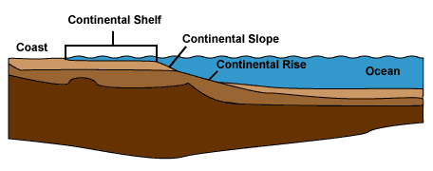
The above diagram depicts the general features of continental margin regions: the coast, continental shelf, continental slope, and continental rise, which all eventually give way to the deep ocean. There are two basic types of continental margins: active (associated with plate boundaries, plate convergence, and subduction zones leading to high seismic activity and typically narrow shelves) and passive (a continent-ocean transition on the same plate; low seismic activity and typically wide shelves). Continental shelves are gently sloping and shallow (average depth: 130 m); they are geologically part of the continents, often simply eroded crust that is now submerged (but was most likely exposed land during the last ice age). Continental slopes are the steeply sloping regions at the edge of the shelves; the angle and extent of continental slopes vary, but they are always accompanied by a rapid increase in depth (with active margins having typically much deeper continental slopes). The continental slope may be dissected by submarine canyons, show rocky outcroppings, and/or be bare of sediments. The continental rise is the more gently sloping region at the base of the continental slope, formed by the accumulation of sediment; a distinct continental rise is typically more distinguishable at passive margins where sediments have had longer and more stable periods to settle.
Map at: http://www.ngdc.noaa.gov/mgg/global/relief/ETOPO1/tiled/ice_surface/etopo1_ice_surface.kmz

1. Use the Google Earth map “etopo1_ice_surface.kmz” to compare and contrast the continental margins of the east and west coasts of the United States. The table below indicates which properties you should make sure to consider in your description of the different margins (you don’t have to answer every question). The “ruler” function will be useful for determining width.
Compare and Contrast… | East Coast USA | West Coast USA
Continental Shelf
Consider the following: Which is wider? What is the general shape of the shelf? Are there many canyons or other physical features? How does the shelf end – is there an abrupt transition?

Active or Passive Margin?
Other Observations
Consider the following: Is there a definite continental rise? What do you observe about the continental slope? Are these features easy to distinguish? Which features are most important for helping you describe the continental margin?

2. Can you see a more of a difference between the rise and the slope more on one coast vs. the other? Does this make sense given the observations you made above? Why or why not?

3. Explore the Google Earth sea floor map. Where on Earth are the widest continental shelf regions located? List 2 of the widest shelf regions, and indicate why they are likely so wide.

4. What processes are most important in determining the physical features of continental margins? Suggest at least one process for each feature (shelf, slope, rise).

5. How might the physical features of the continental margin region affect ocean currents and circulation in the area? How might ocean currents affect the physical features of continental margins? Suggest 2-4 ways for both.

Part 3: Exploring the Sea Floor: The Deep Ocean
The deep-sea floor, between 4000 m and 6000 m, covers 30% of the Earth’s surface and is composed primarily of large flat plains extending from the base of the continental slope which are broken up by ridges, rises, fracture zones, and seamounts. These plains, called abyssal plains, have slopes of less than 1:1000 and are formed by the gradual process of sedimentation filling in the irregular topography of the oceanic crust. If an abyssal plain is isolated from other areas by ridges or continents, it is known as a basin. Low ridges may allow some exchange of water between adjacent basins, but higher ridges effectively cut off the basin from the transfer of water and marine organisms. Continuous mountain features known as ridges and rises extend across the deep ocean basins, covering one-third of the sea floor and raising bottom elevations to an average depth of 2500 m. (Mid-ocean ridges are locations of sea-floor spreading and/or where plates are moving apart from each other.) Multiple fracture zones, caused by tectonic activity as plates move toward and away from each other, extend and offset ridge and rise axes, roughening the appearance of the sea floor. These zones can run over a thousand kilometers in length and are prominent features on the sea floor—the ocean floor on either side of a fracture zone can vary by 1500 m in depth. Volcanic submarine peaks and islands develop in the middle of plates; peaks that extend more than 1 km above the abyssal floor are called seamounts (if flattened on top, they are called guyots or tablemounts), otherwise smaller peaks are simply called abyssal hills. Finally, geologic features called “hot spots” can create volcanic islands that reach the surface ocean, such as Hawaii, or remain below the surface, such as the Emperor Seamount Chain.
Biologic activity can also influence the shape of the sea floor. A fringing coral reef forms in the shallow waters adjacent to the shore of a volcanic island that reaches the surface of the ocean. As this island sinks in time due to geologic processes, the coral reef continues to grow upward to reach the surface, becoming a barrier reef. Over time, as the island disappears below water, an atoll is left behind – a ring of coral surrounding a shallow lagoon (which is the top of the sunken and eroded volcano).
Google Earth Bathymetry map at: http://www.ngdc.noaa.gov/mgg/global/relief/ETOPO1/tiled/ice_surface/etopo1_ice_surface.kmz

1a. You travel in a submarine from New York to Spain. Use the Google Earth map “etopo1_ice_surface.kmz” to explore your route. Describe your journey. What general features do you encounter? What is the maximum depth reached? Minimum depth? Use the ruler tool to give an approximate length of your trip.

1b. Sketch a simple profile of your journey showing each major bathymetric feature on the chart below. Label each feature (you don’t have to know names) and include a depth scale. (It may help to make depth readings every 100 km or so to get a good profile.)
Surface: 0 m

Depth

New
York
Spain
2a. On your next trip, you travel by submarine from Japan to Baja, California. Again, use the Google Earth map to explore your route and describe your journey, including all the major bathymetric features you encounter and the min-max depths.

2b. Sketch a simple profile of your journey showing each major bathymetric feature. Label each (again, you don’t have to know their proper names, but it may help your understanding) and include a depth scale.

Depth
Surface: 0 m

Japan
Baja, CA
3. How do your profiles differ in the horizontal and vertical scale? What features are more prominent in your Pacific route than in your Atlantic route (and vice versa)?

4. Describe 2-3 ways in which the different features you found on your routes may impact ocean circulation and biological processes. For example, it was discussed above how ridges may cut off one ocean basin from another, preventing the transfer and flow of water and marine organisms between basins. Try to relate your answer to some of the different things we have been discussing in class (for example, the CCD, thermohaline circulation, etc.).

References: Duxbury, A., et al., An introduction to the World’s Oceans Sixth Edition, McGraw-Hill, 2000; Thurman, H., Introduction to Oceanography Seventh Edition, Macmillan Publishing Co., 1994; and the various websites listed throughout this exercise, especially the data and links in NOAA’s National Geophysical Data Center, http://www.ngdc.noaa.gov/mgg/bathymetry/relief.html and NASA’s topex mission website, http://sealevel.jpl.nasa.gov/mission/topex.html
Image for Part 1a: Comparing Ship-based Measurements to Satellite Data
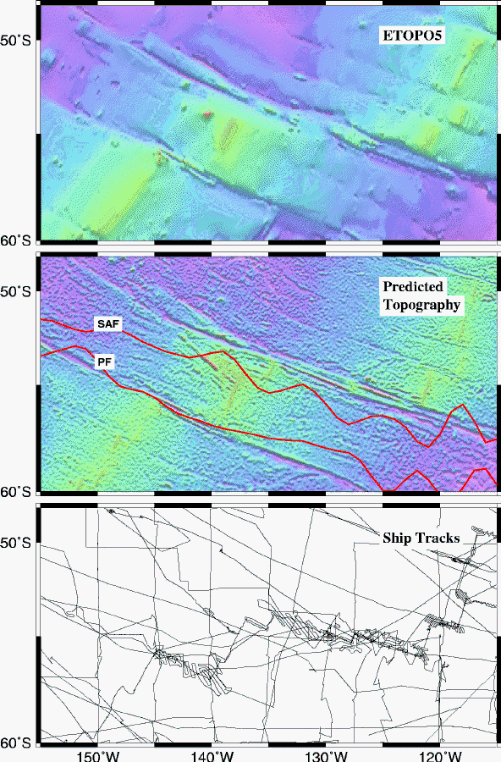
image from: http://topex.ucsd.edu/marine_topo/text/topo.html

Image for Part 1b: Comparing Satellite Data to Predicted Topography
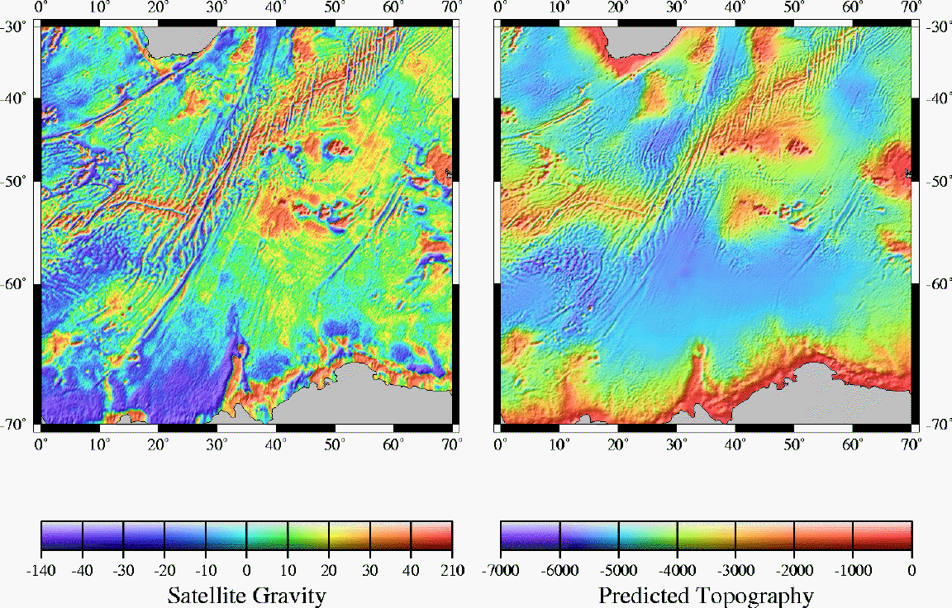

image from: http://www.ngdc.noaa.gov/mgg/image/predictnew.gif

