EARTHSYS / EESS 8: The Oceans
Activity 2

Seafloor Sediments

Guidelines:
Students will work in small-groups to complete the assignment. All students must work together on each step of the activity. A single document will be turned in as a group (include everyone’s names) via email to instructors (Kate, Hannah, and Amber). The document should be clearly named as “LAST_NAMES_activity1.” You can answer the questions directly in this document, but please type answers in a different color text. The activity is due before the start of the next class (4/13).

It is important to fully read all of the background information provided in this document – this will help you answer the questions in the activity. You may also consult your textbook, lecture notes, or reputable internet resources to aid you in your answers. For this activity, at least one member’s computer must have Google Earth (to download: https://www.google.com/earth/download/ge/agree.html).

Summary:
This exercise is designed to introduce to you the various types of marine sediments and their distribution on the sea floor. You will be using core photos and authentic datasets from the Ocean Drilling Program (ODP), an international cooperative effort to explore and study the composition and structure of the Earth's ocean basins.

In Part 1, you will be given photographs of cores and asked to make observations. In Part 2, you will be given information on the types of sediments in your core and asked to classify your core type. In Part 3, we will understand what controls the distribution of different sediment types in the ocean.

Objectives:
- Identify patterns of marine sediment distributions
- Utilize and interpret real scientific data
- Describe marine sediment distributions and controls
- Develop hypotheses regarding marine sediments

Background:
The ODP was designed specifically to conduct research on the history of ocean basins and the nature of the sea floor. This was the first time that such a large and organized attempt was made to study marine sediments and the sea floor. The data it generated has greatly expanded the field of oceanography as well as our understanding of climate change, Earth history, marine resources, natural hazards, and the development and evolution of life. ODP began in 1985 as a US and international collaboration and by the end (2004, when it was converted to a new program called IODP, or the “Integrated” ODP), over 2000 deep-sea sediment cores from major geological features were collected. You will be using a small subset of these cores, but much of the data (and more information) is available on the web at http://www-odp.tamu.edu/ or for newer data, at http://www.iodp.org/.

This activity was modified by Molly Palmer (Stanford University) from the activity “Building Core Knowledge: Reconstructing Earth History: Sea Floor Sediments” developed by K. St. John, M. Leckie, M. Jones, and K. Pound.

Part 1: Core Observation & Description

Each group will describe their assigned sediment cores (below) by considering information of the sampling location (in Table 1) and color photos of the cores (core_photos.pdf). Your goal is to become acquainted with what marine sediments cores look like and what kind of information you can gain simply by making visual observations. Note that all of the cores in Table 1 end with core number 1, 2 or 3. This means that these cores are at or close to the top of the sediment sequence on the seafloor, with “1” representing the section closest to the seafloor. Therefore, all the sediment in these cores represents modern or very recent environmental conditions at that location in the ocean.

Group 1: 145-886B-2H, 178-1101A-2H, 202-1236A-2H
Group 2: 178-1096A-1H, 199-1215A-2H, 198-1209A-2H
Group 3: 145-882A-2H, 8-75-1, 33-318-2
Group 4: 145-887C-2H, 28-274-2, 29-278-3
Group 5: 19-188-2, 136-842A-1H, 37-333-2
Group 6: 145-886B-2H, 178-1101A-2H, 202-1236A-2H
Group 7: 178-1096A-1H, 199-1215A-2H, 198-1209A-2H
Group 8: 145-882A-2H, 8-75-1, 33-318-2
Group 9: 145-887C-2H, 28-274-2, 29-278-3
Group 10: 19-188-2, 136-842A-1H, 37-333-2
Group 11: 145-886B-2H, 178-1101A-2H, 202-1236A-2H
Group 12: 178-1096A-1H, 199-1215A-2H, 198-1209A-2H
Group 13: 145-882A-2H, 8-75-1, 33-318-2

- Record your group number and which cores you were assigned.

- For each core:
- Find the sampling information in Table 1 and record their location and water depth.
- Examine your core photos and make a list of observations (e.g., color, sediment grain size/texture, distinct features, etc.).
- Brainstorm a list of questions that you have after making these initial observations.

- How do you think scientists organize and record these types of visual observations? What information do you think is important to record if you wanted to be able to understand a core without having the actual sample available? Brainstorm a few different ways to organize the data. This means you need to come up with categories (for example, color) for your observations and also a means of recording them (for example, all written, all sketch, a combination?). Record your ideas below.

- After answering, look at actual log sheets used by scientists (“visual core description” on the class website). Notice what features are considered important enough to diagram with a sketch vs. which are handled in written form. Also notice which categories are emphasized – grain types, structure, disturbed parts, etc. How does your ideas in question 3 compare to this log sheet?

Part 2: Sediment Core Composition

Beyond visual observations alone, scientists often analyze small segments of cores under the microscope to determine sediment composition. Then, the sediment observed under the microscope is matched with categories of known grain types. Take a look at the handout of “Microscope Slide Images” (on website) to get an idea of what the different types of sediment would look like if you analyzed them under the microscope.

Table 2 “Sediment Core Data” (on website) contains data from microscopic analysis of all the intervals of each core in this exercise. The data in the table includes sediment size/texture (sand, silt or clay) and mineral composition (estimated abundances of specific minerals and microfossils) which you will use to determine the sediment type of each core.

- After reading the instructions below, use the Marine Sediment Decision Tree with the information from Table 2 “Sediment Core Data” and “Core Photos” to determine the types of sediment in each of your cores. Consider the information provided for each interval of the core. Record what sediment type classification best represents each of your entire cores.

How to use the Marine Sediment Decision Tree:
The decision tree aims to characterize sediment samples as one of the following sediment types:
- Calcareous ooze – calcareous nanofossils and/or foraminifera
- Siliceous ooze – diatoms, radiolarians, sponge spicules, and/or silicoflagellates
- Deep Sea “Red” Clays – may contain siliceous microfossils, fish teeth, Mn-Fe micronodules, and/or volcanic glass
- Deep Terrigenous Sediment – sediment on the continental slopes or rise that are derived from land materials.
- Shallow Terrigenous Sediment – sediment on the continental shelves that are derived from land materials.
- Glaciomarine Sediment – inorganic and organic material deposited in a marine setting by a combination of glacier- and marine-related processes

Important notes!! READ!! :
- In many settings, the sediment types can be mixed. For example, it’s possible to have both microfossils and mineral grains. In this case, you should list the main components in order of abundance with the most abundant component listed last. For example, a “siliceous clay” would be mostly clay minerals, but with a large proportion of siliceous microfossils. If you have mixed sediment, be sure to note which component is most abundant and which component(s) are less abundant using this naming convention!

- If there is one microfossil group that dominates the composition, it is also appropriate to be more specific with the name; for example, a siliceous ooze that is primarily composed of diatoms could be more specifically termed a “diatom ooze”.
- Also note that in any of the sediment types, but especially in biogenic oozes and deep-sea (“red”) clays, layers of volcanic ash may be distinguishable. If you notice this from your visual inspection of “Core photos”, you should include this information in your classification.

Marine Sediment Decision Tree
To determine the dominant type of marine sediment based on smear slide data, visual core observations, and site characteristics.
--------------------------------------------------------------------------------------------------------------------------------------------
BIOGENIC SEDIMENT
Is the sediment >50% microfossils?
yes
no

It is a biogenic-rich sediment. It is a non-biogenic sediment.
Go to the next chart.

Is it dominated by foraminifera
and/or calcareous nano fossils,
OR is it dominated by diatoms,
radiolarians, silicoflagellates,
or sponge spicules?

Diatoms, radiolarians, silicoflagellates, sponge spicules
Forams, calcareous nanos

Sediment Type = Sediment Type =
Calcareous Ooze Siliceous Ooze

-------------------------------------------------------------------------------------------------------------------------------------------
NON-BIOGENIC SEDIMENT
Is the texture and/or the mineral composition primarily clay (dust-size)?
yes
no

Is the drill site location in a deep basin, Go to next chart.
Or is it on (or near) a continental slope/rise?

Deep basin,
Abyssal Plain

Continental slope/rise

Sediment Type = Red Clay Sediment Type = Deep Terrigenous Sediment
(Also known as Pelagic Clay Additional evidence may include fining-upwards sequences
and Deep Sea Clay). Additional or sequences with sharp bases.
evidence is a red/brown color, and
sometimes black “spots” or nodules
in the sediment, which are Mn and Fe
mineral precipitates.

--------------------------------------------------------------------------------------------------------------------------------------------
MIXED GRAIN SIZE, PRIMARILY NON-BIOGENIC SEDIMENT
Does the sediment contain isolated pebbles or gravel? (look at “core photos.pdf”)
no
yes

Sediment Type =
Glaciomarine Sediment

Is this sediment on the continental shelf or the continental rise?

Continental shelf

Continental rise

Sediment Type = Sediment Type =
Shallow Terrigenous Sediment Deep Terrigenous Sediment
(Also known Neritic Sediment and Margin Additional evidence may include
Sediment). Some margin sediment may fining upward sequences with sharp
contain sea shells (mollusks), and titled bases.
(cross)-bedding.
--------------------------------------------------------------------------------------------------------------------------------------------

Part 3: Sea Floor Sediment Synthesis

Open the Google Earth “Core Locations.kmz” file (on the class website). A push-pin represents each sediment core location. The ‘push-pin’ color scheme (see below) illustrates the dominant sediment types of all the sediment cores from Table 1. Click on each pin to see the name and description of the core location and sediment composition.
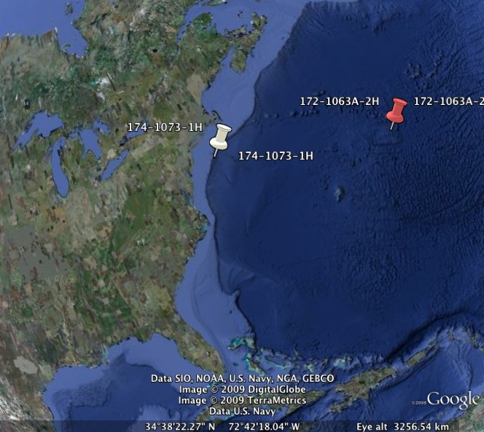
 | Siliceous Ooze
 | Deep Terrigenous Sediment
 | Shallow Terrigenous Sediment
 | Glacimarine Sediment
 | Red Clays
 | Calcareous Ooze

- Locate your cores. Does the sediment type that your group came up with agree with the sediment type listed on the map? Why might your answer differ from the one given on the map (even if you correctly used the sediment tree to indentify the sediment type)?

- Now, zoom out on the Google Earth map of the core locations and types. Considering all the cores in all ocean basins (not just your three), make a list of observations of the distribution of each of the different sediment types.

- Based on your observations, describe at least two factors that control the distribution of each of the sediment types in the ocean. Consider factors that may influence the pattern of sediment distribution such as distance from the continents, water depth, and latitude/longitude (be specific). Why do the different sediment types exist in the regions you see on the map?

- Compare the Google Earth map of core locations to a more general sediment distribution map (Rothwell, 1989). How do you think the general map was created? How are the two maps similar and different? What might cause these discrepancies?
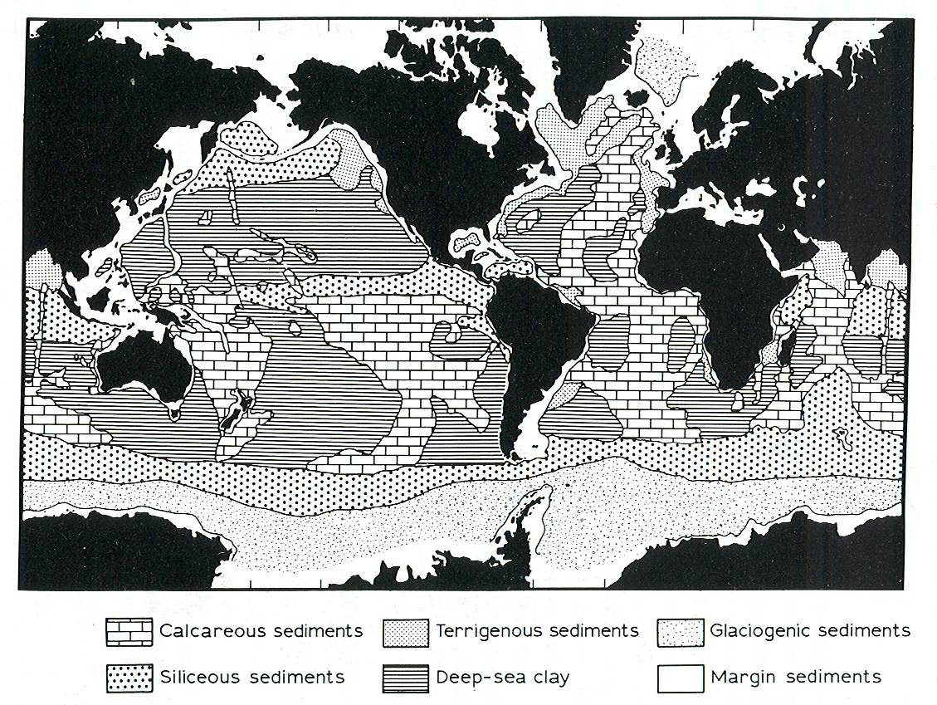

5. Describe the glaciomarine sediment distribution on both the general and the Google Earth maps. How might you explain the abundance of this type of sediment in the North Atlantic?

6. The carbonate compensation depth (CCD) is the depth in the ocean below which the rate of supply of calcium carbonate (CaCO₃) equals the rate of dissolution such that no CaCO₃ is preserved. Above the CCD, calcium carbonate shells can remain solid and form calcareous oozes. Below the CCD, calcium carbonate shells dissolve back into ions. How could you use the sediment core data to locate the depth of the CCD in different parts of the ocean? For example, are calcareous-rich sediments in the North Pacific found at the same depth or shallower/deeper than depths in the North Atlantic? Why might this be the case?
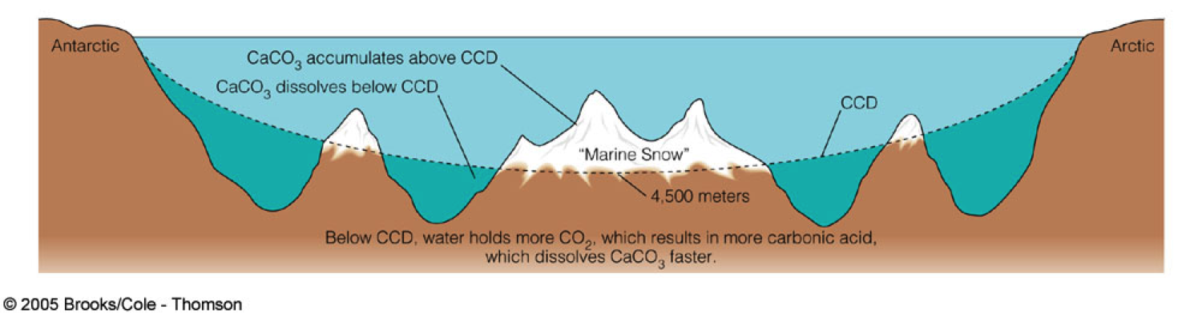
7. The map constructed using these sediment cores represents the modern distribution of sediment types on the world ocean. Do you think this map would also represent sediment type distribution in the geologic past and in the geologic future? What factors might vary (in the past and the future) that could change the distribution of sediment types? Give at least 3 examples.

